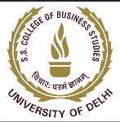 | SKILL DEVELOPMENT CELL (SDC)  Shaheed Sukhdev College of Business Studies  University of Delhi
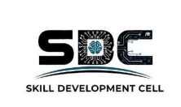
E V E N T R E P O R T
CONSULTING WORKSHOP
A Deep Dive into Business Frameworks Through a Consultant's Lens

Organized By | Skill Development Cell (SDC)
Institution | SSCBS, University of Delhi
Event Name | Consulting Workshop
Duration | 4 Days, 4 Hours Each
Dates | 19th, 20th, 25th & 31st March 2026
Average Participants | ~65 per day
Document Type | Official Event Report

1. Event Overview
The Skill Development Cell (SDC), SSCBS, organized a four-day Consulting Workshop, with each session running for four hours, held on 19th, 20th, 25th, and 31st March 2026. The workshop was designed to introduce students to the business landscape through the lens of a real consultant, drawing an average of around 65 participants across each of the four sessions.
2. About the Activity
The workshop took participants through a range of consulting frameworks used to structure and solve business problems, including MECE (Mutually Exclusive, Collectively Exhaustive), the McKinsey Three Horizons framework, and other widely used problem-solving tools. Facilitators explained how these frameworks help consultants break down complex, ambiguous problems into clear, structured components, forming the backbone of professional business analysis.
These frameworks were brought to life through real-world case studies, including an in-depth look at the Airtel-Jio rivalry, which was used to explore competitive strategy, market positioning, and disruption within the telecom industry. On the other end of the spectrum, participants also examined a small, local chai wala business, using it to understand how foundational business concepts and strategic thinking apply just as much to small-scale enterprises as they do to large corporations.
A significant part of the workshop was dedicated to understanding business moats — the sustainable competitive advantages that allow companies to defend their market position over time — and how businesses are built and scaled with these moats in mind. Participants also learned how to approach problems the way a consultant would: structuring the problem, forming hypotheses, gathering and analyzing relevant information, and arriving at clear, actionable recommendations.
3. Event Photograph
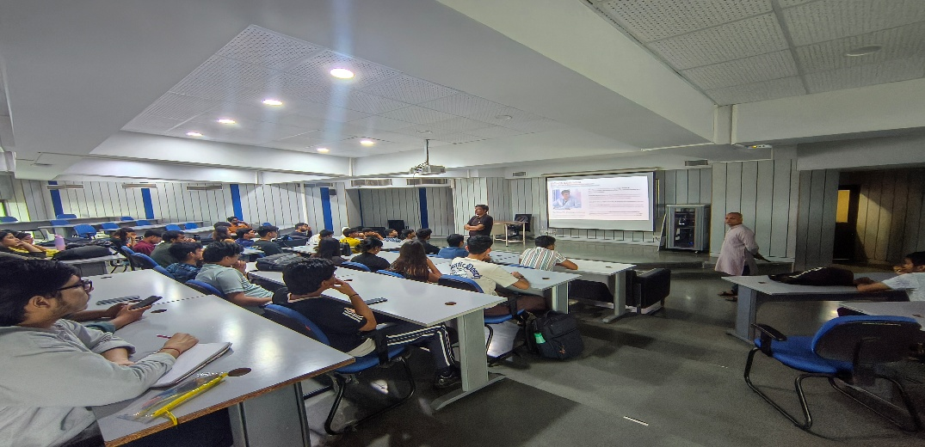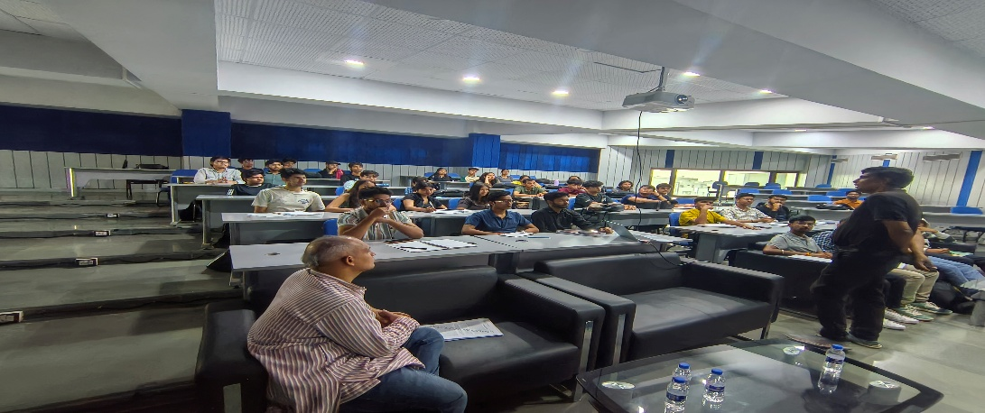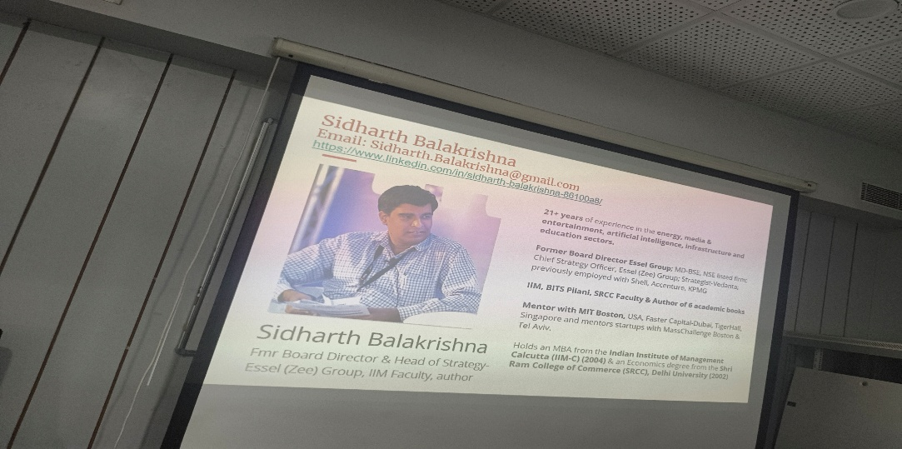
4. Conclusion
The Consulting Workshop gave participants a rare, immersive glimpse into how real consultants approach and solve business problems, blending structured frameworks with grounded, real-world case studies ranging from telecom giants to a neighborhood chai wala. With an average of 65 participants engaging across all four sessions, the workshop successfully built both conceptual understanding and practical problem-solving skills among students.
By combining frameworks such as MECE and the McKinsey Three Horizons with diverse case studies and a focus on business moats, the workshop equipped participants with a consultant's toolkit for approaching ambiguous business problems. The Skill Development Cell looks forward to organizing more such in-depth, multi-day programmes to continue building strong analytical and strategic thinking skills among students.

