
SHAHEED SUKHDEV COLLEGE OF BUSINESS STUDIES
(UNIVERSITY OF DELHI)
Dr. KN Katju Marg, Sec-16, Rohini, Delhi-110089
  - About Course: FMAT is a joint Certification Program of Shaheed Sukhdev College of Business Studies (SSCBS) & BSE Institute Ltd (BSEIL), an arm of the Bombay Stock Exchange (BSE). The course has been especially designed to equip students with specialized skills needed to work with the ever-increasing challenges of the financial markets and develop them into holistically knowledgeable, skilled and competent financial professionals.
The course would help develop competencies in vital areas of management and finance such as risk management, valuation modeling, project finance, algo trading, financial statement modeling and data mining amongst others.
A strong practical approach including case discussions, hands-on practice, and live (Algo) trading using specialized software’s and research orientation are some of the key highlights of this course. Shaheed Sukhdev College of Business Studies and BSE Institute Ltd. are known for their quality in house faculty and contact resources from industry.
  - Payment:
Net Banking/ UPI/ Cheque in the college “Shaheed Sukhdev College of Business Studies”.
Net Banking/ UPI/ Cheque details:

Account Name: | Principal SSCBS Students Society A/C
Bank: | State Bank of India
Account Number: | 35810781108
IFS Code: | SBIN0011550
MICR: | 110002303
Branch: | (11550)- Pascon Building Garg Trade Centre, Sector-11, Rohini, New Delhi-110085
Note: Students need to deposit online transaction receipt of Total fees ₹ 27,500 (Rupees Twenty Seven Thousand Five Hundred only) with the filled-up application form.
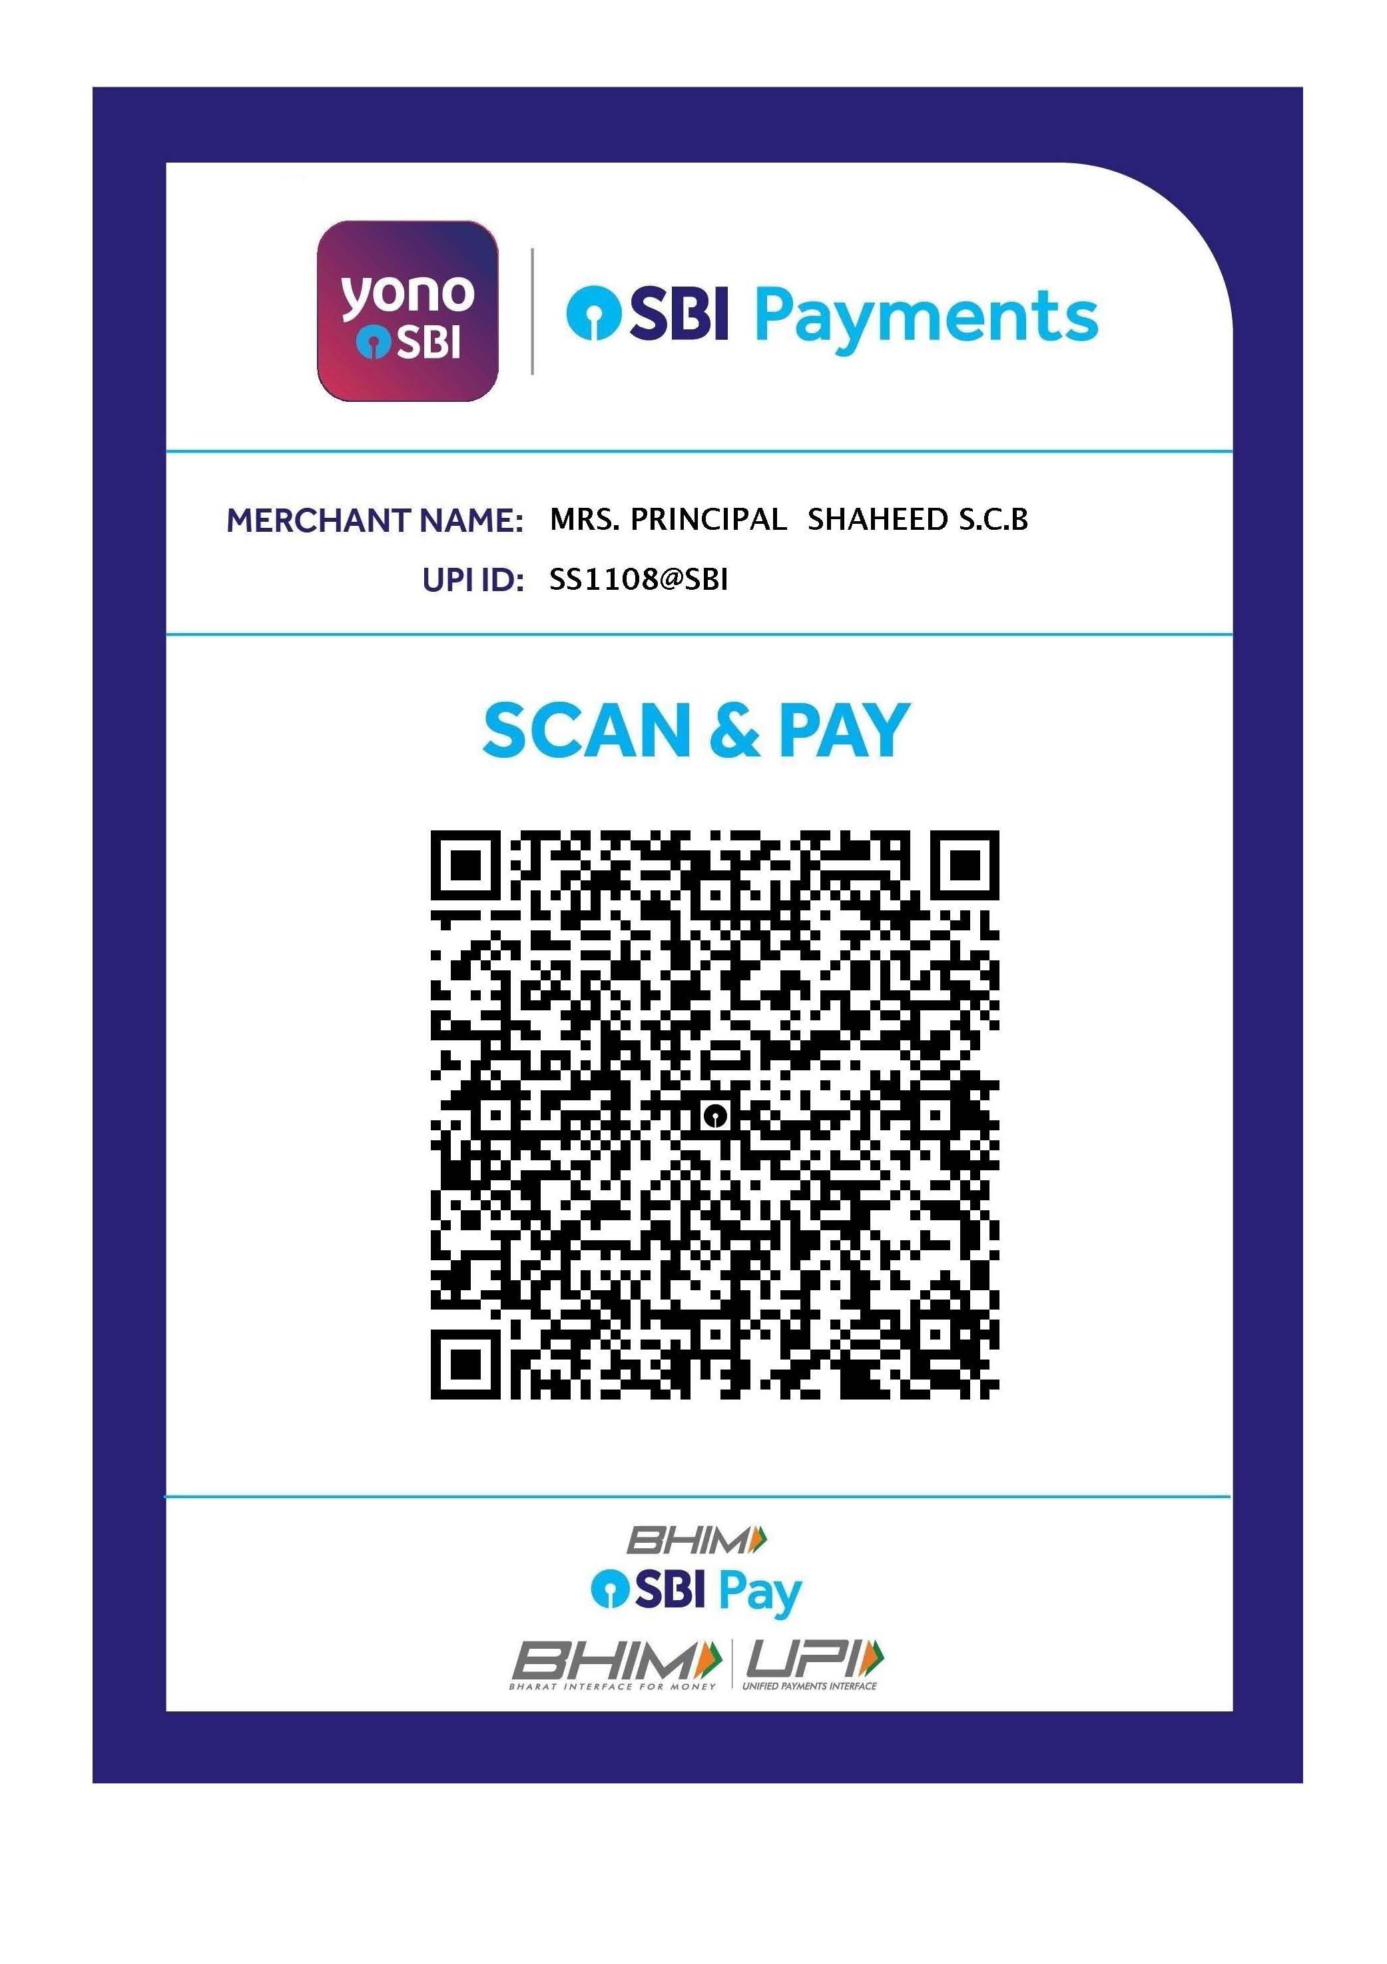
Syllabus: Financial Modeling & Algo Trading : 160 hrs.
Module1: Basics of Financial Market (10hrs)

- Money Market
- Capital Market
- Forex Market
- Derivatives Market
- Financial Instruments
- Various Invesment Vehicles
Module2: Introduction to Excel, Financial Modeling and Spreadsheet Essentials (15hrs)

- Introduction to Financial Modeling
- Strengths and weaknesses of spreadsheets
- Golden rules of spreadsheet design
- Do we make the most of modeling?
- Spreadsheet essentials
- Lookup and reference functions
- NPV and IRR functions
- Data tables
- IF function
- Excel Skils - Shortcuts, Formulas, Array Function and Pivot Tables
- VBA
- Macros
- Simple exercise/models in excel

Module 3: Integrated financial modeling (Financial statement analysis) (20hrs)
- Equity Modeling - Equity Infusion
- Modeling Paid Up Capital and Share Premium Account
- Modeling Retained Earning Schedule
- Modeling the projected P/L and BS
- Modeling the projected Cash Flow Statement
- Conducting Covenant Testing
- Performing Ratio Analysis
- WACC and Cost of Equity Analysis
- Performing Valuation using DCF (FCFF & Enterprise Value) and Comparable analysis (Relative Valuation)
- Performing sensitivity/scenario analysis

Case study 1
Case study 2
Case study 3

Module 4a: Risk Analysis (10hrs)

- Estimating betas with regression analysis
- Using daily, weekly, and monthly data
- Testing market efficiency
- With regression analysis
- With pivot tables
- Recording and editing macros

Module 4 b: Advanced risk analysis (10hrs)

- Sensitivity, Scenario
- Monte-Carlo simulation
- Risk analysis of discounted cash flow models
- Spreadsheet features
- Using @Risk for Monte-Carlo simulation
- Combining macros with @Risk

Case study 1
Case study 2
Case study 3

Module 5: Portfolio Optimization (15 hrs)

- Mean-variance portfolio selection
- Computing mean-variance portfolios
- Back-testing portfolio performance
- Research on portfolio selection
- Bond portfolio selection
- Capital budgeting
- Spreadsheet features
- Matrix operations in Excel
- Using Solver for optimization
- Using macros to generate the efficient frontier

Module 6: Derivatives (30 hrs)

- Introduction
- Intro to Derivatives
- Futures Contract, Terminology, Mechanism & Pricing
- Applications of futures contracts
- Basis risk, why hedge?
- Types, positions, spreads, margins, markets, underlying assets, options on futures
- Factors affecting option prices, upper bounds, lower bounds, put & call parity.
- Spreads, combinations, payoffs
- Black-Scholes formula
- Pricing European options
- Estimating implied stock return volatilities
- Application of Options contract

- Trading of Derivatives Contracts

- F & O Market Instruments: Individual & Index based

- Clearing & Settlement: Entities, Mechanism, Settlement Procedure

- Risk Management

Module 7 ( Strategies): Practical Training (50hrs)
- Conversion & Reversion
- Future to Future
- Cash to Future
- Box, Butterfly, Straddle, Strangle
- Condor, Ladder
- Ratio
- Bull/Bear Spread
- Calender Spread
- Covered Call
- Covered Put

