International Yoga Day
We held an online yoga session led by Ms. Varsha Jha, in collaboration with NSS on International Day of Yoga, June 21, 2024. 18 people participated in the event. Which took place from 7:00 AM to 8:00 AM. Ms. Jha guided the participants through yoga postures and meditation techniques, emphasizing the importance of focus and proper spinal alignment. The session provided a valuable opportunity to learn about the benefits of yoga for both physical and mental well-being.

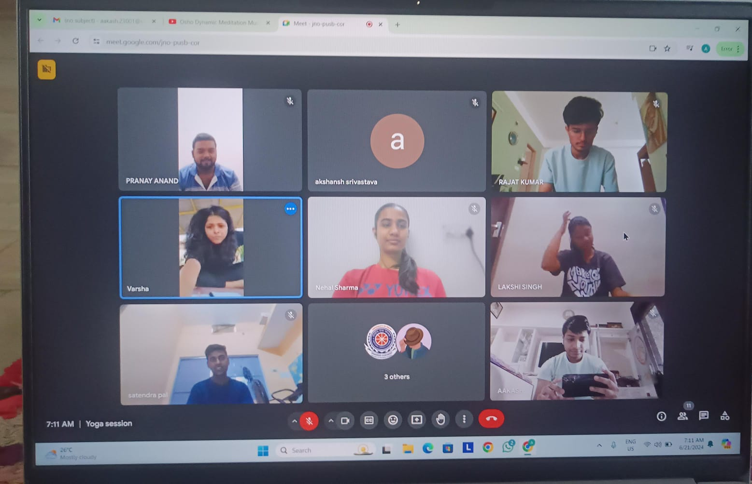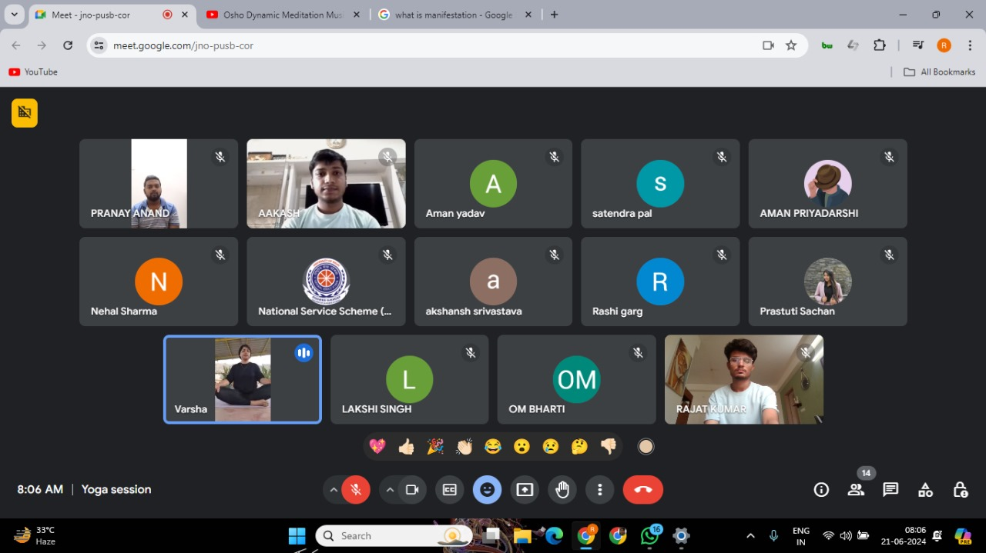
We also participated in the program organized collaboratively by Bhartiya Yog Sansthan, the Ministry of AYUSH and DDA at Japanese Park, Rohini. The well-organized and informative event aimed at promoting the benefits of yoga.
