EVENT REPORT

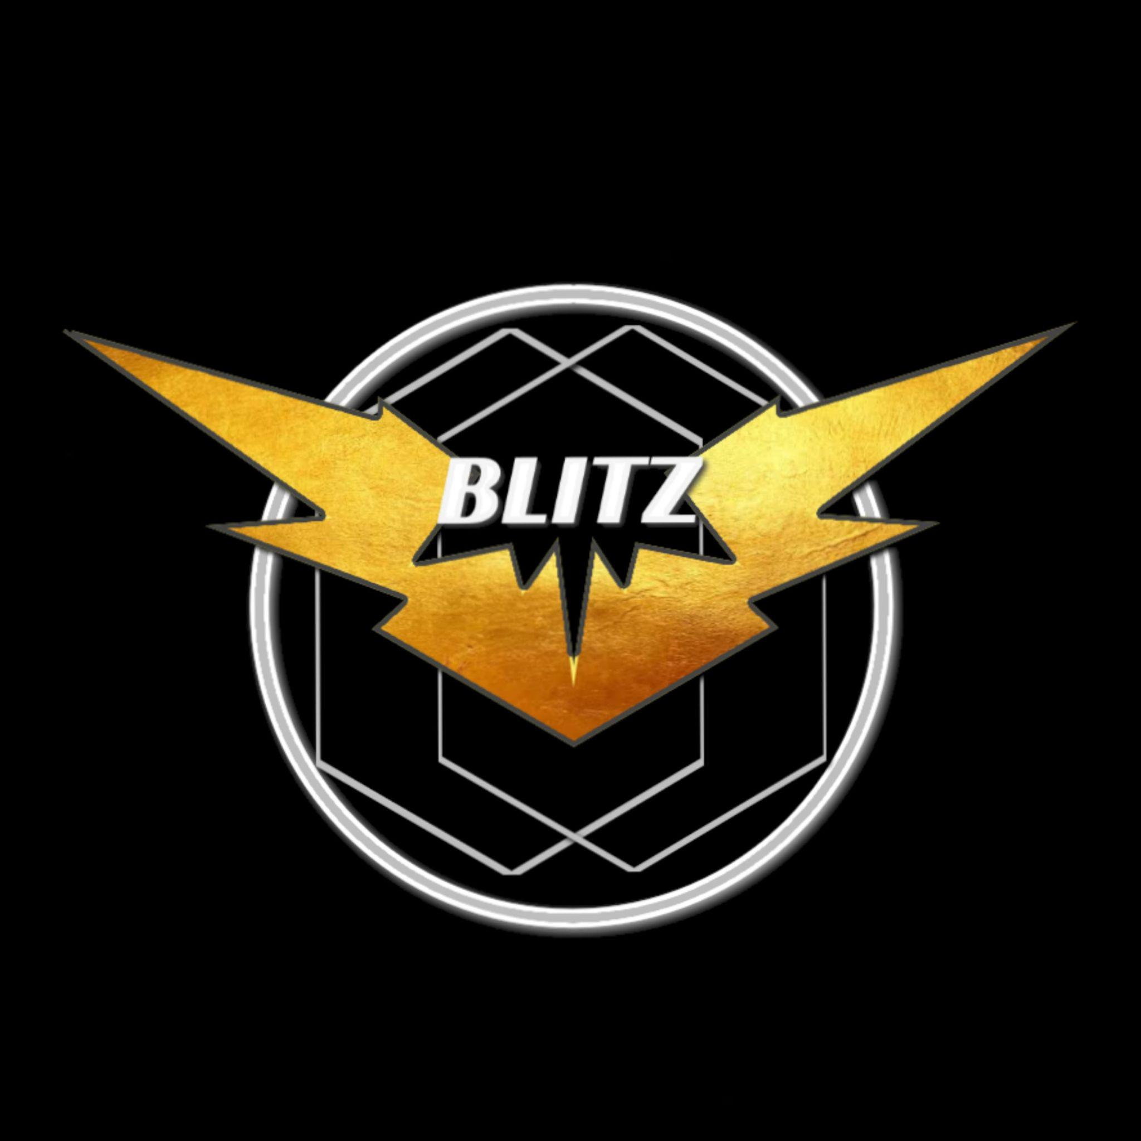
ABOUT BLITZ - The Western Dance Society Of SSCBS, DU

Blitz is a vibrant community of dance enthusiasts coming together to celebrate the joy, expression, and diversity of dance. We create and perform dazzling routines, showcasing our talents at our college events. We also work with choreographers and attend workshops to improve our dancing skills. We even arrange workshops for college students who have a passion for dancing. Each year we prepare an annual production under the guidance of some choreographers and perform in different college competitions.

WHAT HAS BLITZ DONE THIS YEAR?
FLASHMOB 2024
Blitz organised and choreographed the flashmob dance at SSCBS highlighting the importance of voting in elections under the Mera Pehla Vote Desh Ke Liye campaign. The flash mob was also broadcasted by DD INDIA on their youtube channel.

CRESCENDO - PRE EVENT 2024
BLitz gave a sizzling performance at the Crescendo pre event. It included both solo and group performances and danced to a variety of songs. The energetic performances won the audience loud applause whereas the dance with a calm vibe won their hearts.

ANNUAL EVENT - ENCORE 2024
Blitz organized its flagship dance event, 'ENCORE,' which was a highlight of its annual fest, "Crescendo". Held on 30th April, ENCORE'24 captivated an audience of over 1,000 individuals with its dazzling western group performances in the college premises. The event ignited the stage, attracting diverse college participants. Esteemed judges critiqued and crowned winners, fostering community and inspiring dancers year after year with this inclusive celebration of rhythm and talent. As the curtains closed on another successful year, participants departed with cherished memories, new friendships, and a renewed passion for dance. As anticipation built for the next installment of ENCORE, one thing was certain: the rhythm would resound louder and brighter than ever before.

