Shaheed Sukhdev College of Business Studies University of Delhi

Hostel Bulletin of Information 2024-25

Principal’s Message

Welcome to SSCBS Hostel

You are privileged to be one of the residents of the SSCBS hostel. It should be a great feeling indeed and the privilege comes to you with a great sense of responsibility. As residents of the hostel, you will establish and grow the ecosystem and culture of the hostel. You will build a community that is exemplary in conduct, care, safety, culture, and co- living.

The next three/four years will be full of excitement and learning for you. While the classrooms will make you learn leadership concepts, your hostel will be the laboratory to apply all those concepts and learn very essential life skills. You will have to learn to mutually adjust and live happily with your room-mates / hostel-mates so that when you step out of college, you have beautiful memories of the hostel life, and a network to leverage in your long professional life.

It is also the highest obligation and responsibility of all the residents, staff, and stakeholders that they must keep the college hostel free from alcohol, smoke, tobacco products, drugs, pollutants, and any immoral act unlawful act including ragging.

Enjoy, and make the best of your stay at SSCBS! With my utmost sincere wishes and hopes,

Prof. Poonam Verma Principal

About the College

Shaheed Sukhdev College of Business Studies (SSCBS) is one of the premier institutions of the University of Delhi, imparting education in the fields of management and information technology with excellence and vision. It was established in August 1987 by the Delhi Administration on the initiation of UGC and the Ministry of Human Resources. The vision behind the college was of its founder principal Dr. S.S. Gulshan.
When the college was established, it was named “COLLEGE OF BUSINESS STUDIES”. But later the college was rechristened as ‘Shaheed Sukhdev College of Business Studies' in 1997, to pay homage to Indian revolutionary Sukhdev Thapar who along with Bhagat Singh and Shivaram Rajguru became part of independence folklore for their sacrifice.
Shaheed Sukhdev College of Business Studies, or CBS, as it is better known in corporate circles, was the first undergraduate management school under the aegis of the University of Delhi (DU).
In 1987 when our college was started it offered only one course i.e. BBS (Bachelor of Business Studies). But with the growing demand in 1991, the College of Business Studies became the first college in Delhi University to adopt the semester system, for its BBS course. The college moved to a new campus in the Academic Year 2017-18 and now has a well-equipped hostel block for girls and boys for occupation.
The Hostel is directly under the control of the principal of the college whose authority is final in all matters. She is assisted by the Warden and the Hostel Committee which is responsible for all the matters related to the hostel.

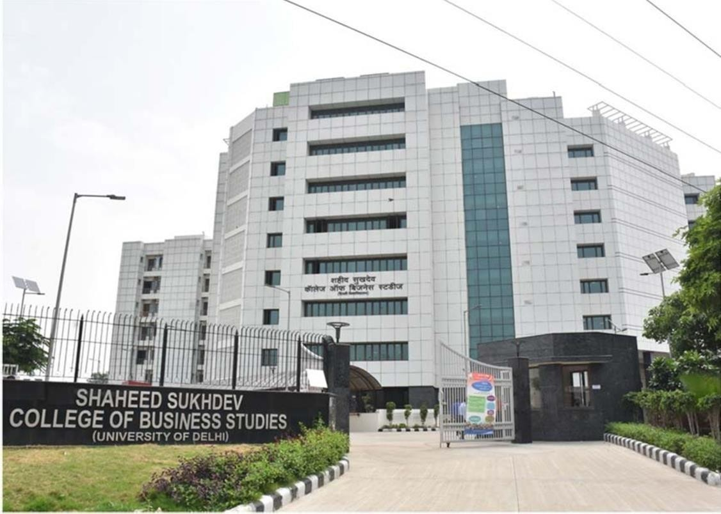

Hostel Infrastructure

The college has a hostel for boys and girls with a capacity of 90 beds for boys and 82 for girls. Most of the rooms are shared by 3 students each, but some are shared by 2 students. Each room has three cots with mattresses, a writing table with chairs, and a wardrobe and bookshelf for each student. Every room has an air conditioner and an attached toilet and bathroom. The housekeeping staff provided by the service provider will help in maintaining all the areas of the hostel including the rooms.

Hostel also has the following facilities:
- Mess facility
- Wi-Fi facility
- Common room with TV facility
- Air-conditioned rooms
- Indoor games room (table tennis, carom, chess etc.)
- Playground (football, cricket)
- Open gym facility
- Water cooler
- Common pantry equipped with refrigerator and microwave
- Laundry facility (washing machine on paid basis at very a reasonable cost)
- Lift facility
- Common study room

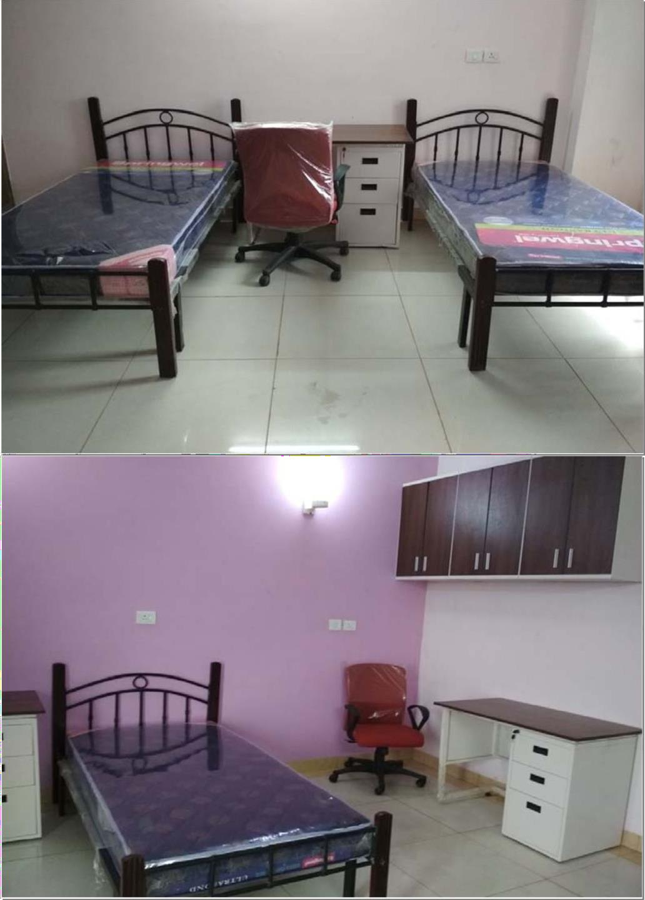

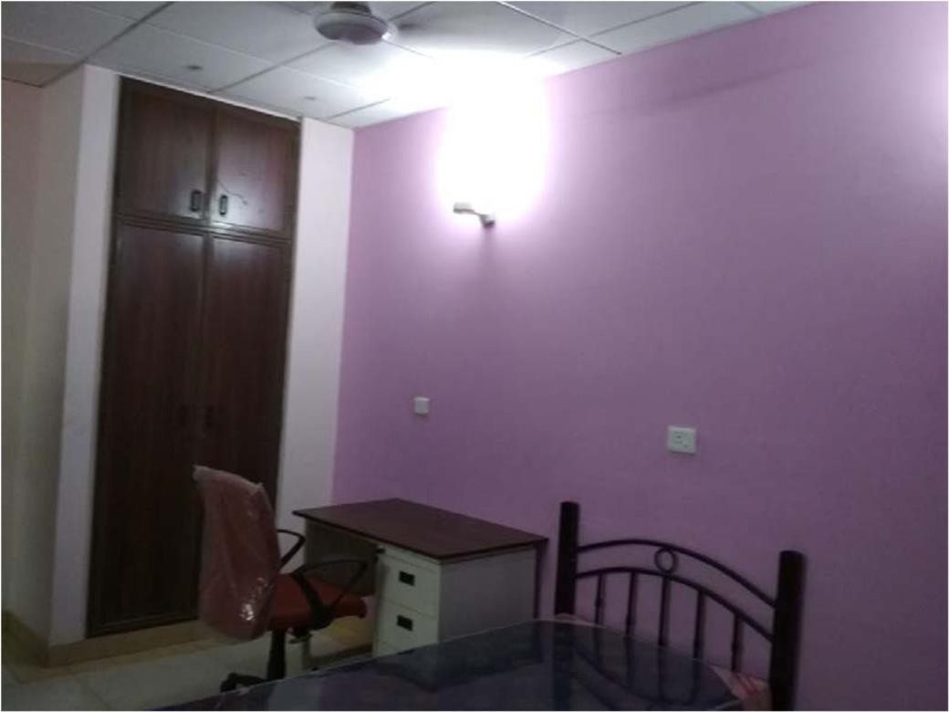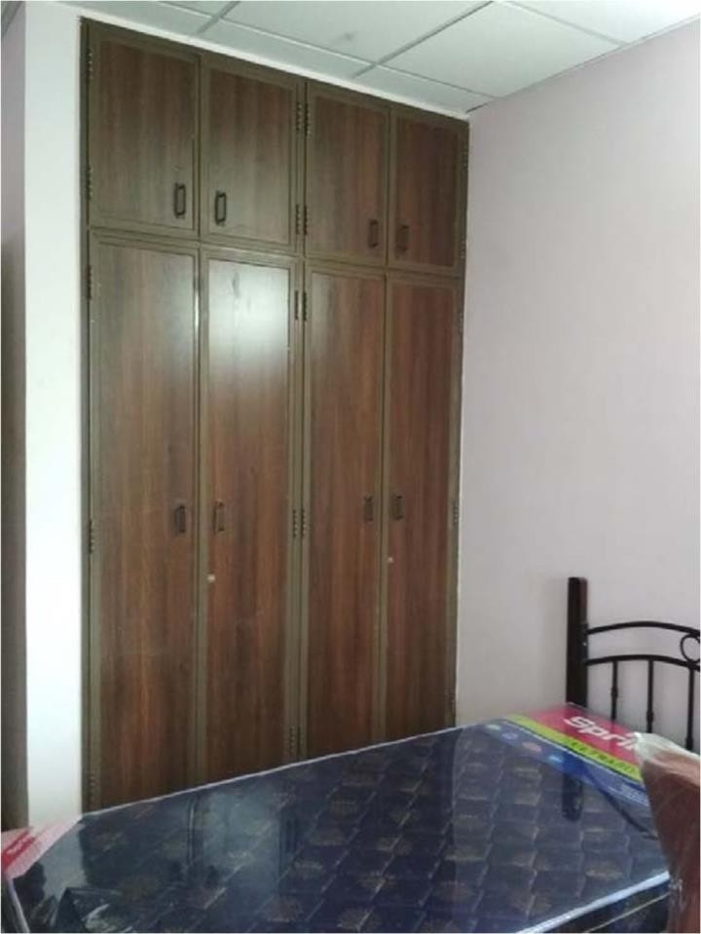

Contact Details
Principal Office 011-27573446
College email id cbs@sscbsdu.ac.in
College website www.sscbs.du.ac.in

Hostel Office (Girls) matrongirlshostel@sscbsdu.ac.in
Hostel Office (Boys) hostelmanager@sscbsdu.ac.in

University website www.du.ac.in

College Administration
Principal Prof. Poonam Verma

Bursar Dr. Rishi Rajan Sahay Administrative Officer Mr. Ankur Aggarwal (Officiating)

Hostel Administration
Warden (Girls) Ms. Kishori R Shankar Deputy Warden (Girls) Dr. Sonika Thakral Warden (Boys) Dr. Neeraj Kumar
Deputy Warden (Boys) Dr. Narander Kumar Nigam

Right to Information
Public Information Officer Ms. Kishori Ravi Shankar Appellate Authority Prof. Poonam Verma (Principal)

Distribution of Seats
The hostel has 90 seats for boys and 82 seats for girls.
The distribution of the seats across various categories of students shall be according to the rules of the University of Delhi.

Note: The seats will be distributed among the 1st, 2nd, and 3rd-year students (BMS/ BBA(FIA)/B.Sc.) Duration of stay in the Hostel: Admission is made to the hostel for a period of one academic year. The student may be readmitted for up to a total period of three years (minimum duration of the program.)

Procedure for Admission
- Hostel Bulletin of Information is available on the college website.
- All applicants are also required to fill in the online registration form available at the college website www.sscbsdu.ac.in.
- Hostel form is available in the college office and on the college website. Interested students can fill out the hard copy of the form and submit it along with the required documents in the hostel office. Students can submit the hostel fee after the form is verified by the hostel office.
- Admission to the hostel will be done only on the basis of registration after admission to this college.

Criteria of Admission

First Year
For 2024–25 | - Hostel seats to be allotted to only those students whose home is beyond 60km from the college (distance shown by Google map)  - Hostel admission will be based on merit.  - Merit will be determined by the rank in CUET on the basis of which admission was taken in the University of Delhi. For merit will be determined by the marks scored by the student in 12th exam on the basis of which admission has been taken in the University of Delhi.
Second Year
For 2024–25 | - Students should have passed all papers of all the previous semesters.  - There should be no disciplinary action or any other proceedings against the student.  - Student should have 66.67% of attendance in previous year.  - The student should have complied with all other conditions and rules and regulations as per the college hostel policy.  - Hostel seats to be allotted to only those students whose home is beyond 60 km from the college (distance shown by Google map)  - Hostel admission will be based on merit. Merit will be determined by the marks (CGPA) scored by the student in the 1st year. In case the 2nd semester results are pending at the time of hostel admission, the 1st semester results will be considered.  - Any medical exemption shall be considered on a case-by-case basis.

Third Year
For 2024–25 | - The student should have passed all papers of all the previous semesters.  - There should be no disciplinary action or any other proceedings against the student.  - Student should have 66.67% of attendance in previous year.  - The student has complied with all other conditions and rules and regulations as per the college hostel policy.  - Hostel seats to be allotted to only those students whose home is beyond 60 km from the college (distance shown by Google map)  - Hostel admission will be based on merit. Merit will be determined by the marks (CGPA) scored by the student in the 2nd year. In case the 4th semester results are pending at the time of hostel admission, the 3rd semester results will be considered.  - Any medical exemption shall be considered on a case-to-case basis.
However, if seats remain vacant then the applications received from the students whose home is within a distance of 60 km will be considered

Eligibility for Admission
The students satisfying the following criteria will be considered for admission:
- The applicant should be a full-time bona fide undergraduate student of this college.
- Students should not be employed anywhere on a full-time, part-time, ad hoc, or temporary basis.
- Admission shall not be granted to a student against whom disciplinary action had been taken by her previous educational institution/ hostel.
- Suppression of information or giving wrong information or false attestation pertaining to any of these eligibility criteria would make the defaulting student liable for disciplinary action, including expulsion from the Hostel.
- Seat Allocation: Hostel seats will be allotted category-wise, as per the rules of the University of Delhi. Since the hostel has to run on a self-sustainable basis, efforts will be made to fill all the seats. \

Documents Required for Admission
  - Hostel admission form, duly filled and counter-signed by parents / Legal Guardian / Local Guardian
  - Acknowledgement of fee deposited in the hostel bank account
  - Undertaking(s) as specified and signed
    - Medical fitness certificate from a Qualified Medical Practitioner
  - Duly filled Identity card proforma of student
  - Duly filled Identity card proforma of local guardian
  - Self-Attested photographs of the student (seven copies)
  - Self-Attested photograph of the Father / Mother / Legal Guardian (one copy)
  - Self-Attested photograph of the Local Guardian (One copy) (a student cannot become the local guardian of another student)
    - Copy of the mark sheet of the previous year/semester (applicable for 2nd and 3rd-year students only)
  - Address proof of Parents / Legal Guardian (any one of the following)
- Self-Attested copy of the Aadhaar Card
- Self-Attested copy of the Election Card/ Ration Card/ Passport
- Proof of Parent’s present address
- In the absence of the above, an Affidavit on a non-judicial stamp paper of Rs. 10has to be submitted

Re-admission to the hostel
Admission to the hostel is made for a period of one academic year. Residents, who wish to re-join the hostel for the 2nd and 3rd year need to apply afresh for each year.
- All eligible students seeking hostel readmission for the new academic session should register and submit their hostel application form as per the notice on the college website.
- Proof of permanent residence must be submitted afresh at the beginning of each academic year.
- Students should not have an essential repeat in any papers of the previous semester.
- There should be no disciplinary action or any other proceedings against the student.
- Student should have 66.67% of attendance in previous year.

The following residents will not be considered for re-admission
- Those who have failed in their respective examination or have dropped out.
- Those who have ER pending in one or more subjects.
- Those who have secured less than 40% marks in the first year and second years.
- Those who have violated the Hostel rules or committed acts of misconduct or indiscipline in their college or Hostel, and the Hostel Administration has decided to drop them.
- Those who have not fulfilled the necessary attendance requirement of the college.
- Those who have submitted false affidavits.

Cancellation of Hostel Admission
Admission of a resident may be canceled for any of the following reasons:
- Involvement in ragging.
- Non-payment of dues for more than 30 consecutive days.
- Keeping guest/s without permission.
- Cessation of regular studentship.
- Violation of rules and discipline.
- Suppression of facts and/ or providing wrong information.
- Forging parents’/ authorized guardian’s signature.
- Making casteist, communal or racist remarks against other students.
- Not clearing or not appearing for the odd semester examinations.
- Submitting false affidavits at the time of admission.
Residents are not to plead ignorance of the rules and regulations contained in this Bulletin of Information and also any notified modification made from time to time.

Foreign Students
- All hostel rules are applicable to foreign students.
- Where there is no Local Guardian, the respective Embassy / High Commission will be contacted in case of emergencies, including medical conditions requiring hospitalization.
- A Medical Fitness Certificate from the Qualified Registered Medical Practitioner.

Medical
- The resident should have compatibility with community living.
- Students suffering from any chronic illness are advised home care.
- Residents must have the required immunization.
- Any major or minor illness should be reported immediately to the authorities.
- Residents must have their complete medical files with them during their stay in the hostel.
- In case of a medical emergency, the student will be admitted to the nearest available medical facility for which the cost will be borne by the student. The LG/ parents are required to take charge of the patient thereafter.

Hostel Rules and Regulations
- RAGGING IN ANY FORM IS STRICTLY PROHIBITED.
- Foreign embassy will be contacted for any issues related to foreign students.
- Resident students are expected to follow covid protocols.
- Students will be charged for any abuse of electronic devices like refrigerator, TV, microwave, and washing machine. The fine will be charged to that student concerned or all the students.
- In case of a medical emergency if the local guardian and parents do not pick up the call, the college will not be held responsible and the student will be admitted to the hospital.
- Consumption of liquor, drugs, and tobacco is strictly prohibited. Action will be taken against any student found indulging in these activities and those present in gatherings where such activities take place.
- Resident students found forging signatures of parents/local guardians/fellow students will be subject to strict disciplinary action.
- Resident students are not allowed to take up any full-time/part-time employment or enroll for any course without the prior permission of the College.
- With prior information and permission of the principal, students may attend coaching classes, only outside of the class hours and academic programs of the department/College.

- Any act of vandalism/soiling of the toilets/common areas/loss of keys (of rooms/cupboards) and locks etc., will attract individual/collective fines followed by other disciplinary action.
- All damages caused by vandalism and breach of discipline will be charged to the students, individually or collectively, and may include forfeiture of the Caution Money.
- Resident students will be issued Hostel Photo Identity Cards. This card has to be shown tothe hostel gatekeeper to enter the hostel. Residents are required to retain and carry this care with them at all times.
- The charge will be imposed for the loss of the hostel identity card as imposed by the hostel authority.
- Residents are expected to dress in a manner appropriate to a shared workplace, in spaces so defined i.e., the dining hall, visitors’ lounge, and other common spaces in the hostel.
- Resident students are advised not to bring expensive jewelry or keep large sums of money in their rooms. Hostel authorities will not be responsible for any loss/theft.
- No hostel resident can keep any motorized vehicle in the university. However, bicycles are permitted for local transport. Disciplinary action including fines will be imposed on the defaulters.
- Ragging is strictly prohibited inside as well as outside the Hostel/Campus. If anyone is found involved in ragging, he/she may be taken up as per Hon’ble Supreme Court orders. Freshers should promptly report to the matron/manager /warden/anti-ragging committee or any other competent authority if ragged.
- Any act of intimidation or violence, willful damage to property, or drunken and riotous behavior constituted an offense. If anybody is found to do so, he/she shall be liable for expulsion from the Hostel/University.
- If they are found indulging in these activities, they will be expelled from the hostel without serving any notice in this regard and disciplinary action shall be taken.
- Use of narcotics, consumption of alcoholic beverages, smoking, and gambling are strictly prohibited.
- Misbehavior or Indulging in a row with staff members/security staff will be treated as an offense and will be liable for expulsion from the hostel.
- Hostel inmates shall be required to enter their names into the register before leaving the campus and seek written permission from their hostel matron/manager before leaving the hostel for a long leave.
- All Hostel inmates shall not be allowed to leave /enter the college after 8.30 pm and the hostel after 10 p.m. In the event of anyone reporting late, necessary disciplinary action will be taken against them.

- All the hostelers are required to sign their attendance daily register. The attendance register is available with the hostel Matron/Manager. If someone fails to sign their attendance consecutively for seven days without permission of their Warden, their accommodation will be canceled without any notice.
- No female member is permitted to visit the room of the boys’ hostel. However, the visitors are permitted to see their wards in the visitors’ room only.
- No male member is permitted to visit the room of the girls’ hostel. However, with the permission of the warden, the visitors are permitted to see their wards in the visitors’ room only.
- No day scholar/ any other person is permitted to stay in the hostel, otherwise suitable disciplinary action will be taken. However, if anyone wants to meet students living in the hostel should take necessary permission from the warden.
- Entertaining / providing accommodation to any unauthorized person in the hostel room is punishable. If anyone is found to do so, he/she will be expelled from the hostel.
- Not adhering to the time norms will be treated as grave misconduct, which may result in expulsion from the hostel and the decision of the Hostel committee will be final and binding in this regard.
- Outsiders are not allowed in the girls’ hostels/boys’ hostels.
- The hostel inmates should take care of the safety of their belongings inside the room. The University shall not be responsible for any such losses. Items like jewelry, costly watches, and mobile phones must not be kept inside the hostel rooms.
- Display of any type of vulgar posters/ calendars inside the allotted rooms is strictly prohibited. Non- Compliance will lead to disciplinary action.
- Cooking food of any sort and keeping any inflammable items inside the hostel is strictly prohibited.
- Attendance shall be reviewed on a regular basis and for any student short of attendance, allotment shall be canceled and could further be allotted to needy students.
- In case of loss of hostel identity card, the student will be fined (as imposed by the hostel authority) and a copy of FIR is required to issue duplicate hostel identity card to the student.
- All the hostel residents shall abide by the mentioned Hostel Rules. Any violation of the Hostel Rules will be viewed seriously. The Hostel Wardens are fully empowered to deal with residents in the manner the situation demands.
- In case of emergency, residents are advised to get in touch with the concerned hostel matron/ manager/ warden.
- Residents are required to see the Notice Boards for necessary announcements made from time to time. Any suggestion to improve the social, cultural, academic, and intellectual environment of the hostel is always welcome.
- Resident students found forging signatures of parent/local guardian/fellow students will be subject to strict disciplinary action.
- Resident students are not allowed to take up any full-time/part-time employment or enroll in any course without the prior permission of the college.
- With prior information and permission of the principal, students may attend coaching classes, only

outside of the class hours and academic programs of the department/college.
- Any act of vandalism/soiling of the toilets/ common areas/loss of keys (of rooms/cupboards) and looks etc., will attract individual/collective fines followed by other disciplinary action.
- All damages caused by vandalism and breach of discipline will be charged to the students, individually or collectively, and may include forfeiture of the caution money.
- Residents are expected to dress in a manner appropriate to a shared workplace, in spaces so defined i.e., the dining hall, visitor’s lounge, and other common spaces in the hostel.

Hostel Attendance Rules
- Resident students are expected to be present in the hostel on the first day and the last day of each semester.
- It is mandatory for students to maintain the minimum required attendance (66.67%) without waiver failing which, admission to the hostel in the subsequent semesters will be denied. Attendance in all assessment-related tasks is compulsory.
- All resident students must be present in the hostel by 8:30 p.m. and register their presence unless they are on approved leave. No resident is allowed to be absent from the hostel after 8:30 p.m. without valid prior permission. Any unexplained or unauthorized absence from the hostel after 8:30
p.m. will be subject to disciplinary action. Attendance will be taken thrice once in the morning at 8:00 A.M., 8:30 P.M., and at 10:00 P.M.

Hostel Committee
The Hostel Committee is a consultative committee consisting of faculty members, appointed by the College Staff Council, to assist the Principal and the Warden in the administration of the hostel. The Matron/Manager will be a special invitee on the Hostel Committee.

Hostel Fees

Students have to pay the fees online using the link provided at the time of admission. The entire fees have to be paid at the time of admission.
Fees Breakup for the amount payable at the time of admission 2024–25: **

 | Particulars | Amount (Rs) (For Odd Semester  Students) | Amount (Rs) (For Even Semester  Students)
1 | Admission Fees | 1,000.00 | 00.00
2 | Caution Money (Refundable) | 5,000.00 | 00.00
3 | Development Fees | 10000.00 | 00.00
4 | Establishment Charges | 37002/- | 37002/-
5 | Mess Charges** | 27342/- | 27342/-
 | Total | 80344/- | 64344/-

** Subject to revision in 2024-25

Notes:
- Except for the caution money, no other fees are refundable.

Foreign Students are required to pay an additional fee of 19,800/- as a one-time payment (non- refundable), besides the mentioned categories of 1, 2, 3, 4, and 5 at the time of admission. (Student from SAARC countries are exempted to pay the additional fee).

Vacating the Hostel
- Students have to vacate the hostel on the day after the completion of their semester examination in May-June/August. Since the academic calendar and the examination timetable are notified well in advance, students are advised to book their tickets for travel as soon as their exam schedule is notified.
- The student must inform the hostel Warden/Manager/Matron of the date and time of vacating the room.
- The College is not in a position to accommodate any student in the Hostel when it closes for vacations, and all such students will be required to make their own arrangements for their stay.
- On vacating the room during every break, the student must ensure that the room is handed over with all accessories.

Refund of Hostel Fee
In case a student applies for withdrawal within a week from the date of fee payment, then all fees except admission fee will be refunded on a pro-rata basis according to the no. of days of stay in the hostel.
In other cases, only the Caution Money and Mess Advance will be refunded after the resident has paid all the dues and vacated the room allotted to her/ him. All refunds will be made by direct bank transfer.
The Caution Money can be claimed within a month of vacating the Hostel after clearing all Hostel dues. The same must be claimed within a period of six months after leaving the Hostel; otherwise, it will lapse. No interest will be paid for the Caution Money & Mess Advance deposited. Hostel fees will be accepted through online payment only at the time of admission. No fee will be accepted in cash.

Hostel Timings and Leave Rules for Residents

Residents are required to report to the hostel by 8:30 P.M. sharp. It is mandatory for every resident who is present on the hostel premises to have herself/himself marked present in the attendance register at night. No resident is allowed to leave the Hostel and college premises after 8:30 p.m.

P.M. Three Repeated long absence from the Hostel is liable for disciplinary action.

Mess Timings
Mess timings shall be as follows:
Breakfast : 07:30 a.m. – 8:45 a.m. Lunch : 12:00 noon – 01:00 p.m. Tea : 04:30 p.m. – 05:30 p.m.
Dinner : 07:30 p.m. – 9:00 p.m.

Leave from Hostel
Home leave is allowed during breaks or for special purposes. The resident shall contact the warden/ deputy warden’s office for the same. Residents may avail of the following types of leaves:

Leave to visit LG | Weekends (Saturdays and Sundays) and Gazetted holidays
Home Leave | During breaks/ for special purposes.

How to Apply for Leave
- Application for any kind of leave has to be submitted at least 24 hours in advance. Residents can proceed on leave only after ensuring that leave is duly sanctioned by the Warden. Prior letter of request is to be furnished from parents in case of home leave / leave for special purposes.
- Residents are required to sign in the appropriate register before proceeding on any kind of leave and on their return. Any resident found leaving or entering the hostel without signing the register is liable to disciplinary action.
- The Local Guardian is required to be available on the contact number provided to the College and any change in contact details should be intimated to the College immediately.
- The college/hostel will not be responsible for the whereabouts of the resident, once she steps out of the Hostel.

Visitors
Male Visitors and Female Visitors visiting hours: 9:00 a.m. to 8:00 p.m.

No visitors are allowed on the day of HOLI.
The Residents are not permitted to receive any male or female visitors either in the common room or in their rooms of the Hostel. Visitors are to be received only in the Visitor’s area.
All visitors must leave the hostel by the time specified above.

Grievance Redressal
Any hostel resident who has a grievance with regard to any electrical or civil maintenance and housekeeping issues should contact the matron/manager and bring it to their notice in writing. If there is any grievance with regard to the quality of food a written complaint may be given to the matron/manager explaining in detail. The same will be discussed with the service provider and if it is not redressed the matter can be regarded by the hostel committee.
Any other types of grievances may be brought to the notice of the matron/manager in writing of respective hostels. If the same is not redressed by them, it can be referred to the hostel committee. The decision of the hostel committee will be final in this regard.

Maintenance of Discipline in the Hostel (Ordinance XV- B, C & The Sexual Harassment of Women at Workplace (Prevention, Prohibition and Redressal) Act 2013)
At the time of admission, every student shall be required to sign a declaration that she submits herself to the disciplinary jurisdiction of the V.C./ Director, South Campus, the Provost and other authorities of the University who may be vested with the authority to exercise discipline under the Act, the Statutes, the Ordinances including Ordinance XV – B and C and The Sexual Harassment of Women at Workplace (Prevention, Prohibition and Redressal) Act 2013 (14 of 2013) – website http://wcd.nic.in/wcdactsex.pdf, and rules that have been framed by the University.

RAGGING IN ANY FORM IS A CRIMINAL OFFENCE AND IS STRICTLY PROHIBITED. ANY OCCURRENCE OF THE SAME SHOULD BE IMMEDIATELY REPORTED TO THE PROCTORIAL COMMITTEE. (SEE ORDINANCE XV – C) ORDINANCE XV –B
- All power relating to discipline and disciplinary action are vested with the Vice–Chancellor.
- The Vice–Chancellor may delegate all or such powers as he/ she deems proper to the Proctor and to such other persons as he/ she may specify on his/ her behalf.
- Without prejudice to the generality of power to enforce discipline under the Ordinance, the following shall amount to acts of gross indiscipline.
  - Physical assault, or threat to use physical force, against any member of the teaching and non-teaching staff of any institution /Department and against any student within the University of Delhi.
  - Carrying of, use of, or threat of use of any weapons;
  - Any violation of the provisions of the Civil Rights Protection Act, 1976;
  - Violation of the status, dignity, and honor of the students belonging to the scheduled castes and tribes;

  - Any practice, whether verbal or otherwise, derogatory to women;
  - Any attempt at bribing or corruption in any manner;
  - Willful destruction of institutional properties;
  - Creating ill-will or intolerance on religious or communal grounds;
  - Causing disruption in any manner of the academic functioning of the University system;
  - Ragging as per Ordinance XV-C.
- Without prejudice to the generality of his/ her power relating to the maintenance of discipline as may seem to him/ her appropriate, the Vice-Chancellor may exercise his/ her powers aforesaid, order or direct
  - That any student or students be expelled, or
  - Any student or students be, for a stated period, rusticated, or
  - Be not for a stated period, admitted to a course or course of study in a college, Department, or institution of the University, or
  - Be fined with a sum of rupees that may be specified, or
  - Be debarred from taking a University College or Departmental Examination or Examinations for one or more years, or
  - That the result of the student or students concerned in the Examination or Examinations in which he/ she or they have appeared be canceled.
- The Principals of the Colleges, Heads of the Halls, Deans of Faculties, Heads of Teaching Departments in the University, the Director, the School of Open Learning, and Librarian shall have the authority to exercise all such disciplinary powers over students in their respective Colleges, Institutions, faculties and Teaching Departments in the University as may be necessary for the proper conduct of the Institutions, Halls, Hostels, Libraries and Teaching in the concerned Departments. They may exercise their authority through, or delegate authority to, such of the teachers in their Colleges, Institutions, or departments as they may specify for the purpose.
- Without Prejudice to the powers of the Vice–Chancellor and the Proctor as aforesaid, detailed rules of discipline and proper conduct shall be framed. These rules may be supplemented, where necessary, by the Principals of Colleges, Heads of Halls, Dean of Faculties, and Heads of Teaching Departments in this University. Each student shall be expected to provide himself/ herself with a copy of these rules.
- At the time of admission, every student shall be required to sign a declaration that onadmission he/ she submits himself/ herself to the disciplinary jurisdiction of the Vice-Chancellor and the several authorities of the University who may be vested with the authority to exercise discipline under the Acts, the Statutes, the Ordinances and the rules that have beenframed thereunder by the University.

Anti-Ragging Ordinance ORDINANCE XV-C
Prohibition of and Punishment for Ragging

The UGC has recently formulated very strict guidelines to curb the menace of ragging, which are available at their website www.ugc.in
- Ragging in any form is strictly prohibited, within the premises of any College/ Department or institution and any part of Delhi University system, as well as on public transport.
- Any individual or collective act or practice of ragging constitutes gross indiscipline and shall be dealt with under this Ordinance.
- Ragging for the purposes of this Ordinance, ordinarily means any act, conduct or practice by which dominant power or status of senior students is brought to persons/ students freshly enrolled or students who are in any way considered junior or inferior by the other students and includes or collective acts or practices which
  - Involve physical assault or threat or use of Physical Force;
  - Violate the status, dignity, and honor of women students;
  - Violate the status, dignity, and honor of students belonging to the scheduled castes and tribes;
  - Expose students to ridicule and contempt and affect their self-esteem;
  - Entail variable abuse and aggression, indecent gesture, and obscene behavior.
- The Principals of Colleges, Heads of Departments or Institutions, the authorities of a College, Provosts of University Hostels, or Halls of Residence shall take immediate action on any information of the occurrence of ragging.
- Notwithstanding anything in Clause (4) above, the Proctor may suomoto enquire about any incident of ragging and make a report to the Vice–Chancellor of the identity of those who have engaged in ragging and the nature of the incident.
- The Procter may also submit an initial report establishing the identity of the perpetrators of ragging and the nature of the ragging incident.
- If the Principal of a College or Head of the Department or Institution or the Proctor is satisfied that for some reason, to be recorded in writing, it is not reasonably practical to hold such an inquiry, he/ she may so advise the Vice-Chancellor accordingly.
- When the Vice-Chancellor is satisfied that it is not expedient to hold such an inquiry, his/ her decision shall be final.
- On receipt of a report under Clause (5) or (6) or a determination by the relevant authority under Clause (7) disclosing the occurrence of ragging incidents described in Clauses 3 (a),(b), (c), the Vice-Chancellor shall order or direct rustication of the student or students for a specific number of years.

- The Vice-Chancellor may in other cases of ragging order or direct that any student or students be expelled or be not for a stated period, admitted to a course of study in a college, Department examination for one or more years or that the results of the students concerned in the examination or examinations in which they appeared to be canceled.
- In case of the students who have obtained degrees or diplomas from Delhi University and are found guilty under this Ordinance, appropriate action will be taken against them under Statute 15 for withdrawal of degrees or diplomas conferred by the University.
- For the purpose of this Ordinance, abetment to ragging will also amount to ragging.
- All the institutions within the Delhi University system shall be obliged to carry out instructions/ directions issued under this Ordinance and to give aid and assistance to the Vice-Chancellor to achieve the effective implementation of the Ordinance.

THE SEXUAL HARASSMENT OF WOMEN AT WORKPLACE (PREVENTION, PROHIBITION, AND REDRESSAL) ACT, 2013 (14 OF 2013) – WEBSITE
http://wcd.nic.in/wcdact/womenactsex.pdf

Note: Notwithstanding any provision in the previous pages, the Provost of the Hostel is the final authority in all matters.
The following undertakings can also be filled-in/ obtained from the below-mentioned websites: http://www.antiragging.in; http://www.amanmovement.org

Anti-Ragging Committee
A committee of the following faculty members is being constituted as Anti Ragging Committee/Disciplinary Committee as per the requirements of the University of Delhi.

S. No. | Name | Phone | Email
1. | Ms. Shalini Prakash | 9873424231 | shaliniprakash@sscbsdu.ac.in
2. | Dr. Neeraj Kumar | 9582391231 | nrjsehrawat@sscbsdu.ac.in
3. | Dr. Madhu Totla | 9555759554 | madhumaheshwari@sscbsdu.ac.in
4. | Mr. Amit Kumar | 9958161303 | amit.catlog@sscbsdu.ac.in

Anti-Ragging Cell

S. No. | Name | Phone | Email
1. | Ms. Kishori Ravi Shankar | 9968067846 | kishorirshankar@sscbsdu.ac.in
2. | Dr. Neeraj Kumar | 9582391231 | nrjsehrawat@sscbsdu.ac.in
3. | Mr. Amit Kumar | 9958161303 | amit.catlog@sscbsdu.ac.in
4. | Dr. Madhu Totla | 9555759554 | madhumaheshwari@sscbsdu.ac.in
5. | Dr. Mona Verma | 9953969492 | monaverma@sscbsdu.ac.in

Students are advised to contact them for the redressal of their grievances regarding discipline/ragging issues.

Internal Complaints Committee ICC
A committee of the following members is being constituted as an internal complaint committee (ICC) as per the University of Delhi notification No. PCTO/2017/1149 dated 19/04/2017:
S.No. | Name | Phone | Email
1. | Ms. Kavita Rastogi  (Associate Professor), Presiding Officer | 9810510518 | kavitarastogi@sscbsdu.ac.in
2. | Ms. Manisha Singh - (Advocate) | 9811941495
3. | Dr. Anuja Mathur - (AssociateProfessor) | 9871109444 | anujamathur@sscbsdu.ac.in
4. | Dr. Rishi Rajan Sahay - (AssociateProfessor) | 9818011766 | rajansahay@sscbsdu.ac.in
5. | Dr. Deepti Khatri | 9873037790 | deeptikhatri@sscbsdu.ac.in
6. | Mr. Ankur Aggarwal (A.O.) | 9717090832 | ankuraggarwal@sscbsdu.ac.in
7. | Mr. Jaivarsh Anand | 9711713539 | anandjv@sscbsdu.ac.in
8. | Uday Chaudhary (BSc Comp Sc)
9. | Ms. M Sindhuja (21119)
10. | Ms. Yashika Goswami (21426)

Smoke-Free Zone Announcement
- College campus is a smoke-free zone. Smoking is banned in our college.
- Consumption of tobacco and alcohol/banned/abused drugs is strictly prohibited

