 | AFFIX A
SHAHEED SUKHDEV COLLEGE OF BUSINESS STUDIES  (UNIVERSITY OF DELHI) | RECENT
 | PASSPORT SIZE
Dr. KN Katju Marg, Sec-16, Rohini, Delhi-110089
 | PHOTOGRAPH

APPPLICATION FORM FOR ADMISSION TO FINANCIAL MODELLING AND ALGO TRADING COURSE (FMAT BATCH-15) (2024) (TO BE FILLED UP BY THE CANDIDATE IN HIS / HER OWN HANDWRITING)

1 NAME OF APPLICANT: ____________________________________________________________________

(IN CAPITAL LETTERS AND AS ENTERED IN THE CERTIFICATE OF QUALIFYING EXAM.)

2. NATIONALITY: ______________________________ AADHAR NO.:___________________________________

3. E MAIL: __________________________________________________________________________________
4. DOB (DD/MM/YYYY) ___________________

5. LOCAL / MAILING ADDRESS: _______________________________________________________________

____________________________PIN:____________________ PHONE/ MOBILE: _____________________

6. FATHER’S NAME: ________________________________________________________________________

OCCUPATION: ________________________________ PHONE/ MOBILE: __________________________

7. MOTHER’S NAME: ________________________________________________________________________
OCCUPATION: ________________________________ PHONE/ MOBILE: ___________________________

8. QUALIFICATIONS:

CERTIFICATE / |  | UNIVERSITY / | SCHOOL/COLLEGE | MONTH AND |  |  |  | PERCENTAGE
DEGREE/CLASS |  | BOARD |  |  | YEAR* |  |  |  |  | MARKS
1
2
3
* Actual date of completion or expected date of completion if currently enrolled
9. WORK EXPERIENCE:
S. NO. |  | EMPLOYER | DESIGNATION |  | START DATE |  |  |  |  | END DATE
1
2
3
 |  |  |  |  | ________________________
 |  |  |  |  | APPLICANT’S SIGNATURE
UNDERTAKING

- I SHALL ABIDE BY THE RULES & REGULATIONS W.R.T. THE COURSE DESIGNED & ISSUED BY THE COLLEGE FROM TIME TO TIME.

- I UNDERSTAND THAT IN CASE I AM FOUND INELIGIBLE FOR ADMISSION AT ANY STAGE, MY ADMISSION TO THIS COURSE SHALL STAND CANCELLED.

- I ALSO UNDERSTAND THAT FEE ONCE DEPOSITED IS NON-REFUNDABLE UNDER ANY CIRCUMSTANCES.
Note: Attach self-attested copy of supporting documents like: Certificates & Mark sheet of Graduation / XIIth, Online Fees Deposit Receipt (If fees paid online) and copy of aadhar card or id proof.

________________________

APPLICANT’S SIGNATURE

FOR OFFICE USE

ROLL NO._______________________________________________________________

CLASS & SECTION________________________________________________________

DUES PAID RS____________________________________________________________

DD NO_____________BANK________________________________________________

FEE RECEIPT NO ______________________________DATE________________________

___________________________

CASHIER

ADMISSION ORDER

ADMIT PROVISIONALLY MR. / MS. __________________________________________________ TO FINANCIAL MODELLING AND ALGO TRADING COURSE ON PAYMENT OF THE PRESCRIBED FEES. THE ADMISSION IS SUBJECT TO THE APPROVAL OF THE BSE Institute.

COUNTER SIGNED BY:

(PRINCIPAL)
(COURSE CO-ORDINATOR)
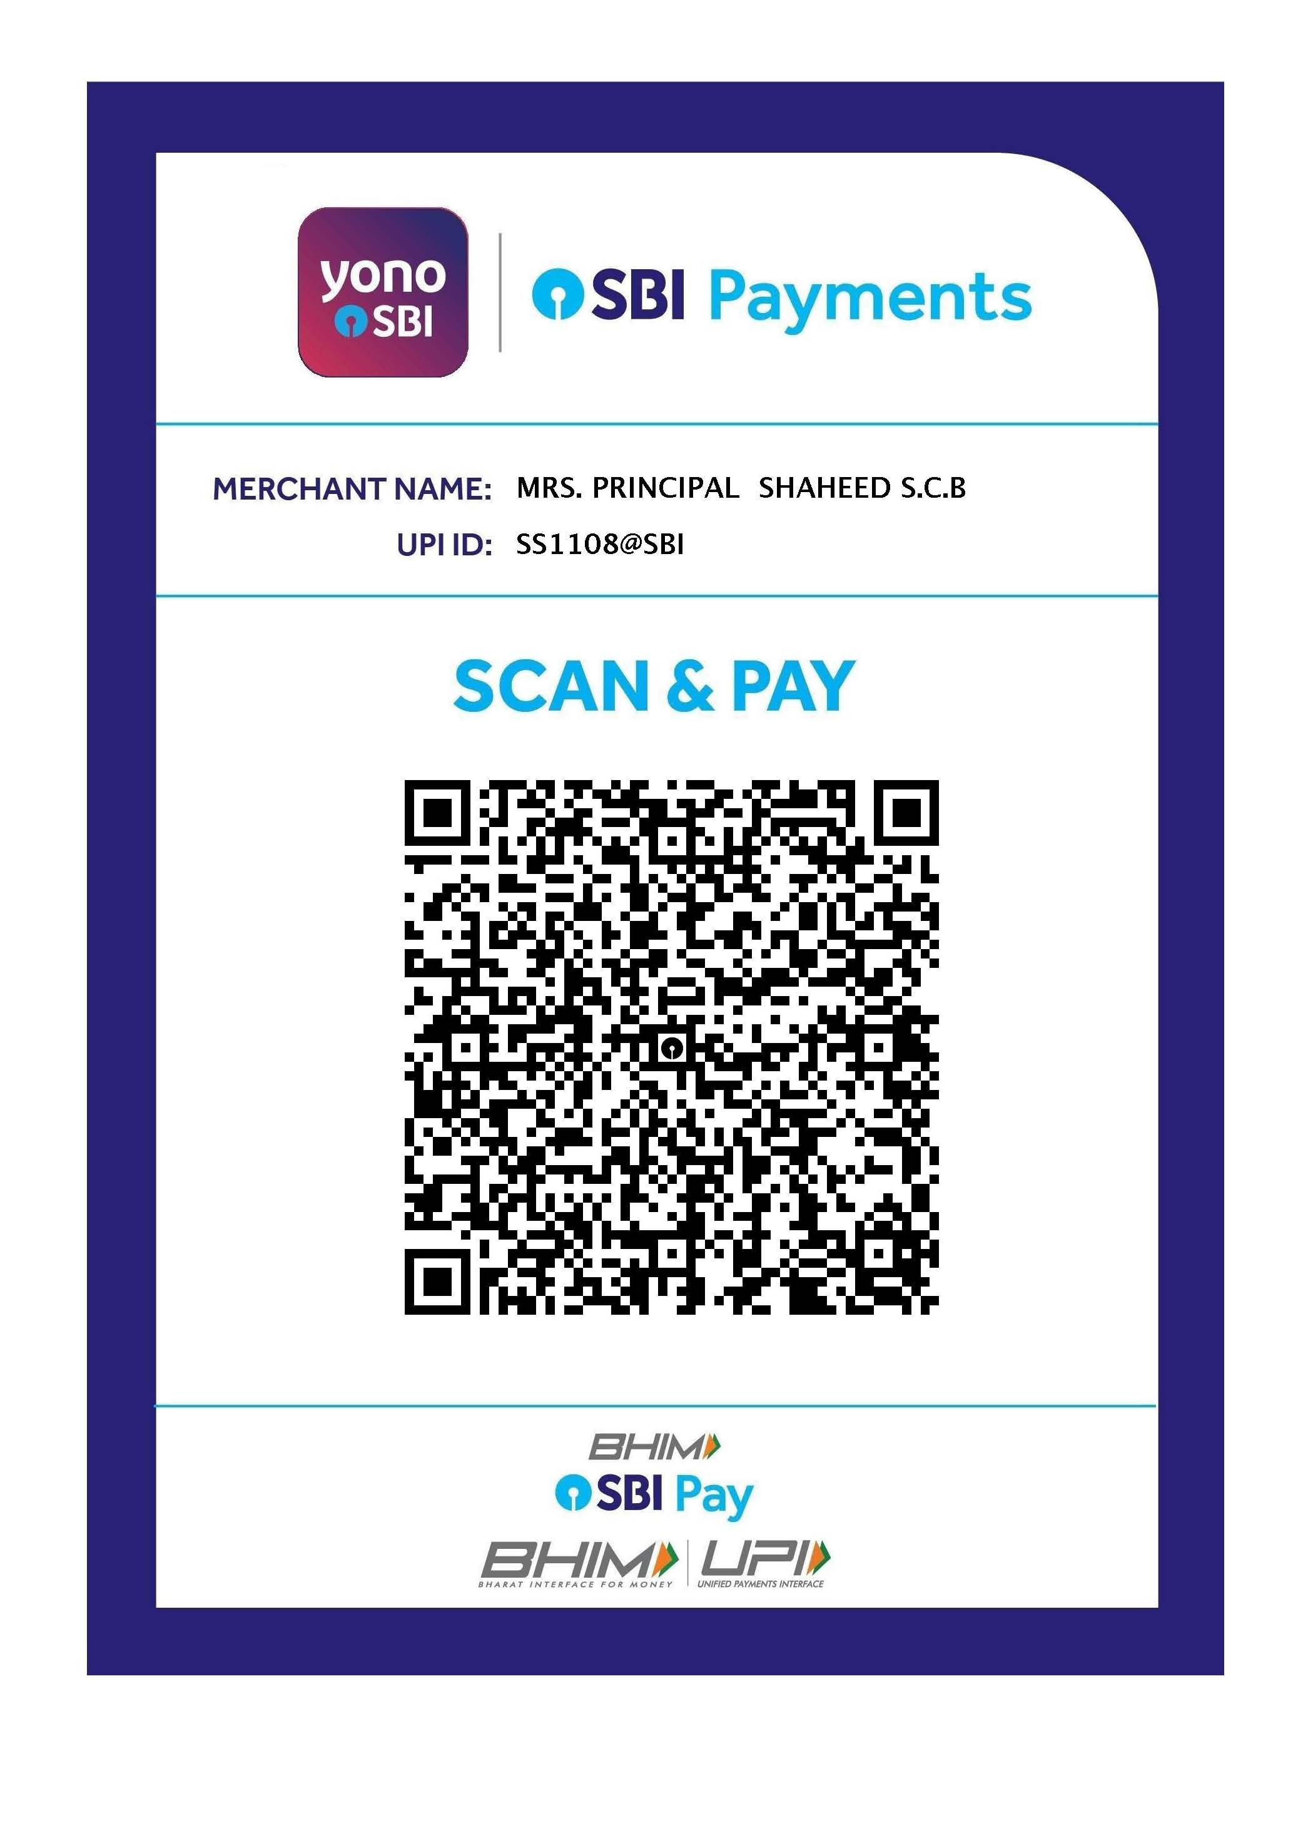
Note: Students need to deposit online transaction receipt of Total fees ₹ 27,500 (Rupees Twenty Seven Thousand Five Hundred only) with the filled-up application form.

