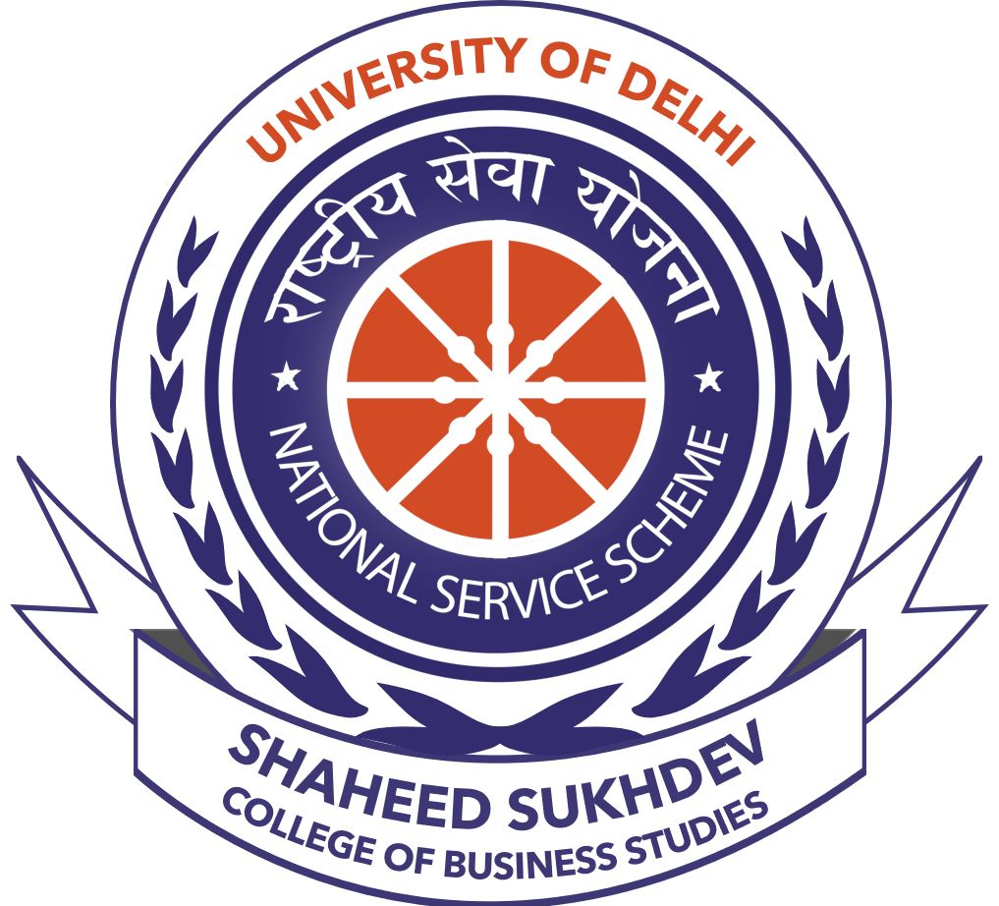

National Service Scheme (NSS) SSCBS

Information about the society in brief: We are the NSS unit of SSCBS, a student-run fraternity that aims to foster the feelings of social service among the students and provides them with a platform where they can make a difference to the society. We have been working rigorously on a plethora of humane activities like literacy drives, community healthcare, and women empowerment. We stay true to our motto ‘Not Me But You’. The aim of the organization is to produce socially responsible managers and work for the all-round development of the nation.

Summary of work done throughout the year 2020-21: In these times of distress, we conducted a number of webinars, workshops, online sessions, documentary screenings, case competitions, quiz and literary competitions. We started our new Project Rakt, which aims at solving the problem of plasma availability and bringing awareness among the masses about the importance of plasma donation during this time of pandemic. On the eve of Shaheed Diwas, as the NSS unit, we conducted various events in the honor of our martyrs. We showed our gratitude by propelling the flowers, conducting singing, poetry competition as well as the slogan competition. We recently took the initiative for educating the masses about the vaccination drive.

KEY EVENTS

- TREE PLANTATION DRIVE

On the occasion of the 74th Independence Day of India, a tree plantation drive was organized. Everyone was asked to plant a sampling at the garden and share the picture with us. This was a medium to appreciate everything we have and celebrate the great miracle of freedom by planting a sapling. This was also aimed to fight against the ever-increasing pollution in the environment. This initiative was supported by many people who planted a sapling and shared the picture too.

- ATMANIRBHAR BHARAT QUIZ

On the occasion of 74th Independence Day of India and with the onset of Atmanirbhar Abhiyan, an online quiz was organized in collaboration with NSS GEC Delhi. The online quiz was based on the theme of Atmanirbhar Bharat. E-certificates were also provided to every participant who scored more than 50% in the quiz. The quiz made the participants realize that Atmanirbharta is not only a need but a necessity

- WEBINAR ON ATMANIRBHAR BHARAT

On the occasion of 74th Independence Day of India, the NSS unit of SSCBS organized a webinar on Atmanirbhar Bharat on 15th August 2020. The guest speaker for the webinar was Aryan Narwat, a proactive social worker. He shared some inspiring stories of some freedom fighters. Also, he talked about the ways in which India can move towards the path of atmanirbharta. The participants got aware about their part in making India more self-reliant after this webinar.

- WEBINAR ON ‘DECRYPTING MANTRAS TO STAY FIT IN YOUR VIRTUAL COLLEGE’

As we entered this Global Pandemic we also entered into a new era of online education. It was difficult for everyone to adjust immediately in the virtual life and everyone was struggling to adjust to these changes, thus NSS SSCBS, in association with Nirvana-Wellness Community organized a webinar on 'Decrypting the mantras to stay fit in your virtual college'

- FIT INDIA FREEDOM RUN

To celebrate some days of fitness and joining the Fit India Movement (26th August to 2nd October), NSS came forward taking part in Fit India Freedom Run where every NSS volunteer was required to go out for a walk or running around their locality for one to one and a half hours. People living in containment zones were required to walk on their terrace. And everyone was requested to take proper precautions and keep themselves safe from Coronavirus.

- LIVE SESSION: ENTREPRENEURSHIP AND QUEER STRUGGLE

NSS SSCBS, in collaboration with Kartavya- The Social Service Forum of SSCBS and Queer Straight Alliance SSCBS, on September 20, 2020, organized a live session on "Entrepreneurship & Queer Struggle" with Mr. Ashish Chopra, co-founder of Beunic, a gender-inclusive apparel brand, a talent researcher at Phillips, and 1st runner-up- Mr. Gay India, where he recounted his struggles of becoming an entrepreneur and tackling stigmas attached to the LGBTQ+ community.

- SESSION ON MEDITATION AND STRESS MANAGEMENT

NSS SSCBS, in collaboration with NSS Maharaja Surjamal Institute, on September 29, 2020 organized an online session on the importance of Meditation, Yoga, and Stress management. The session was conducted by Dr. Kush Panchal, an international yoga trainer, and the personal trainer of Kangana Ranaut & Shahid Kapoor, who taught us that looking after mental health can preserve a person’s ability to enjoy life and that doing this involves reaching a balance between life activities, responsibilities, and efforts to achieve psychological resilience.

- VIGILANCE AWARENESS OATH CEREMONY

NSS SSCBS, on October 31, 2020 conducted a Vigilance awareness oath ceremony on an online platform, wherein all the staff- teaching and non-teaching, NSS volunteers and students of SSCBS took a pledge to sustain their integrity, maintain transparency and work meticulously for the eradication of corruption in our country.

- VIGILANCE AWARENESS CAMPAIGN

The issue of corruption in our nation has prevailed since ages, from a common citizen to the highest position in governmental hierarchy. Corruption is like a cancer, eating away a citizen’s faith in democracy and diminishing their instinct for innovation and creativity thus holding back the economy from reaching new heights. NSS SSCBS, contributing its bit towards fighting corruption, organized a vigilance awareness campaign.

- E-PLEDGE ON NATIONAL UNITY DAY

NSS SSCBS was joined by NSS volunteers and students of SSCBS to take an e-pledge to commit themselves to the ideals that guide the National Unity Day. The rationale behind the pledge was re-affirming the inherent strength and resilience of our nation to withstand the actual and potential threats to the unity, integrity and security of the country.

- WORLD YOUTH SKILLS DAY

- Social Suite Case Competition

The NSS unit of SSCBS organized 'Social Suite-The Finance Case Study Competition' on occasion of World Youth Skills Day. Participants were provided with a financial case study with a social twist. It gave an opportunity to all financial enthusiasts who have a flair for social welfare to put their financial acumen to test, while competing with others.

- Markoventure Case Competition

NSS SSCBS also organized 'Markoventure- the marketing case study competition'. The competition was conducted with a view to enable participants experience the revolution in the marketing industry as more and more brands wake up to their social responsibility and conduct cause marketing campaigns. Participants were provided a marketing case study with a social twist. Selected teams presented their solutions in front of the judges.

- Live Session on “Skills required to get into top B-schools”

NSS SSCBS conducted an Instagram Live Session with a CBS Alumnus, Mr. Rajat Goel on the topic-"Skills required to get into top B-Schools". Mr. Rajat is pursuing MBA from FMS, Delhi and also converted many IIMs. He shared his experiences and valuable suggestions on how students can prepare themselves for premier B-Schools, even in times of the pandemic.

- Live session on “Inside an Artist’s Mind”

The NSS Unit of SSCBS celebrated World Youth Skills Day with an Instagram Live Session on "Inside an Artist's Mind" by Actor Shaan Grover, who has starred in multiple web series and advertisements. He acquainted the students with the nuances of theatre arts and shared his valuable insights with everyone.

- Under PROJECT CHETNA

- Live session episode-1 for #westandagainsttrolling (13th February 2021)-

Under the Project Chetna, the 1st activity to take place was the live session where the NSS volunteers contacted different social media influencers and invited them to speak upon the social media hate they face in their daily life, the 1st episode was the Instagram live session with the influencer named Ayushee Ghoshal who shared her experience about how it feels to be an influencer on social media platform and what challenges one faces while being on same. She quoted "the hate they give has everything to do with them and nothing to do with you"

- Live session episode-2 of #westandagainsttrolling (17th February 2021)-

The 2nd episode of activity #westandagainsttrolling went live on Instagram on 17th February and was with the well-known name on social media and especially to DU children Mr. Nishant Parmar who was asked different questions and to share his experience about how his life has been since he started his journey on social media and what all problems he faced and faces. He quoted "start prioritizing interest and confidence above toxicity and hatred, then see the difference"

- Virtual Meditation session (20th February 2021)-

Meditation session took place on 20th February was taken by Mr. Ankit Gupta. Because of the pandemic everyone is supposed to accept the new normal that has put students under great pressure and to give students some break and time for themselves to be free and relax and get stress free for their mental peace, NSS volunteers organized a Meditation workshop and everyone underwent several meditation activities.

- Under PROJECT SANGRAKSHAN

Project Sangrakshan was an initiative of the NSS unit of SSCBS to create an impact by awaring the volunteers on cybercrimes and possible ways to protect from them. This project aimed to create awareness regarding cybercrimes by various social media posts and webinars.

- Cyber Security Webinar
A webinar was conducted on 19th february 2021 which witnessed an audience of over 70 people. The webinar aimed to spread awareness about the need of cyber security. The guest speaker for the webinar was Jaganath BG, senior cyber security analyst at Inspira enterprise pvt ltd. He talked about cyber related issues and correct framework to deal with it. This webinar helped the participants to know about various ways to protect themselves from cybercrimes. The participants also asked their doubts and also shared their views on various topics related to cyber security.

- COVID VACCINE AWARENESS CAMPAIGN

NSS SSCBS started a COVID Vaccination Awareness Campaign to build an environment of universal vaccine acceptability. With a desire to give credit to our scientific community that raced against time to develop the vaccine and to assure people about the reliability of the vaccine, this awareness campaign was started, covering the entire procedure of registration and vaccination.

- ROAD SAFETY WEBINAR

The NSS unit of SSCBS organized a webinar on ROAD SAFETY AWARENESS in collaboration with Honda Motorcycle and Scooters India private. Ltd. on 27th January 2021. The aim of the webinar was to empower youth and to bring all the stakeholders together on one platform to discuss and learn about various aspects of road safety. This webinar helped the volunteers by making them realize the importance of learning how to drive before actually driving along with the importance of following rules and regulation on the road while driving. This webinar also made the volunteers aware about the services offered by Honda Motorcycle and Scooters

India private Ltd. in the field of driving training.

- DOCUMENTARY ON “OUR PLANET”

The NSS unit of SSCBS organized remote screening of a documentary on “OUR PLANET” in order to raise awareness and educate people about CLIMATE CHANGE. This documentary aimed to throw some light over the catastrophic danger of climate change on our planet. The documentary showed the natural beauty of our planet and exploitation being done by the people over the starting of their existence. The documentary also showed the deadly implication of the exploitation of the planet. The documentary created an impact by making the volunteers realized the implication of their deeds on the environment.

- WEBINAR WITH ''VISIONARIES''

NSS SSCBS conducted a webinar in collaboration with an organization named 'Visionaries' founded by Mr. Chirag. The webinar was graced by Mr. Chirag who tries to see the world in a different manner and sensitized the students towards the differently-abled. Mr. Chirag, himself being deprived of the ability to see, motivated the students to volunteer to help the blind in reading and writing.

- DOCUMENTARY ON “ALL THAT STANDS IN THE WAY”

The NSS unit of SSCBS celebrated Women's Day by organizing a remote screening of the documentary “ALL THAT STANDS IN THE WAY”. This documentary examined the lives of 4 teenage girls from different backgrounds in an effort to understand the roots of gender inequality. This documentary raised the awareness regarding the root causes which lead to gender discrimination in our society.
This documentary created an impact by making the people realize the need for gender equality in this modern world.

- SHAHEED DIWAS

Every year 23 March is celebrated as Shaheed Diwas to pay reverence to the brave heroes of our nation- Shaheed Bhagat Singh, Shaheed Sukhdev Thapar and Shaheed Shivaram Rajguru, who sacrificed their lives to enable us to be what are we today- A proud, independent, democratic nation. NSS SSCBS celebrated 23 March 2021 as Shaheed Diwas wherein a plethora of activities were conducted which are as follows:

- Phool Samarpan Samaroh

The event commenced with a 2-minute silence for the martyrs, followed by 'Phool Samarpan Samaroh' i.e., Petal Showering Ceremony. All the teachers came forward to pay homage by offering flower petals at the statue of Shaheed Sukhdev Thapar in the college premises. The occasion was graced by the kind words of our teachers which made everyone reminisce the struggles of the heroes.

- Candle Lighting Ceremony

The Petal Showering Ceremony was followed by Candle Lighting in memory of the departed souls. The gleam of the lit diyas and candles was a sight to behold.

- Webinar on Shaheed Diwas

The event concluded with a webinar conducted by NSS SSCBS where we aimed to enlighten the students and help them recognize the sacrifices of those great men who achieved martyrdom in the struggle against British colonial rule. The guest speakers were Dr. Iliyas Husain and Dr. Salil Misra. The varied anecdotes shared by our guest speakers were really intriguing and inspired all the students and teachers, whose respect for the martyrs increased manifold.

Apart from these activities, NSS SSCBS also organized various competitions for the same:

- Slogan Writing Competition

The competition was organized in 2 categories- English and Hindi. Participants were required to submit slogans in memory of the brave martyrs.

- Essay Writing Competition

The competition was conducted in 2 categories-English and Hindi. Participants were required to write an essay in about 500 words on any one of the given topics:
- Self before nation and nation before self
- What was the idea of freedom of our martyrs.

- Poetry Competition

Poetry is a great way to put more emotions in lesser words. This competition was also held in 2 categories- English and Hindi. Participants were required to submit poetry in honor of the sacrificed.

20. WEBINAR: “THRIVING, NOT JUST SURVIVING”

Under Project Muskaan, the women safety project, the National Service Scheme of SSCBS, in collaboration with Chhanv Foundation, organized a webinar with real-life acid attack survivors, Ms. Roopa and Ms. Anshu. to escalate the importance of the growing outrush of acid attacks in India, our guest speakers shared their personal experiences and their inspiring journeys of fighting back. The session not only raised awareness about the increasing incidences of acid attacks in India and the hardships of the victims, but also motivated the participants that if you are determined, nothing can ever stop you from thriving.

21. DOCUMENTARY SCREENING ON “JALLIANWALA BAGH MASSACRE”

On the occasion of the 102nd anniversary of the Jallianwala Bagh Massacre, a remote screening of a documentary on the Jallianwala Bagh Massacre was conducted. The documentary highlighted the events that traced back to 13 April 1919 when thousands of brave hearts and innocents lost their lives. It was organized with a motive to invoke responsibility to remember and keep everyone in prayers who lost their lives for our freedom. The documentary was followed by an online quiz on the same, where all volunteers participated actively.

22. COVID AID

A team of volunteers from NSS SSCBS has been working to verify covid resources like oxygen supplies, medicines, hospital beds, doctors, plasma donors etc. and proving the verified leads of the same to the needy. It started with some of our volunteers working with external organizations to help the cause. Now, we are a team of 40+ CBS Covid Fighters, working the entire day for the people in need.

23. PROJECT RAKT

NSS Unit of SSCBS has always been proactive to help the underprivileged and creating awareness for the same in order to make this world a better place. As the COVID-19 pandemic takes a toll on life and health, NSS SSCBS did it’s bit in the fight against this deadly virus. Project Rakt, an initiative by NSS SSCBS, aims to bridge the gap between plasma donors and donees.

24. WEBINAR ON CANCER PREVENTION & PALLIATIVE CARE

NSS Unit of SSCBS realizes that cancer prevention is an important topic that needs to be brought to the limelight so that we can acquaint more and more people to take steps to prevent cancer in the first place. For this purpose, we organized a webinar in collaboration with Dharamshila Cancer Foundation and Research Centre.

The details of the webinar are as follows:
Date and Time: May 13, 2021, 04:00 PM

25. WEBINAR ON BLOOD THELESEMIA

‘The first step towards change is awareness.’ Thalassemia is a blood related, genetic disorder. Blood donation plays a key role in helping the Thalassemic people.

The BloodConnect team recognized 2nd-8th May as Thalassemia awareness week. In this context, NSS Unit of SSCBS collaborated with them and conducted a session on Thalassemia Awareness. This helped us to understand how blood donation plays a key role in in Thalassemia and why it is our top-notch priority to be aware of it.

The details of the webinar are as follows:
Date and Time: May 5, 2021; 6:00 PM

