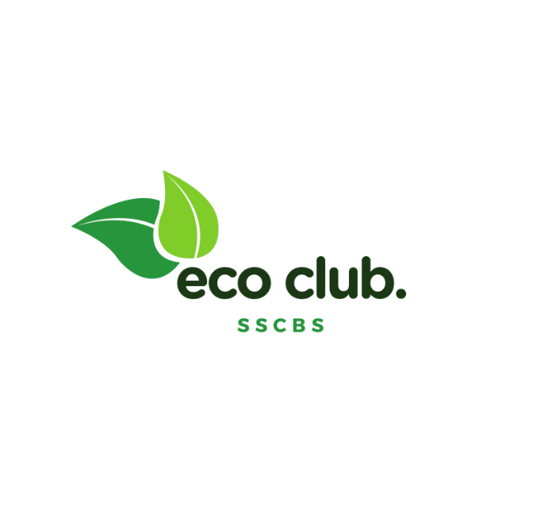

**ECOCLUB - SSCBS**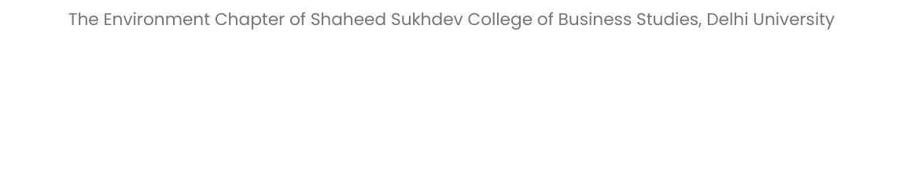

**What We Do ?**

EcoClub SSCBS promotes sustainability through tree plantation, waste management, and educational seminars. They collaborate with local organizations, participate in clean-up drives, and encourage members to engage in environmental competitions. The club serves as a platform for idea exchange, eco-friendly projects, and mentorship programs, shaping students' eco-conscious mindset and preparing them for sustainable practices ahead.

**Key Events in 2022-23**

**1. Har Ghar Tiranga Celebration**

To celebrate 75 great years of independence and instil in everyone a patriotic spirit, the Government of India launched the Har Ghar Tiranga programme. It aimed at encouraging everyone to take pride in their nation and spreading awareness about the importance of the national flag. Volunteering under Kartavya - The NSS Forum of SSCBS, EcoClub students took part in this great campaign and organised various activities and events under the programme.

We celebrated Flag hoisting, Phool samarpan activity, Tiranga yatra , Patriotic song performances and Pen and Mug distribution with the highly supportive and encouraging members from societies of NSS and Kartavya. Finally we would not have been able to conduct the 75th day of Independence without the extensive support and coordination with our college teachers and we are truly grateful to them.

**2.** **National Pollution Day Celebration**

To mark National Pollution Prevention Day on 2nd December, Shaheed Sukhdev College of Business Studies organized various activities under the IQAC and IIC-SSCBS initiative, Kartavya, NSS and the Eco club. The activities included:

A Social Impact Case Competition on Sustainable Energy, where participants had to propose a business plan for eco-friendly alternatives to fossil fuels. Team Seeker won the competition among 25+ teams.

A Slogan Writing Competition on the theme of ‘National Pollution Day’, where the winning slogan was ‘Our Kartavya - Erase the pollution menace, ace the development race’.

A Poster Making Competition, where participants displayed their artistic skills and created posters related to the theme.

**3. World Environment Day Celebration**

On the occasion of World Environment Day, we conducted a movie screening , namely Carbon and a Mockumentary on Plastic Waste , an online poster making activity , a survey on environmental awareness among students at our campus and an online questionnaire about general environmental awareness and a cleanliness drive with BHUMI organisation where we conducted animal welfare ,plogging drive and a clay pot making activity.

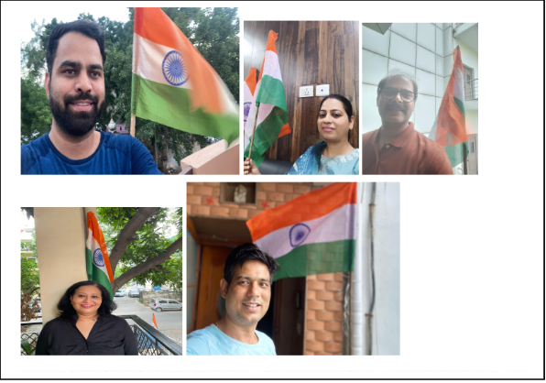

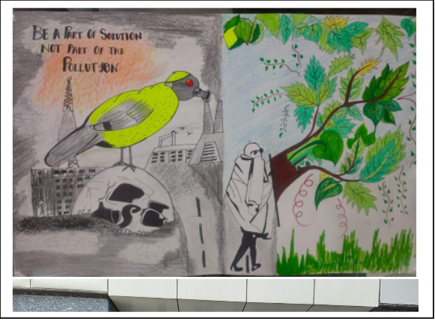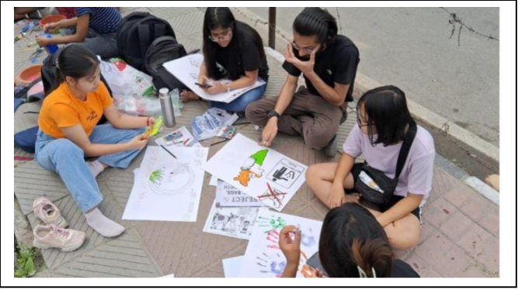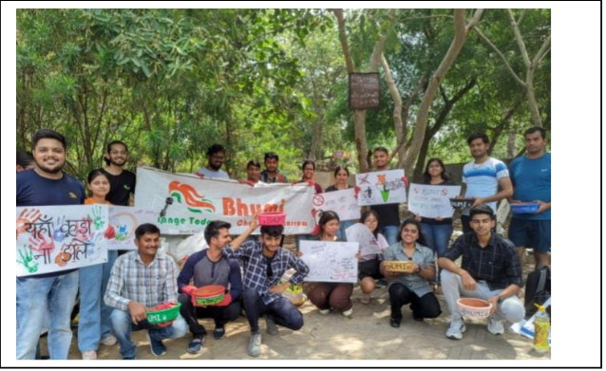

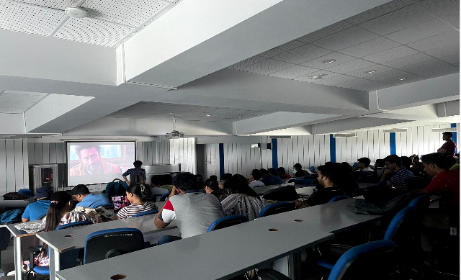

**Contact Us**

**LinkedIn :** <https://www.linkedin.com/company/eco-club-sscbs>

**Instagram :** [https://instagram.com/ecoclub_sscbs](https://instagram.com/ecoclub_sscbs?igshid=OGQ5ZDc2ODk2ZA==)

**Email :**

[ecoclubsscbs@gmail.com](mailto:ecoclubsscbs@gmail.com)

**Name(s) of the TIC(s)**

* **Dr. Narendra Kumar Nigam**
* **Dr. Saumya Jain**

**Name of Contact Person**

* **Anuj Bansal (**anuj.22032@sscbs.du.ac.in**)**
* **Htet Yamon Myo (**htet.22096@sscbs.du.ac.in **)**