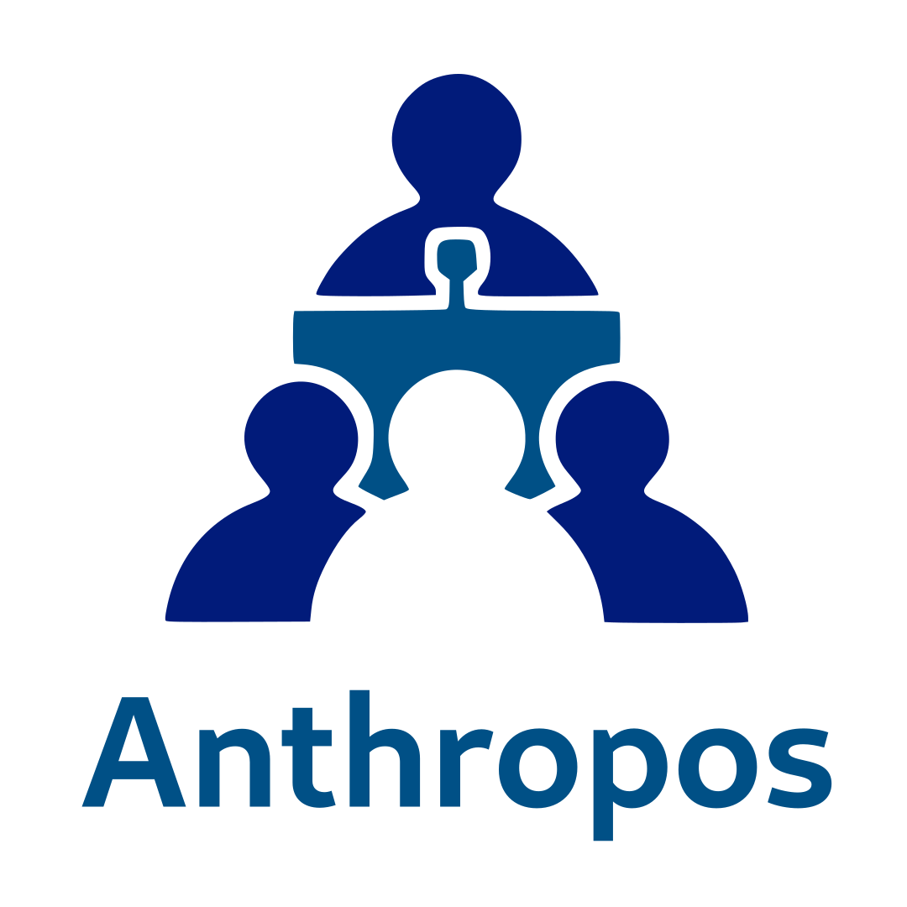
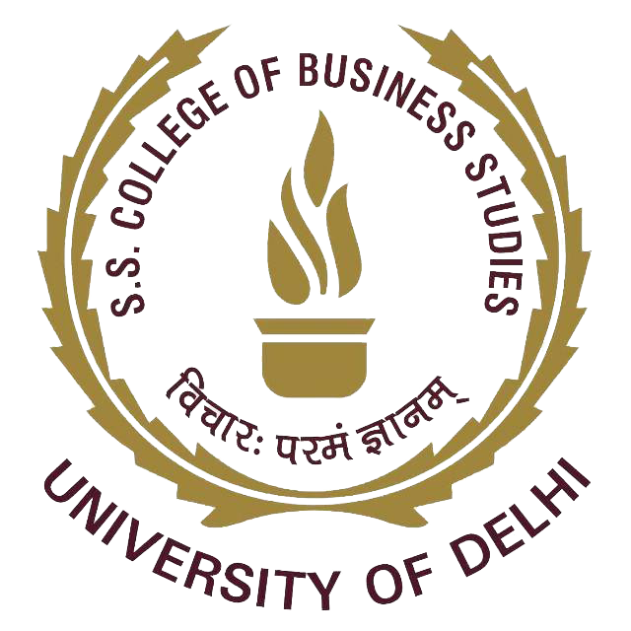

Anthropos Report 2022-23

Outcomes of KRAs

What Do We Do?

Welcome to ANTHROPOS – The Human Resource Development Cell of SSCBS, where we are dedicated to fostering the holistic development of the college's most vital asset – its human resource. Our primary objective is to mould students into world-class professionals equipped with the well-rounded skills necessary for success in the corporate world.

Mission:
ANTHROPOS is committed to nurturing interpersonal skills essential for thriving in the dynamic corporate environment. Through strategic collaborations with diverse organisations and HR managers, we aim to provide valuable guidance to students throughout their academic journey.

We actively collaborate with various firms and organisations to facilitate live projects and augment the skill sets of our students. These partnerships contribute to a practical and industry-relevant learning experience.

Key Events in 2022-23

- INCEPTRA: Our Annual Flagship Event
Unfolded from April 24th to April 26th in the previous year, drawing a substantial footfall of 1100+ students from prestigious institutions such as IIMs, ISB, NMIMS, etc.
This distinguished event comprises three key components:
- Deem Dilemma:
Participants are tasked with designing a solution to a case related to the HR field. This competition is intended to enhance the managerial acumen, problem-solving skills, and professional ethics of participants.
- Boardroom Charades:
This challenge necessitates finding solutions to real business problems and experiencing corporate boardroom dynamics. This challenge is designed to test the participant's decision-making abilities and presentation skills and contribute to their development as top-tier professionals.
- House of Trades:
This is a trading competition, conducted on a social virtual trading platform. This focused on creating an enjoyable and collaborative online environment to enhance the trading abilities of participants.

- POORVABHYAAS: A prestigious event conducted by Anthropos across the DU circuit, it serves as a pre-placement or internship session. It aims to provide participants with a realistic interview environment. This includes one-to-one mock interviews with the HRs from the renowned firms, which provide valuable experience and the opportunity for participants to confront the challenges of actual interviews.

- MANTAVYA: Mantavya, held during the annual fest of CBS, Crescendo'23, as an addition to Inceptra on April 19th. It showcased an HR case discussion/debate competition. This platform facilitated illuminating conversations and debates on human resources, testing participants' analytical prowess and HR intelligence through thought-provoking tasks. Mantavya provided an engaging educational opportunity for individuals with varying degrees of HR expertise, welcoming novices and seasoned professionals alike.

SEMINARS, WEBINARS, AND WORKSHOPS are timely conducted by the cell to help the students achieve their goals. The ones organized during the year were:

- Webinar: 6-month Study Plan for CAT
SPEAKER: Mr. Gautam Puri
Mr. Gautam Puri, an alumnus of IIM-B, conducted a webinar on crafting an effective 6-month study plan for the CAT (Common Admission Test). The session provided valuable insights, strategies, and tips to help participants prepare effectively for the CAT exam. Date: 21.05.22; Participants:100+

- Workshop: Resume Building and Interview Skills
SPEAKER: Mr. Sunil Dua
Mr. Sunil Dua led a workshop focusing on resume building and interview skills enhancement. Participants learned techniques to create impactful resumes and gained valuable insights into mastering interview techniques. Date: 15.09.22; Participants: 60+

- Aptitude Test: Logical, Qualitative, and Data Interpretation Skills
An aptitude test was administered to measure participants' logical, qualitative, and data interpretation skills. The test aimed to assess participants' proficiency in critical areas relevant to MBA admissions.

- Webinar: Cracking Case Studies
SPEAKER: Mr. Jayanta Saha
Mr. Jayanta Saha conducted a webinar focused on strategies for cracking case studies. Participants gained practical insights into approaching case studies effectively, enhancing their problem-solving abilities crucial for MBA preparations. Date: 22.11.22; Participants: 80+

- Webinar: Why MBA?
SPEAKER: Mr. Jayanta Saha, Senior Regional Head at T.I.M.E.
Mr. Jayanta Saha, a seasoned professional and Senior Regional Head at T.I.M.E., led a webinar exploring the significance of pursuing an MBA. The session delved into the various reasons individuals choose to pursue an MBA and the potential career opportunities it unlocks. Date: 15.06.23; Participants: 50+

Achievements of the Society Members

The society members participated in a lot of competitions on the national level, with podium finishes in the following:
- Winner - Imperium Case Competition - Thiagarajar School of Management
- Winner - Case Junction - Gargi, DU
- 2nd position - SustainUp - Shri Ram College of Commerce, Du
- 2nd position - Brief Case - BITS Pilani
- 3rd position - Parabellum - SSCBS
- 3rd position - Vyaparkosh - Keshav Mahavidyalaya, Du
- 3rd Position - Saahas - Vivekananda College, DU
And many more…

Teacher-In-Charges
Mr. Abhimanyu Verma
Ms. Anusha Goel

About the team -

President – Nimish Gupta
Vice-President – Aarushi Yadav

Advisory committee -
Suneet Sinhmar, Aman Kr. Pathak, Aftab Ansari, Yashika Goyal, Nimish Gupta, Shivam Agarwal,
Kush, Ramavatar Singh Jadon, Akash Kumar Singh, Utkarsh Jindal, Kunal

Core Committee –
Urfa Saleem (coordinator)
Divyansh Desarda (coordinator)
Deepak Jaiswal, Namrata Singh, Malvika Sharma, Nikhil Sreenivas, Adarsh Soni, Loveneesh Kumar, Ibrahim Gaffar, Mohommad Saad, Sahil Yadav, Arya Nanda, Shaurya Verma

Organizing Committee –
Vardaan, Twinkle Walia, Anshul Verma, Aryan Pundir, Ayush Gupta, Mansi Goel, Muskan Agrahari, Pradeep Neel, Pushp Aiswal, Tathagat Kumar, Vineet Singh, Abhishek Kumar, Himanshu Yadav, Rohit, Himanshu Mehar, Dheeraj Kumar, Harsh Rana

