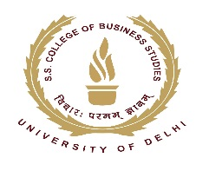
SHAHEED SUKHDEV COLLEGE OF BUSINESS STUDIES
(UNIVERSITY OF DELHI)
Dr. KN Katju Marg, Sec-16, Rohini, Delhi-110089

About NCCMP Course & Frequently Asked Questions

1. What is NSE Academy Certified Capital Market Professional?: NSE Academy Certified Capital Market Professional (NCCMP) is a short duration 100 hours (4-6 Months) weekend course launched jointly by “Shaheed Sukhdev College of Business Studies (SSCBS): An esteemed college of University of Delhi” and “NSE Academy Ltd: A wholly owned subsidiary of National Stock Exchange (NSE)” to impart knowledge and awareness about the securities market and thereby upgrade the skills and proficiency of the participants of the course.

2. Class timings: During the Weekends and Vacations 9:00 am onwards.

3. Duration of the course: 100 Hours (over 4 -6 Months, 80 hours of theoretical sessions and 20 hours of practical sessions).

4. Eligibility: Anyone who pursuing Graduation or passed class 12th or equivalent.

5. Forms Availability: Admission form is available on the college website (https://sscbs.du.ac.in/nccmp-sscbs/). Download the Application form (photocopy of downloaded form may be used).

6. Total Fees ₹17,200/-(Course fee 17,000/-, Application fee 200/-).

7. Mode of Payment: By Net Banking & UPI.

8.Net Banking/ UPI details:
Account Name: | Principal SSCBS students Society A/C
Bank: | State Bank of India
Account Number: | 35810781108
IFS Code: | SBIN0011550
MICR: | 110002303
Branch: | (11550)- Pascon Building Garg Trade Centre, Sector-11, Rohini, New Delhi-110085

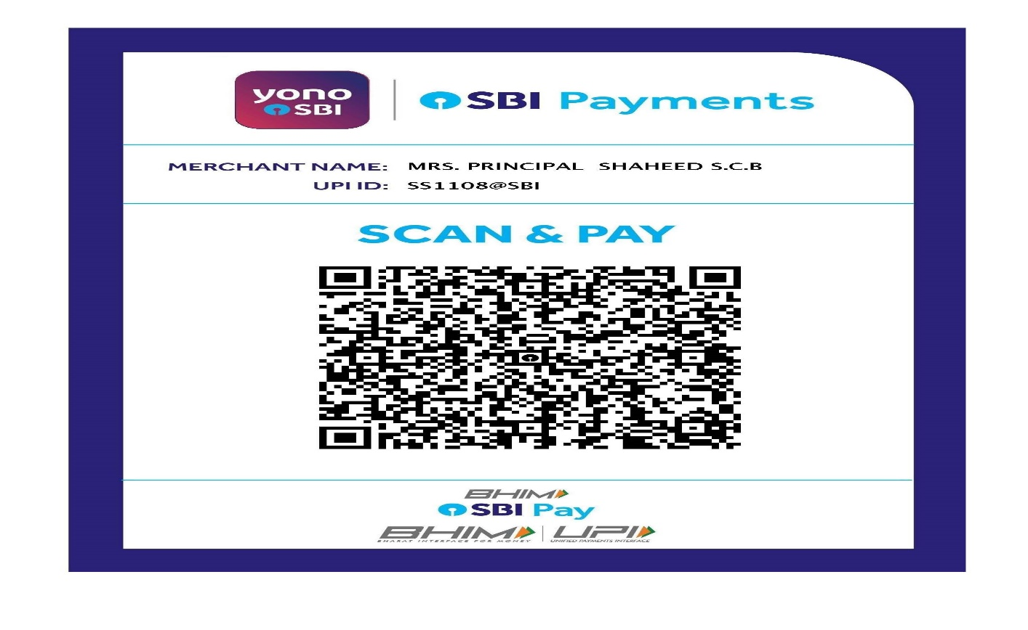
Students need to deposit online transaction receipt of Total Fees 17,200/-(Course fee 17,000/-, Application fee 200/-) with application form and supporting documents.

9. Documents required at the time of Admission: Attach Photocopy of Mark sheet & Certificates of Class 12th or above, Online Fees Deposit Receipt (If fees paid online) and Aadhar card / Identity Proof.

10. Timings of Application form submission in the college: Forms will be submitted in accounts office (Room No-10) Monday to Friday during working Hours (10:00 am to 4:00 pm).

11. Number of seats: There will be Minimum 40 students in every batch of NCCMP Course.

12. Admission Notice: The date for each new batch will be notified on the College website (https://sscbs.du.ac.in/nccmp-sscbs/).

13. Certification: Certificate shall be provided jointly by SSCBS and NSE Academy Ltd.

14. Course Content: 80 hours theory (in the college premises):

- Introduction to Financial Market

- Fundamental Analysis

- Technical Analysis

- Derivatives

- Advanced Derivative

- Research Project

Soft copy of study material will be provided for each module separately.

20 hours of practical training: Live Trading system, Financial Database, Technical Analysis, Spreadsheets etc.

15. Examinations:
(i) Mid Term Exam - Conducted by the college,
(ii) Project work - Assigned and Evaluated by College (To be submitted prior to end term exam),
(iii) End term Exam - On line exam conducted by NSE Academy Ltd.at their Delhi Office.

Note-Date of exams shall be notified later during the course. Once notified, no change of date will be allowed for any candidate.

16. Requisites for course completion: Securing at least 50% marks in each of the followings;
(i) Internal Examination,
(ii) Project Work,
(iii) End Term Examination.

17. What if candidate is unable to secure the requisite percentage? The candidate would be given another opportunity to meet the above-mentioned requisite. If the same is not meet then the candidate can avail of a participation certificate or appear for the exam along with the next batch of students by paying the examination fees/project evaluation fee to SSCBS/NSE Academy Ltd.

18. When the certificate will be awarded: After successful completion of Internal Examination, Project work and End Term Examination candidates would be issued a certificate jointly by SSCBS and NSE Academy Ltd.
For further clarification: Contact the course coordinator Dr. Narander Kumar Nigam, Assistant Professor or to - Mr. Hemender Sharma, Mob: 9268706463 (Room No: 326).

(Dr. Narander Kumar Nigam)
Course coordinator, Assistant Professor
(Mob: 9873041007)
SSCBS-University of Delhi
Dr. KN Katju Marg, Sec-16, Rohini, Delhi-110089
Email: narandernigam@sscbsdu.ac.in,
Website: https://sscbs.du.ac.in/nccmp-sscbs/

