Activity Report

Title of event: VC Investments in the Gaming Industry
Date of Session: 22nd January 2022
Time: 3 PM
Speaker(s): Mr. Tushar Behl

Links:
Facebook: https://www.facebook.com/105687805336027/posts/113365954568212/ Instagram:https://www.instagram.com/p/CY66hPss8P-
/?utm_source=ig_web_button_share_sheet

Poster/ Banner/ Brochure:
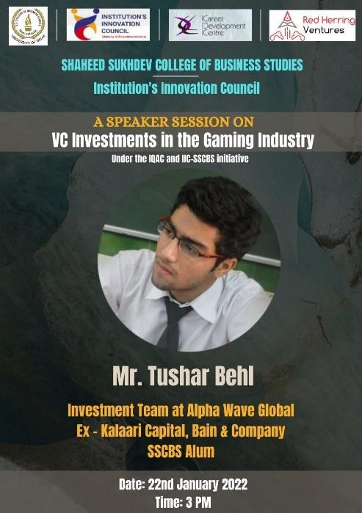

Activity Summary

Brief Introduction of the Speaker
Tushar Behl, an alum of the batch of 2017, started his professional career with the highly touted Private Equity group at Bain and Company. Following this, he worked at Kalaari Capital (one of India's leading VC funds), before beginning his journey at the investment team at Alpha Wave Global LP.

Outcome
Mr. Tushar Behl shared his valuable experience, dwelling deep into the concept of what is Venture Capital, how it is used, it’s importance in industries, moving on to its encounter with Gaming industry. He elaborated on the real-life examples of venture capital investments in Gaming Companies.

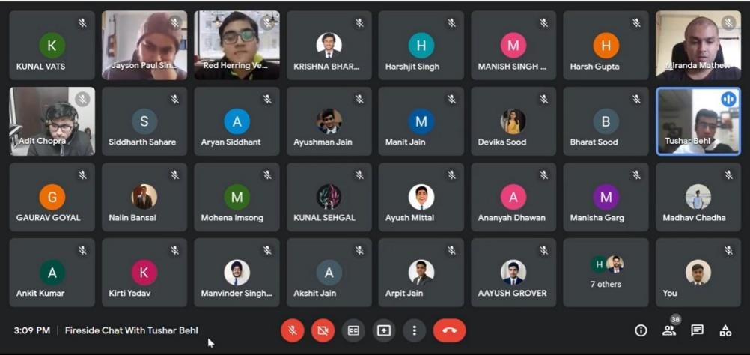

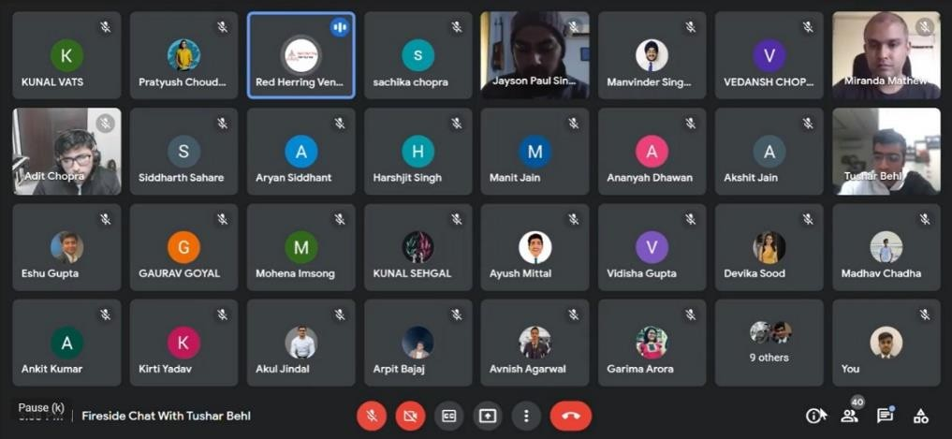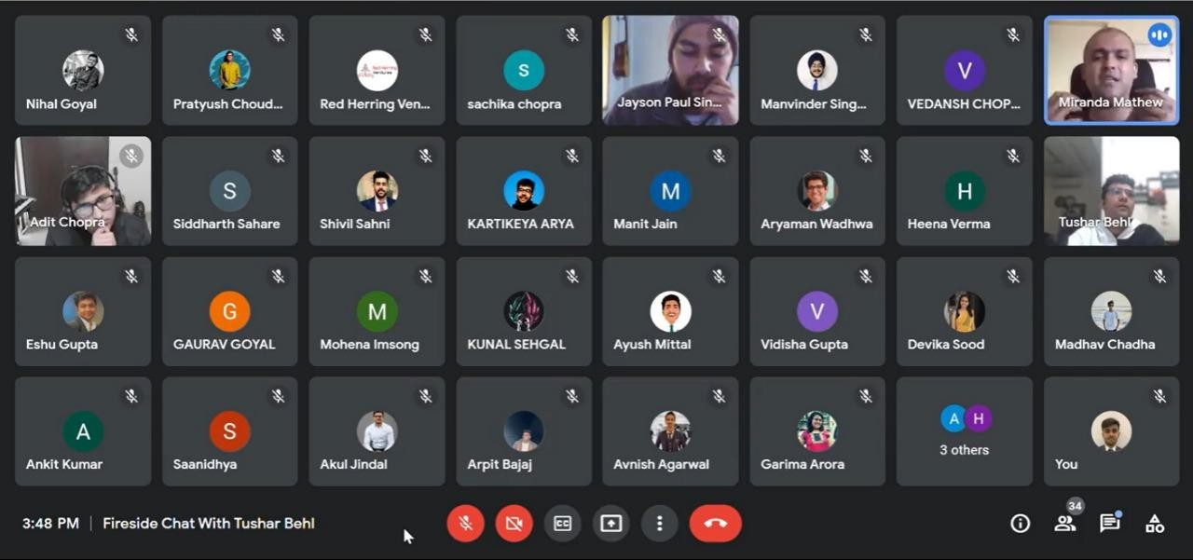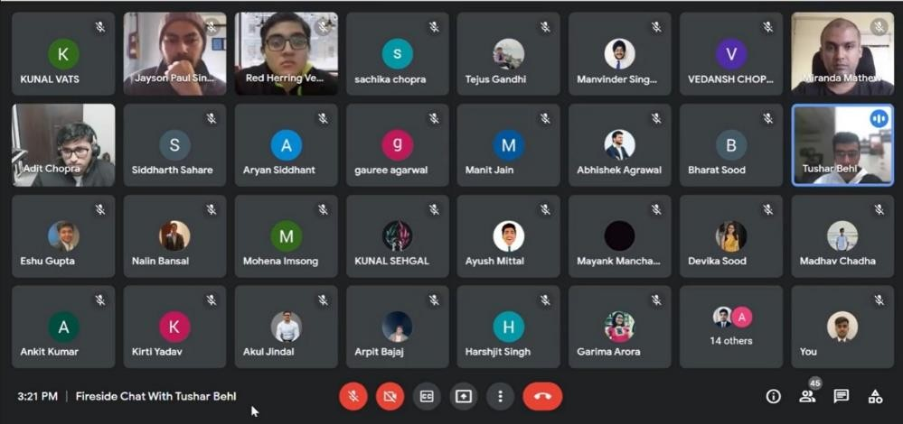

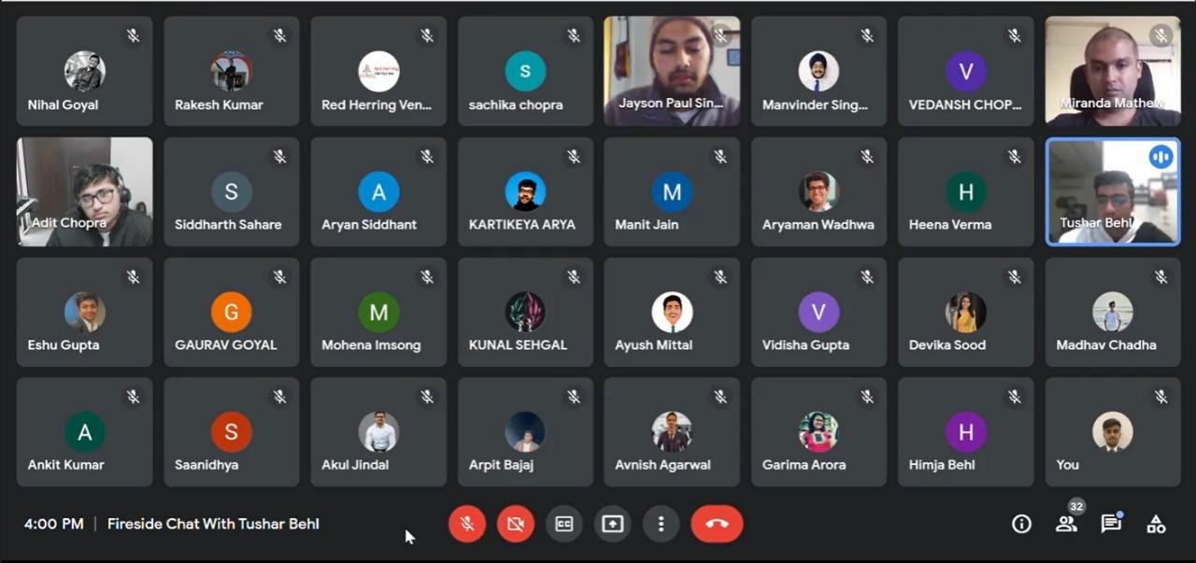

Attendance: 35

Feedback:
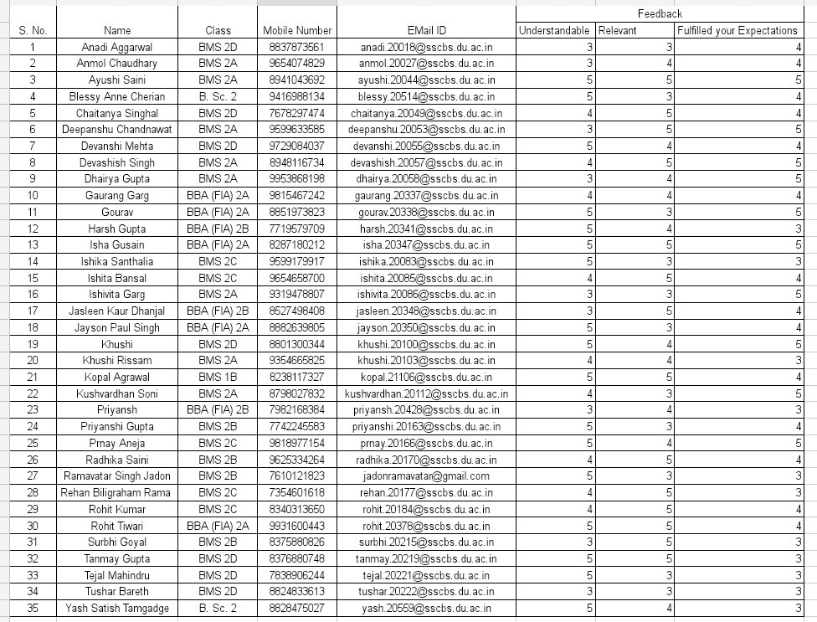

Recording Link:
https://youtu.be/AK-OY-pXvLc

