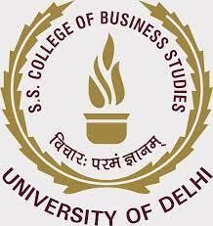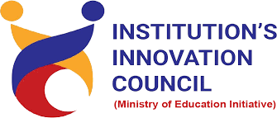

Activity Report

Title of event: Design Thinking For Start-Up Success Workshop
Date of Session: 24 February, 2022 Time: 1530 hrs onwards Speaker(s): Ms. Ramya Mahendran

Poster/Banner/Brochure of the event:
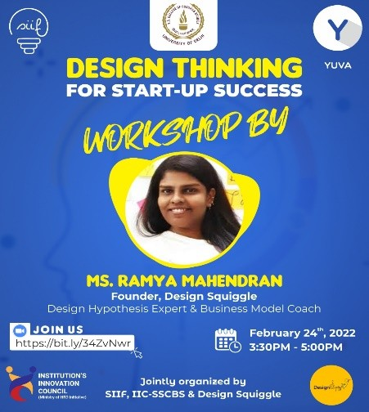

Activity Summary

- Title of the event: Design Thinking For Start-Up Success Workshop
- Date and Day of event: 24 February, 2022 (Thursday)
- Objective of the event: To foster innovative ideas and design thinking amongst the students of SSCBS
- Speakers Details (brief bio-data):
Ramya Mahendran is the founder of Design Squiggle, a company that is dedicated to bring affordable best in class innovation services and consulting to India based institutions and organisations. Ms. Ramya is a design thinking expert and business model coach who

envisions new offerings, creates contextual consulting services and delivers the best of workshops and strategic coaching to students, young entrepreneurs and positively contribute to set up an innovative culture at organisation of all shapes and sizes. Before Design Squiggle, Ms. Ramya worked for more than 7 years with the Cognizant Innovation Group and Cognizant Accelerator as an Innovation Consultant and Coach and worked with the aspiring intrapreneurs and help them shape their ideas into viable business models. Prior to working as an innovation consultant, she also contributed to the growth of Cognizant group in Programmer Analysts capacity for almost two years. Ms. Ramya is an MBA in Finance and HR from Satyabhama University as well as a B.Ed. in Computer Engineering. Ms. Ramya works with student entrepreneurs to build their business ideas into successful business models. She works with some of Tamil Nadu’s leading Technology and Business Incubators, Institution Innovation Councils and Entrepreneurship Cells. She specializes in setting up innovation strategy, opportunity identification, large scale ideation campaigns and facilitating rapid prototyping events like design service jams and hackathons, organizing large-scale Innovation summits and global idea crowd-sourcing events.

- Participants details: Students and teachers from Shaheed Sukhdev College of Business Studies (University of Delhi) participated in this event.
- Key outcome of the activity: Participants learnt about the concept of design thinking and how we can apply the same in our daily lives. Entrepreneurially inclined participants learnt about how to use design thinking during product design and how to concentrate on the needs of the potential customers.

Event Photos:
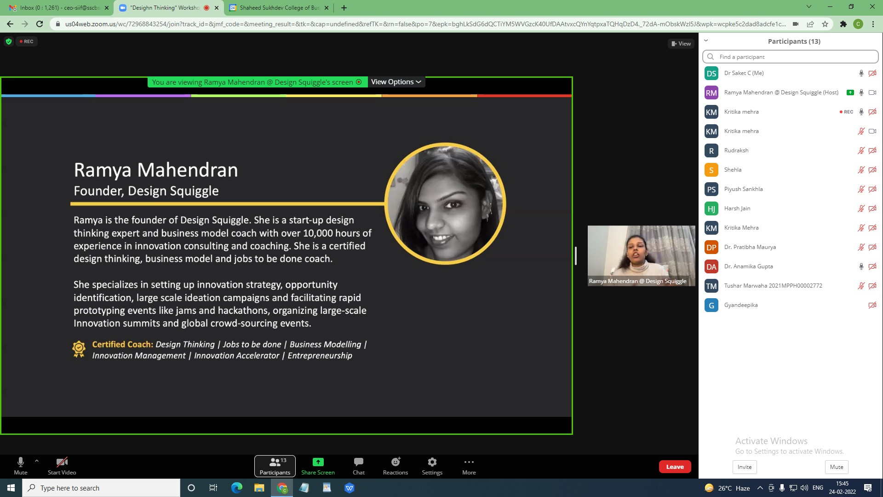

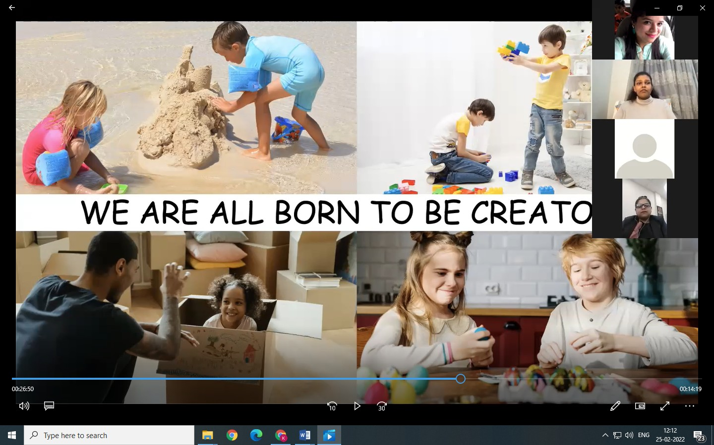

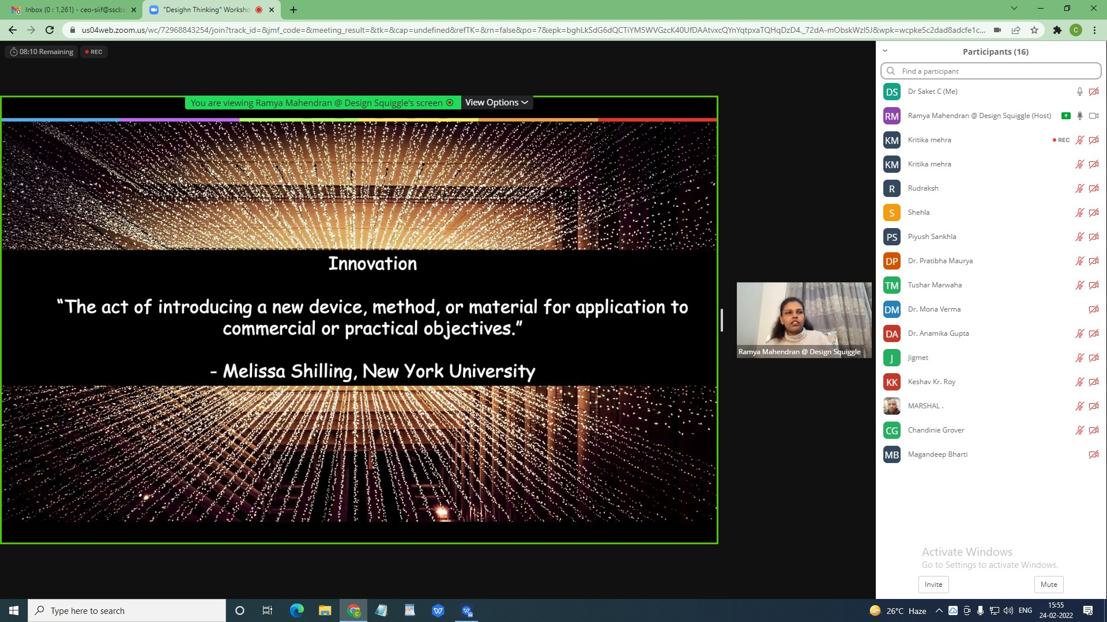

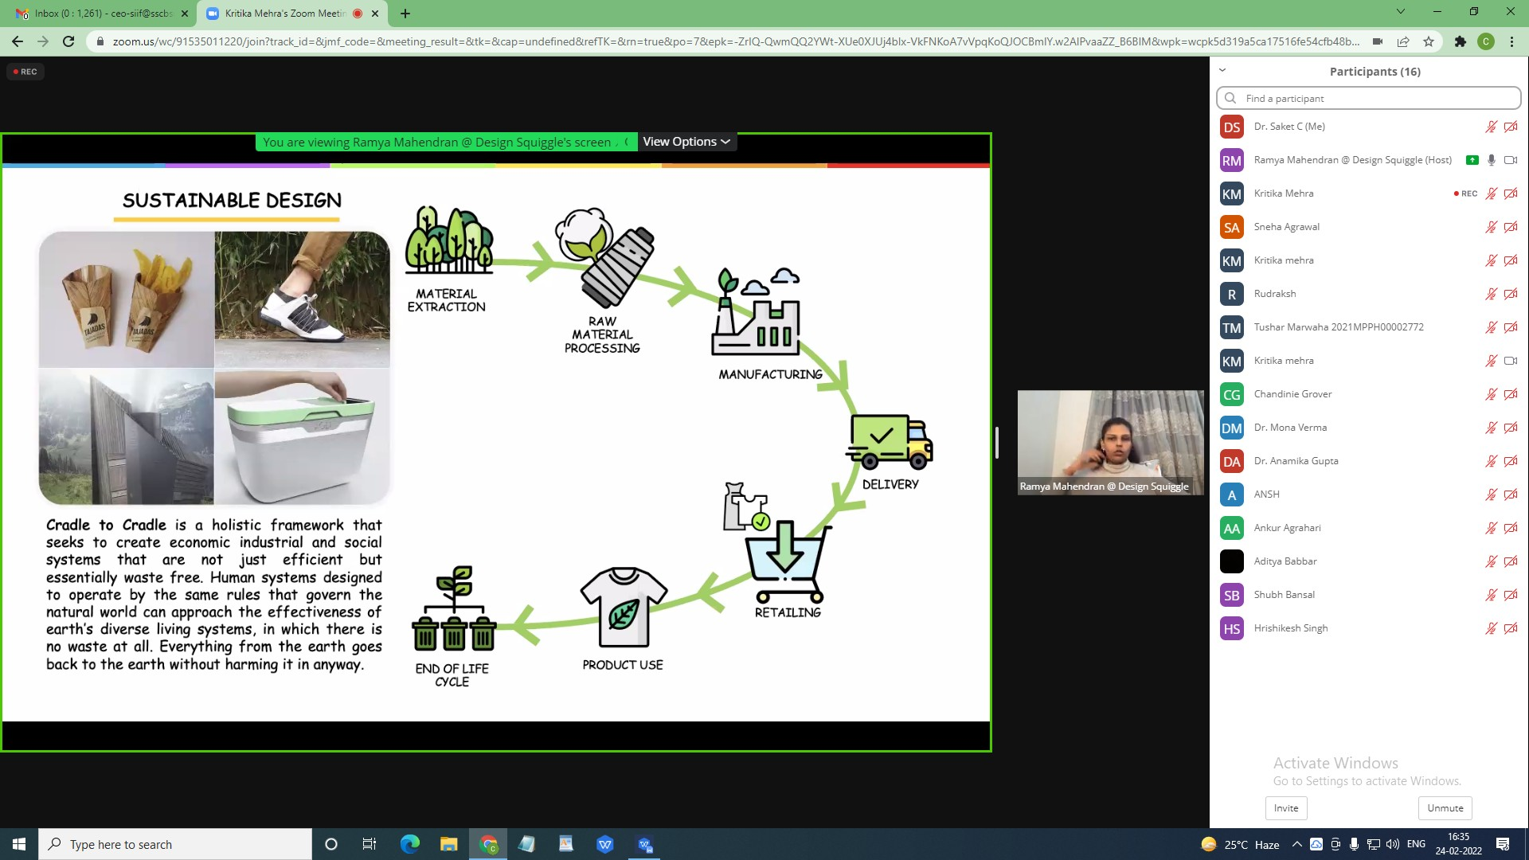

Attendance:

Student Participants
(all students are from SSCBS)
Name of the Participant | Class
Magandeep Bharti | BBA(FIA) 1A
Nishtha Goel | Bba fia 1b
Isha Dalmia | B.Sc. (H) Computer Science 1
Sneha Agrawal | Bsc 1
Harsh Jain | BMS 1-B
Devajay Kapur | Bms-1A
Chandinie Grover | BMS 2nd year
Ansh Magon | BMS 2nd year
Vishesh Gupta | BMS
Priyanshu | BMS
Saumya Gupta | BMS

Faculty/Non-Teaching/Others Participants
(All participants are from SSCBS)
Name of the Participant | Affiliation | Designation
Anamika Gupta | Computer Science | Associate Professor
Dr. Mona Verma | BMS | Assistant Professor
Mr. Tushar Marwaha | BMS | Assistant Professor
Ms. Anusha Goel | BMS | Assistant Professor
Mr. Jigmet Wangdus | BMS | Assistant Professor

Dr. Saket Chattopadhyay | SIIF | CEO, SIIF
Ms. Kritika Mehra | SIF | Intern, SIIF

External Member
Nil

Feedback from all participants:
From Students
Name of the Participant | Feedback
Anamika Gupta | Hope to have a great session
Magandeep Bharti | This is amazing opportunity I have , and I'm going to attend  this session
Sneha Agrawal | Looking forward to have a great workshop.
Harsh Jain | Very interactive and insightful
Devajay Kapur | Excellent

Link of recording on Youtube Channel:
Link - https://youtu.be/ODD5HF-0jeg, https://youtu.be/H-1ZJNW4gBM

Media Coverage (if any)
1/1 Facebook https://www.facebook.com/1187866417927888/posts/4674032282644600/?sfnsn=wiwspmo
