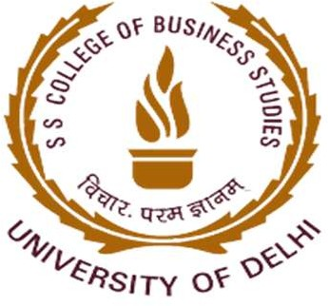

Activity Report
Title of Event: DESIGN THINKING, CRITICAL THINKING AND INNOVATION DESIGN
Date of Session: 15 February 2022 (Tuesday)
Time: 11:00 A.M.
Teacher Coordinator: Ms. Anusha Goel Student Coordinator: Divyanshi, Blessy Speaker(s): Mr. Arjun Panchal

Poster/Banner/Brochure of the event:
Instagram poster link: https://www.instagram.com/p/CZ3n42-swW5/?utm_medium=copy_link
Twitter poster link: https://twitter.com/iicsscbsdu/status/1492400889964863495?t=X8n3OWH1XRrGTSt- edyLxQ&s=19
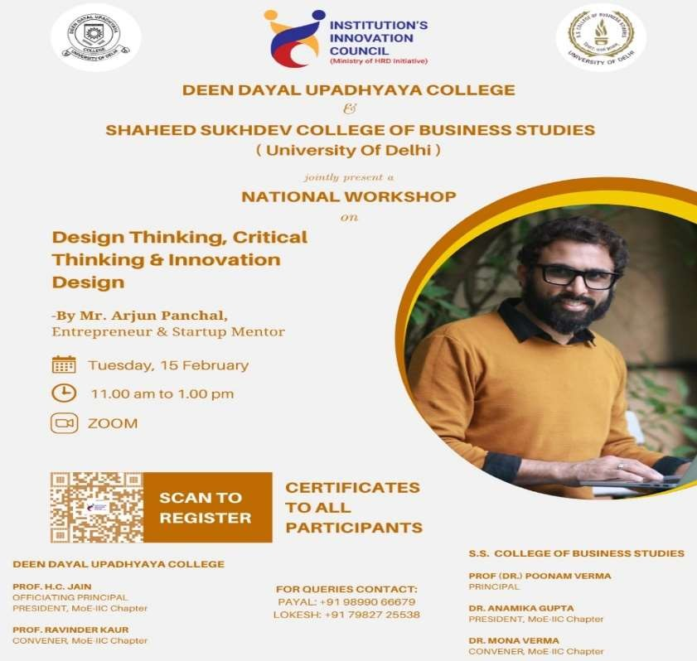

Activity Summary

BRIEF BIO OF SPEAKER

Speaker Name: Mr. Arjun Panchal

Arjun Panchal is an entrepreneur, professor, author and public speaker. He is a start-up mentor at SIBM, Pune, IIT Bombay and Innovation Cell, Ministry of Education. He has mentored 500+ entrepreneurs and assessed 2500+ B Plans in the span of the last 5 years.

OBJECTIVE OF THE EVENT
The session focused on three main phases of design thinking: Empathy, Ideation and Prototyping. The speaker highlighted the importance of understanding the problem that user faces and empathizing with them.

Topics covered by Mr. Arjun Panchal in the session:

- 5 elements of Design Thinking
- Design Thinking Process
- Problem identification techniques/tools
- Empathy map template
- Customer journey map
- Need of social media
- Ideation techniques/tools
- Prototype techniques/tools

KEY OUTCOMES OF THE EVENT
Mr. Arjun Panchal is a versatile speaker and that's quite evident from his ability to keep the group engaged throughout the workshop. The session covered how design thinking is used to make decisions based on what customers really want instead of relying only on historical data or making risky bets based on instinct instead of evidence. He focused on how design thinking brings together what is desirable from a human point of view with what is technologically feasible and economically viable. Overall, it was an informative and impactful session for the participants who intend to take their first step towards innovation.

PHOTOGRAPHS
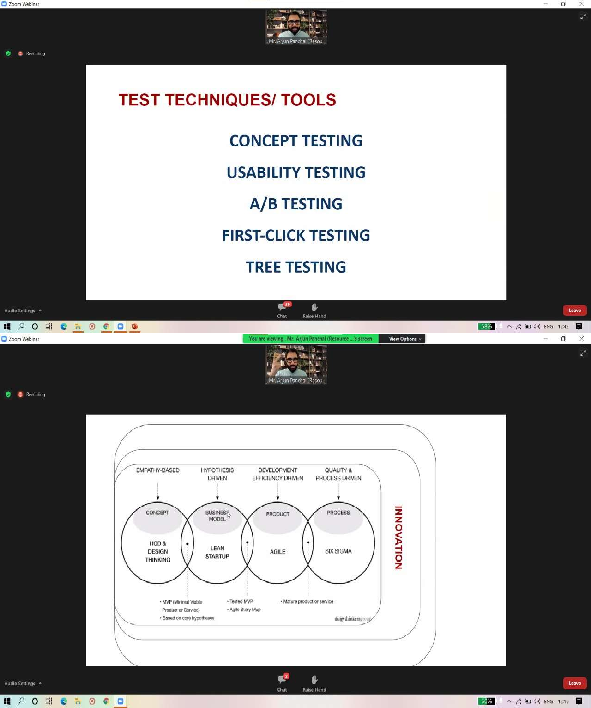

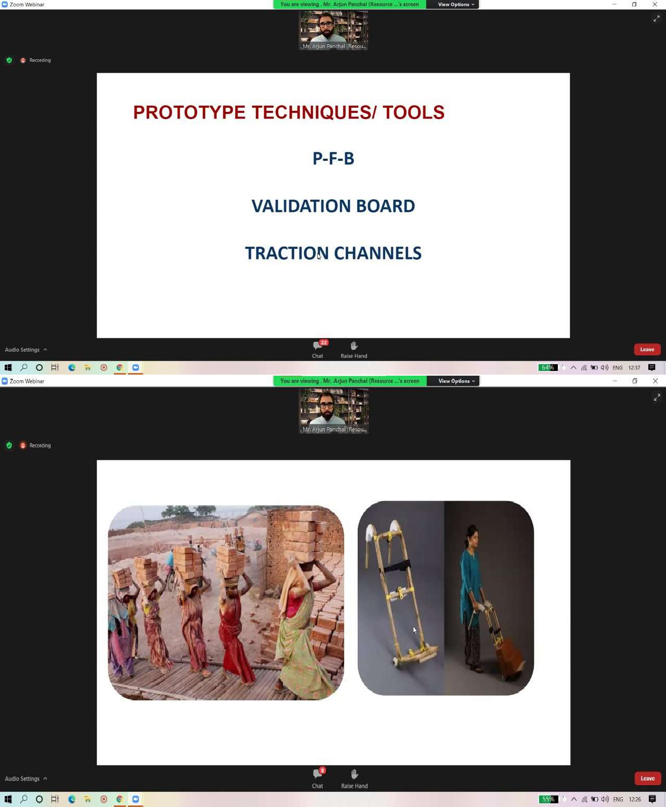

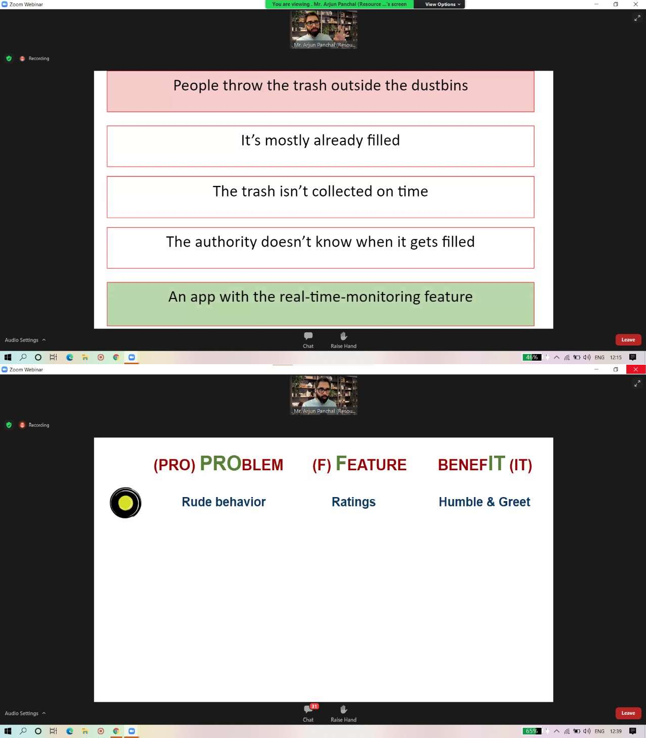

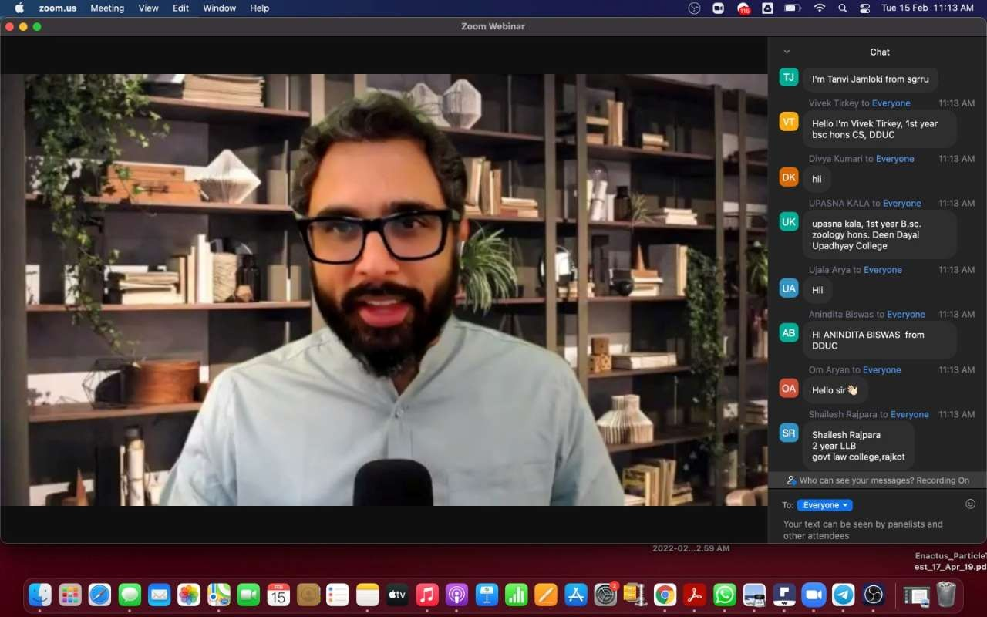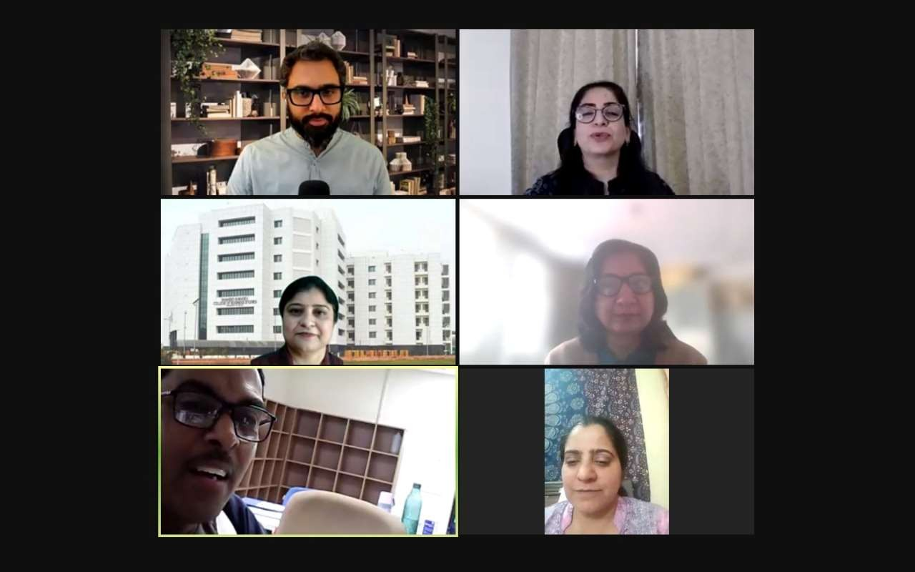

Attendance: 230
Student Participants: 218

Shruti | Abhijya Shrivastava | Abinayapriya.A
Aanchal Kalbalia | Sparsh Garg | Divya
Aarti | Vikrant Yadav | HEMANT KUMAR
Alankrit Vikram Singh | Kritika Dhawan | SANJANA
Amarjeet Jena | Khushi Singh | Ekta Kushwaha
Amit Kumar Nishad | Renu Yadav | Kumar Keshav
Ananta Dutta Choudhury | Nikhil Yadav | Devi Archana Rana
Anirban Bhattacharjee | Harsh Vardhan | MEGHA JHA
Anirban Bhattacharjee | A.S.DIVYA | Yogita
Arnav Agrawal | Vibha Mishra | Govind
Ayush Gupta | Tanya | Rohit Shekhar
B.Senthil Pandi | Vikas Kumar | C.Nandhakumar
Bushra Tasneem | Ravinder Singh | Mukul Bisht
Diksha Singh | Sahil Yadav | Harshita Mongia
Garv Jain | Prince Khatti | Kishan Rajora
Garvit Verma | Saurav Ganguly | Kanika
Gautam Meena | Gaurav Rai | D.Murugan
Harshil Rana | Yashika Yadav | Ujala
Harshita Sharma | Ashutosh | UMAR AZAM
Harshita Syunary | Akshit Goel | Vilvanathan A
Ishika Namdev | Fernando Sankhil Lamkang | Skand Singh Chauhan
Ishita Singh | Hritik | Priyanka Mehta
Ishu Garg | Muhammad Haron | Parvesh
Kabir Verma | Shivansh Shukla | Om Aryan
Kiran Solanki | Idhaant Bisht | Prakash Biswakarma
M SINDHUJA | Nang Wecita Namchoom | Vivek Tirkey
Manan Jain | Divya Kumari | Charu
Manish Singh Maurya | ANUSHKA | Piyush Sankhla
Mayank | Vaibhav Dubey | Smaran Das
Mayank Rawal | Shivani | Gurleen Kaur
Md Fariduddin Rafique | DIVYA SINGH | Dasari Meghana
Milan Singh | Arin Sharma | Nishant Mohan
Mohammed Sandeed Farooq | Muhammed Aqeel | B.Senthil Pandi
Muneeswari.G | Drishti Singh | Shefali Bisht
Neeraj | Khushi | Muskan
NISTHA MALIK | Sanket Tewatia | Harshita Mahori
Nitish Kumar Dungdung | Aaryan Verma | Rishabh Sharma
Palak Khanna | Aniket | Anurag Toppo
Palzes Angmo | Ponraj.K | Sumit Kumar
Pankaj | Vivek Kumar | Prakash Biswakarma
Priyanka Mehta | Upasna Kala | Jiya Kumari
Pushpam Kumari | Sparsh Goel | Shakshi Marko
Pushpendra | Dimple | Tanuja Jantwal

Raja Pandi. P | OM PRAKASH KUMAR | C.Nandhakumar
Rajan Kumar Jha | Nang Wecita Namchoom | SONAL DAHIYA
Rishabh Kumar | Nandini Kiroula | Neha Kriplani
S.Kalidass | ANINDITA BISWAS | Harshita Shrivastava
S.Raja Deepa | Ishita Singh | Mahima Dua
Sakshi | UMAR AZAM | Shashwat Kumar
Sanju Jangir | Ayush Karn | Sudarshan Bhardwaj
Santhosh.S | A.M.Mohamed Rasik | Anuska Banerjee
Santhosh.S | Priyanshi Jain | Bhavana Kashyap
Sathish Raj K | Ibrahim Ghaffar | Durvesh Marwal
Sharat Singh | Koshal Rajora | Aviral Pratap Singh Chawda
Sharmila Devi.M | Ishika | V .Thirumurugan
Shashank Singh | Sanoof K | Anupam Jena
Sonalika Arneja | Ankita Goswami | Surya N
Suraj Singh | Ekansh Gupta | Pankaj Prajapati
Tanvi Jamloki | Vivek Vishwakarma | Ananya C
Tanya Ahlawat | Monika Baghel | N.Rathimalar
VARNIKA SINGHAL | Khushi | Neeraj
Varsha | Siddhant | Gyandeepika
Vatsal Singh | Lovneesh Kumar | Parul
Vedika Upadhyay | Divya Kumari | V.Thirumurugan
Shruti | Abhijya Shrivastava | Abinayapriya.A
Aanchal Kalbalia | Sparsh Garg | Divya
Aarti | Vikrant Yadav | HEMANT KUMAR
Alankrit Vikram Singh | Kritika Dhawan | SANJANA
Amarjeet Jena | Khushi Singh | Ekta Kushwaha
Amit Kumar Nishad | Renu Yadav | Kumar Keshav
Ananta Dutta Choudhury | Nikhil Yadav | Devi Archana Rana
Anirban Bhattacharjee | Harsh Vardhan | MEGHA JHA
Anirban Bhattacharjee | A.S.DIVYA | Yogita
Arnav Agrawal | Vibha Mishra | Govind
Ayush Gupta | Tanya | Rohit Shekhar
B.Senthil Pandi | Vikas Kumar | C.Nandhakumar
Bushra Tasneem | Ravinder Singh | Mukul Bisht
Diksha Singh | Sahil Yadav | Harshita Mongia
Garv Jain | Prince Khatti | Kishan Rajora
Garvit Verma | Saurav Ganguly | Kanika
Gautam Meena | Gaurav Rai | D.Murugan
Harshil Rana | Yashika Yadav | Ujala
Harshita Sharma | Ashutosh | UMAR AZAM
Harshita Syunary | Akshit Goel | Vilvanathan A
Ishika Namdev | Fernando Sankhil Lamkang | Skand Singh Chauhan
Ishita Singh | Hritik | Priyanka Mehta
Ishu Garg | Muhammad Haron | Parvesh
Kabir Verma | Shivansh Shukla | Om Aryan
Kiran Solanki | Idhaant Bisht | Prakash Biswakarma

M SINDHUJA | Nang Wecita Namchoom | Vivek Tirkey
Manan Jain | Divya Kumari | Charu
Manish Singh Maurya | ANUSHKA | Piyush Sankhla
Mayank | Vaibhav Dubey | Smaran Das
Mayank Rawal | Shivani | Gurleen Kaur
Md Fariduddin Rafique | DIVYA SINGH | Dasari Meghana
Milan Singh | Arin Sharma | Nishant Mohan
Mohammed Sandeed Farooq | Muhammed Aqeel | B.Senthil Pandi
Muneeswari.G | Drishti Singh | Shefali Bisht
Neeraj | Khushi | Muskan
NISTHA MALIK | Sanket Tewatia | Harshita Mahori
Nitish Kumar Dungdung | Aaryan Verma | Rishabh Sharma
Palak Khanna | Aniket | Anurag Toppo
Palzes Angmo | Ponraj.K | Sumit Kumar
Pankaj | Vivek Kumar | Prakash Biswakarma
Priyanka Mehta | Upasna Kala | Jiya Kumari
Pushpam Kumari | Sparsh Goel | Shakshi Marko
Pushpendra | Dimple | Tanuja Jantwal
Raja Pandi. P | OM PRAKASH KUMAR | C.Nandhakumar
Rajan Kumar Jha | Nang Wecita Namchoom | SONAL DAHIYA
Rishabh Kumar | Nandini Kiroula | Neha Kriplani
S.Kalidass | ANINDITA BISWAS | Harshita Shrivastava
S.Raja Deepa | Ishita Singh | Mahima Dua
Sakshi | UMAR AZAM | Shashwat Kumar
Sanju Jangir | Ayush Karn | Sudarshan Bhardwaj
Santhosh.S | A.M.Mohamed Rasik | Anuska Banerjee
Santhosh.S | Priyanshi Jain | Bhavana Kashyap
Sathish Raj K | Ibrahim Ghaffar | Durvesh Marwal
Sharat Singh | Koshal Rajora | Aviral Pratap Singh Chawda
Sharmila Devi.M | Ishika | V .Thirumurugan
Shashank Singh | Sanoof K | Anupam Jena
Sonalika Arneja | Ankita Goswami | Surya N
Suraj Singh | Ekansh Gupta | Pankaj Prajapati
Tanvi Jamloki | Vivek Vishwakarma | Ananya C
Tanya Ahlawat | Monika Baghel | N.Rathimalar
VARNIKA SINGHAL | Khushi | Neeraj
Varsha | Siddhant | Gyandeepika
Vatsal Singh | Lovneesh Kumar | Parul
Vedika Upadhyay | Divya Kumari | V.Thirumurugan

Faculty/Non-Teaching/Others Participants: 12

1. Dr. Meghna Aggarwal
2. Joseph Selva Kumar A
3. Ms. Anu Preveen
4. Dr. Pramod Kumar
5. Dr. Rinki Sharma
6. Nidhi Kesari
7. Dr. Pratibha
8. Dr. A. Praveena
9. Dr. Anamika Gupta
10. Dr. Anuja soni
11. Dr. Sujata Khatri
12. Anubhuti Yadav

Feedback from all participants:

Name | Are you a | Institution / College | Cource | Year | How satisf ied you were with the event  ? | How relevant and helpful do you think it was for you? | Which topics would you like Us to consider to conduct in future workshops and training programs? | Any overall feedback  for the event?
S.Raja Deepa | Stud ent | Vaigai college of Engineering | BE | Secon d year | 5 | Very nice and informative | About comercial | Very use full event
Diksha Singh | Stud ent | Deen Dayal Upadhyaya College, DU | Bsc Hons Electronics | Secon d year | 4 | Very helpful | About career counseling | No comments
Anirban Bhattachar jee | Stud ent | Deen Dayal Upadhyaya | BSc (H)  Computer Science | 1st | 5 | Very Helpful | Metaverse | Wonderful
Rajan Kumar Jha | Stud ent | Dduc | Electronics Hons | 2nd | 4 | Good | AI | )[ß good
Ishita Singh | Stud ent | Deen Dayal Upadhyay College | BSc (hons) Zoology | First year | 4 | Very helpful | Employmen t | Very informativ e event
Sanju jangir | Stud ent | Deen dayal  upadhyaya college | B.A.Prog | 2nd year | 5 | It was very helpful and  very relevant too | No suggestions | It clear many things , very well  session .
Palak khanna | Stud ent | Deen Dayal Upadhyay college | Bsc electronic | 2021 | 5 | Its very useful | . | Its very productive event

Shruti | Stud ent | Deen Dayal Upadhyaya College | B.a. program | 1st | 4 | It was great | Start ups | Overall amazing
Priyanka Mehta | Stud ent | Deen dayal Upadhyaya College | Bsc Hons Zoology | 1st year | 5 | It was awesome and informative | Environmen t related issues | It was great! Keep up the good work.  Kudos to entire team for making event a huge success.
NISTHA MALIK | Stud ent | DEEN DAYAL UPADHYAY A | Bsc.ZOOLOG Y HONOURS | 1st year | 5 | IT WAS REALLY VERY HELPFUL | CRITICAL THINKING | We want an offline session with you guys Asap  ....
Bushra Tasneem | Stud ent | Maulana Mazharul Haque Arabic and Persian University | Bsc zoology | 2020-  2023 | 5 | I learned many new things | Anything | It was such an interesting workshop thankyou
Pushpam Kumari | Stud ent | Deen Dayal Upadhyay college | B.com | 2nd year | 5 | It was such a fantastic session | Design thinking | Wonderful session
Aarti | Stud ent | Shaheed Sukhdev College of Buisness Studies | Bsc.(H)  Computer Science | 2nd | 5 | It was really helpful. | Similar topics | The session was amazing.
Amit Kumar Nishad | Stud ent | Deen Dayal Upadhayay a Collage | BSC.  Computer Science | 1st year | 5 | . | . | .
Milan Singh | Stud ent | Deen Dayal Upadhyay college University of Delhi | B.Sc(Hons) Electronics | 1 | 5 | Yes it's for me | Nothing | No
Nitish kumar dungdung | Stud ent | Deen dayal Upadhyay college | Bsc electronic | 2022 | 5 | Very helpful | Internships works | Good
Sonalika Arneja | Stud ent | Shaheed Sukhdev College of Business Studies | B.Sc. (H)  Computer Science | 2 | 5 | Very helpful and relevant | Marketing and Entreprene urship | Very informativ e
M SINDHUJA | Stud ent | Shaheed Sukhdev College of Business Studies | BMS | 1 | 5 | The session was really helpful in understandi ng how | Progess of a startup | Interesting and amazing

 |  |  |  |  |  | important critical thinking is and empathy is in an entreprene urship journey
Pushpendr a | Stud ent | Shaheed Sukhdev College of business studies | BBA(FIA) | 3RD YEAR | 5 | Its was amazing session | D.E.S.I.N.G | Aslo give permissio n to us use microphon e
Arnav Agrawal | Stud ent | SSCBS | BMS | 3rd | 4 | good | - | -
Ishika Namdev | Stud ent | Deen Dayal Upadhyaya College | B.Sc. Zoology honours | 1st | 5 | Though I am a bio student, but I am a bit interested in doing manageme nt like course thi  s session has given me a more wider horizon | MBA after biology.. good or bad | Nice event
Ayush Gupta | Stud ent | Shaheed Sukhdev College of Business Studies, University of Delhi | B.Sc (Hons) CS | 2023,  2nd year | 5 | Very helpful session | Session on various sb topics in Entreprene urship and startups | Very helpful session
varsha | Stud ent | Swami Shraddhana nd collage | B.com | 1st | 4 | Mostly heplful | Empathysis | everything goof
Suraj Singh | Stud ent | Shaheed Shukhdev College of Business Studies | BBA FIA | 1st year | 4 | It was amazing | Recent business developme nts | Good
Mayank | Stud ent | Deen Dayal Upadhyay College,Uni versity of Delhi | BSc.(H)  Mathematics | Secon d | 4 | This webinar really reprogram med my mind for "How to  think" | How to analyse anything be it understandi ng life problems  ,people behaviour etc | This webinar is so informativ e and  learning at all

Anirban Bhattachar jee | Stud ent | Deen Dayal Upadhyaya | BSc (H)  Computer Science | 1st Year | 5 | Very Helpful | Robotics | Wonderful
Muneeswa ri.G | Stud ent | Vaigai college of Engineering | BE | Secon d year | 5 | Yes | Phone | Very use full
Alankrit vikram singh | Stud ent | Deen dayal upadhyaya college | Bsc electronics | 1 | 4 | Excellent | Needs of social media | Amazing
Garvit Verma | Stud ent | Shaheed Sukhdev College of Business Studies | BMS | 3rd | 5 | The event was very well event and relatable being in the field of business manageme nt and the topics were very accurate and to the  point. | The topics in the gift current 12 winner very relevant but other topics should be added which relate to the changes in business in covid times and as we have seen that many businesses have gone down we can talk about the reasons behind them. | A great webinar to attend, the speaker was very confident and understan dable and the topics were to the point and relatable. A great experienc e
Mayank Rawal | Stud ent | Deen Dayal Upadhyay College | Bsc( hons  )Computer science | 1 | 5 | It was absolutely amazing lecture. I wish i could have more like these in upcoming days. ᆍᆎ | on how to be different from other. How to to the critical thinking in the way no one else could. | Amazing. Loved the way Arjun sir explains. Worth it  ✨ᆎᆍ
Ishita Singh | Stud ent | Deen Dayal Upadhyay College | BSc (hons) Zoology | First year | 4 | Very helpful | Self confidence | Great event
sahil yadav | Stud ent | shaheed sukhdev college of business studies | BBAFIA | 1 | 4 | VERY HELPFULL | SEO | NO
Harsh Vardhan | Stud ent | Deen Dayal Upadhyay College | B.Sc.  Electronics | 1st Year | 5 | It was very helpful to me to learn something new. | Crypto currency | It was amazing

Nang Wecita Namchoo m | Stud ent | Deen Dayal Upadhayay a college | Bsc Hons Zoology | 1st year | 4 | I got to learn many new things from this workshop | Mental health within various cultures and  identities | Amazing
hritik | Stud ent | shaheed sukhdev college of business studies | BMS | 1st | 5 | it gave me clarity on how an entreprene ur must think | market research | it was really nice
Ayush Karn | Stud ent | Deen Dayal Upadhyaya College | BSc (hons) Computer Science | 1st | 5 | Very much! | Roadmap to software developme nt | It was a great webinar.
Aniket | Stud ent | Deen Dayal Upadhyaya college | Bsc Electronics Hons. | 2nd | 5 |  |  | Excellent workshop with so much powerful interaction
Abhijya Shrivastav a | Stud ent | Deen Dayal Upadhyaya College ( University of Delhi) | BSc. Zoology honours | Semes ter I ( 1st year) | 5 | Very helpful | As you wish | Keep it up
Upasna Kala | Stud ent | Deen Dayal Upadhyay College | B sc.zoology hons. | 1st year | 5 | It was very helpful | Internships | Informativ e
Sanket tewatia | Stud ent | Deen dayal upadhyay college, delhi | BMS | 1st | 4 | It was a good session and very helpful as per the future needs and plans | Nfts digital currencies | Great session
Ravinder Singh | Stud ent | Shaheed Sukhdev college of business studies | Bms | 3 | 3 | I became aware about critical thinking and design thinking through this session which would enhance my way of thinking.  Absolutely loved it. | Guesstimat es | Very enlighteni ng

Sparsh Goel | Stud ent | Shaheed Sukhdev College of Business Studies | BBA-FIA | 1st year | 5 | It was one of the most engaging and helpful session. It changed my perspective towards my life and look to solve real- life problems. | Workshop on Venture Capital and funding | Highly informativ e session.
Vikrant Yadav | Stud ent | Deen Dayal Upadhyay collage | Bsc(hon) electronics | 2nd | 4 | I help to build 5he idea | How we do markiting | It's good  )ß[
Renu yadav | Stud ent | Deen Dayal upadhyaya college | B. Com programme. | 2 year | 5 | Excellent. | Waste product use. | Wonderful
Arin Sharma | Stud ent | Deen Dayal Upadhyay College | Bsc.hons.elec tronics | 1st year | 5 | Its very amazing session it helpful to manage our life and save our environmen t | We consider to conduct more meeting in future on such like these topics | Its very amazing session for us and Take more sessions
Aaryan Verma | Stud ent | Deen Dayal Upadhyaya College | Bsc. electronics(ho ns) | 1st year | 5 | Great | any | 100
Ankita Goswami | Stud ent | Deen Dayal Upadhyaya College | B. Sc. Hons. Zoology | 2021-  22 | 5 | It was a learning experience | New career options that we can opt for (for us to be informed) | The session was very interesting and interactive  .
Nang Wecita Namchoo m | Stud ent | Deen Dayal Upadhayay a college | Bsc Hons Zoology | 1st year | 4 | I got to learn some interesting facts from this workshop | Mental health within various cultures and identities | Amazing
Dimple | Stud ent | Shaheed Sukhdev college of business studies | Bsc Hons computer science | 2 | 4 | Learnt how actually to think about the problem and then how to solve them | UX Design | Very interactive session
Vibha Mishra | Stud ent | DDU | B.com | 1st | 5 | It was soo... Help ful for Every one.. | Environmen tal problems..a nd . , | It was.. amazing.. thanku

 |  |  |  |  |  |  | Careers opportunity.  . related programs.. | soo much sir..
Fernando Sankhil Lamkang | Stud ent | SSCBS | BMS | 1st year | 3 | Was very helpful | Social media | Amazing
Tanya | Stud ent | Shaheed Sukhdev college of business studies | BBA  (Financial investment analysis) | 1st | 4 | Insightful | . | Good one
Siddhant | Stud ent | Shaheed Sukhdev College Of Business Studies | BSc.(H)  Computer Science | 2nd | 5 | So interesting with interactive audience, perspective changing webinar! | Stock Markets from starting | It was awesome.
Ekansh Gupta | Stud ent | Shaheed Sukhdev College of Business Studies | BMS | First | 5 | Very helpful | How to raise funds? | Very good.. Insightful!
Vaibhav Dubey | Stud ent | Deen Dayal Upadhyaya College | Bsc.(hons.)C S | 1 | 4 | Very much | More related to psychology | Really helpful
A.S.DIVYA | Stud ent | Vaigai college of engineering | B.E(ECE) | 3rd year | 4 | Yes | About business manageme nt | It is very useful for us...thank you very much
Drishti Singh | Stud ent | Deen Dayal Upadhyaya College | Bsc Hons computer science | 1 | 5 | I think it was a topic that everyone would find relevant and personally it was great as I got to know a lot of new stuff which will definitely help me in my life. | Maybe topics related to communicat ion and psychology. | It was a fun and rewarding experienc e and I enjoyed it a lot.
Kritika Dhawan | Stud ent | DDU  College | Bsc CS Hons | 1st year | 5 | The webinar was amazing. The explanation s regarding innovations | How to manage with the struggles in the process of being a successful | Interesting webinar and the webinar was very energetic.

 |  |  |  |  |  | and everything was amazing. I found it interesting and want to know more. | entrepreneu r?
Saurav Ganguly | Stud ent | Shaheed Sukhdev College of Business Studies | B.Sc(Hons) CS | 2nd | 4 | Beneficial for my future career in life. | About how to save our environmen t from the current status of rising  pollution . | Carry on these sessions. Really beneficial for boosting the minds of  students like us.
Shivani | Stud ent | Deen Dayal Upadhyaya | BA  programme | I have done my gradua tion | 4 | It relevant my future if I start a business on that time helpfull innovative  idea | Digital marketing | It was nice it helps full for everyone
Mahima Dua | Stud ent | Shahed sukhdev college of business studies | B.sc(hons) Computer science | 2nd | 4 | Provides a vision to think and grow | Artificial intelligence | Very interesting event
Harshita Mongia | Stud ent | Shaheed Sukhdev College of Business Studies | BMS | 3 | 5 | It was a very insightful session, it helped me learn a lot of things which are useful in our day-to- day life. | Workshops on Personality Developme nt | it was a great session with good quality content
MEGHA JHA | Stud ent | Deen Dayal Upadhyaya College | B.COM | Secon d | 4 | Yes it was really relevant and helpful for me. | Skills and developme nt program | Good
SONAL DAHIYA | Stud ent | DEEN DAYAL UPADHYAY A COLLEGE , DELHI UNIVERSIT Y | B.Sc. MATHEMATI CS (HONS.) | 2021-  24 | 5 | it was too good and interactive | smthg. related to tech. | 10/10 v◆:

Priyanka Mehta | Stud ent | Deen Dayal Upadhyaya College, Delhi Universty | Bsc Hons Zoology | First Year | 5 | Amazing webinar. It was very interesting and knoledgeab  le. | Personality developme nt | Wonderful event.  Learned a lot.
Sudarshan Bhardwaj | Stud ent | Deen Dayal Upadhyaya College | Bsc(hons) electronics | 2021-  24 | 4 | I learned a lot about Enterprene urship and thinking | Innovation techniques | Awesome
Anurag Toppo | Stud ent | Shaheed Sukhdev College of business studies | Bsc Computer science (Hons) | 2 | 4 | Very helpful get to know about innovation and  presentatio n skills | Computer science related | No
Abinayapri ya.A | Stud ent | Vaigai college of engineering | B.E/ECE | 2019-  2023 | 5 | It is very useful | Artificial intelligence related workshops | It's very useful
Jiya kumari | Stud ent | Deen Dayal Upadhyay college | Bsc Zoology honours | First | 5 | It's was nice and very Ben | . | I got to know many new things about which I was not aware  before
Harshita Mahori | Stud ent | Shaheed Sukhdev College of Business Studies | B.Sc. (hons) CS | 2 | 5 | Pretty much helpful | Entreprene urship | Very interesting and good session
Mukul Bisht | Stud ent | SSCBS | BSc Cs(Hons) | 2 | 4 | The event provided a great opportunity to get an exposure of the real world scenarios out there. | Data Science and Entreprene urship | Great experienc e
Shakshi marko | Stud ent | Deendayal Upadhyaya college | B.Sc.(h)  electronics | 3 yr | 4 | Making understandi ng with object gadgets | Marketing | Awesome session
HEMANT KUMAR | Stud ent | DEEN DAYAL UPADHYAY A | B.Sc.(HONO URS) COMPUTER SCIENCE | 2021 | 5 | This session was really knowledge able related | would like to learn more about future technologie | understoo d everything and simple for

 |  |  |  |  |  | to thinking skills, the critical thinking skills and ideation tool part was really good. | s and emerging industries and scopes in them. | anyone to learn from.
Kumar Keshav | Stud ent | Saheed Sukhdev College of Business Studies | BMS | 2021-  24 | 4 | The session was exactly how I expected!  fµ˛๞ | Leadership and Interperson al Skills | The event was quite insightful and fruitful!
Nishant Mohan | Stud ent | Shaheed Sukhdev College of Business Studies, University of Delhi | BMS MARKETING | Third | 5 | Really insightful | How to build a brand | Great session and really insightful
Rishabh Sharma | Stud ent | SSCBS | B.Sc.(H)  Computer Science | 2023 | 5 | A lot | Monetizatio n of startups | Really intriguing
Surya n | Stud ent | Vaigai college of engineering | Ece | 3 | 5 | Useful to my subject | Program | Nice
Vivek Tirkey | Stud ent | Deen Dayal Upadhyay College | Bsc. Hons. Computer Science | 2021-  24 | 5 | Totally relevant to aspiring start entreprene urs. | Market Analysis | 10/10
Tanuja Jantwal | Stud ent | Hansraj | Bsc.(H)Electr onics | 3rd | 4 | it was a friendly environmen t and knowledge able workshop. Best for people thinking about start up and boosting their knowledge in basics. | Ways of doing business, especially D2C | no, i was satisfactor y :))
Govind | Stud ent | Dduc | Bsc cs | 1st | 5 | It is really too good fir ideas ... knowledge etc | Ideas and innovations | No

Skand Singh Chauhan | Stud ent | Deen Dayal Upadhyay college | Bsc Hons computer science | 1 year | 5 | Very helpful | Prototype s | Excellent  )ß[
Rohit Shekhar | Stud ent | Shaheed Sukhdev College of Business Studies | BMS | 2021 | 5 | very helpful | Ideation | Fantastic speaker with lots of energy
Gyandeepi ka | Stud ent | Shaheed Sukhdev College of Business Studies | Bachelor of Management Studies | First | 4 | Very | Nothing except for the ones which were discussed | It was a really nice session
Pankaj Prajapati | Stud ent | Shaheed Sukhdev College of Business Studies | BSc.(H)  Computer Science | 2nd | 5 | Gained a lot of knowledge from being a complete beginner in the field | Prototyping | Great learning and very interactive
Smaran Das | Stud ent | Shaheed Sukhdev college of business studies | Bsc(H) Computer Science | 2nd year | 5 | Nice , it is always good to gain knowledge | Fund accessing or government schemes that may support us financially for such ventures since we are students.  Roadmap | Amazing
Yogita | Stud ent | Deen Dayal Upadhyaya College | Bsc (Hons) Computer Science | 1st | 5 | Yes | Testing Technique/ Tools | One of the webinar
Shefali Bisht | Stud ent | Deen Dayal Upadhyay College Delhi University | Bsc computer science | 1 | 5 | Very helpful | Business related | Amazing
SANJANA | Stud ent | VIT | BBA | 2023 | 5 | IT WAS VERY HELPFUL FOR ME | BUUSINES S SET UP | GOOD
Kanika | Stud ent | Dduc | Bsc zoology (hons.) | 1st year | 5 | To enthusise us to do startup | Interior design and coture | Awesome
Gurleen Kaur | Stud ent | Shaheed Sukhdev College of Business Studies | Bachelor in Management Studies | 2019 | 5 | It is very informative and knowlegde able. | Business Developme nt Strategy | Overall webinar is very helpful and the presentati

 |  |  |  |  |  |  |  | on is also very great
Shashank Singh | Stud ent | Deen Dayal Upadhyay College | BA | 2nd year | 5 | Very helpful. Really helped me how to covert and idea into  capital | Crypto currency basics | Reallly good
Gautam Meena | Stud ent | Deen dayal upadhyay college | Bsc cs hons | 1 | 3 | It is ok | Online creativity | Good session
Tanvi Jamloki | Stud ent | Sgrru | Bachelor of arts | 2nd year | 4 | Its was very helpful . I got a chance to learn new things. How to start a startup and which points should i consider. | Deciosn | Mr. Arjun sir was too good and i was able to understan d everything he was trying to teach. He linked everything in his presentati on. I learnt a lot of new things.  There was no boredom.
Sathish Raj K | Stud ent | Vaigai college of engineering | B.E. ECE | 03 | 5 | Good | Machine learning | Masss
ananta dutta choudhury | Stud ent | deen dayal upadhyay | CS hons | 1st | 5 | i am looking forward to be an entreprene ur one day | sustainable entrepreneu rship | good session
Amarjeet Jena | Stud ent | Deen Dayal upadhyaya college | Bsc(H)CS | 1st year | 4 | . | . | .
VARNIKA SINGHAL | Stud ent | DEEN DYAL UPADHYAY COLLEGE | BSC ZOOLOGY HONS | 1ST YEAR | 5 | VERY HELPFUL | ANY TECHNOL OGY IDEAS | AMAZING
Ishu Garg | Stud ent | Shaheed Sukhdev College Of Business Studies | BMS | 2023 | 4 | Very relevant | It would be great if we can dive deeper into design thinking. | An insightful session.

Yashika yadav | Stud ent | Deen dayal upadhyay college | Bsc (hons) computer science | 1st | 3 | Very helpful for my future plans. | Emotional intelligence, depression and anxiety | I enjoyed the session
Tanya Ahlawat | Stud ent | Deen Dayal Upadhyay College | CS hons | 1st | 5 | Very much helpful enjoyed the session | Internship | Nice
Pankaj | Stud ent | Deen dayal upadhyaya college | BSc hons computer science | 1st | 5 | Seriously i liked it very much. It gave me idea about the basics and what should i see when i am about to do a startup. | What kind of things do people go for the most The most loved businesses | Don't just stuck at one thing...tell others who are wrong that where are  you wrong
Manish Singh Maurya | Stud ent | Shaheed Sukhdev College of Business Studies | BMS | 2021 | 4 | It was very helpful.Got a lot of insights.In future i will work on identifying problems. | Leadership Mind | Excellent
Vatsal Singh | Stud ent | Shaheed Sukhdev College of Business Studies | B.Sc. Hons Computer Science | 2020 | 5 | It was very helpful and relevant | SEO | It was nice
Sharmila devi.M | Stud ent | Vaigaicolleg e of engineering | BE ECE | 04 | 5 | Good | Machine learning | Good
Sharat Singh | Stud ent | Deen Dayal Upadhyaya College, University of Delhi | B. Sc. Honours Electronics | 2nd | 5 | Very relevant | Pitching Deck | Interactive and catchy
Kiran solanki | Stud ent | Deendayal Upadhyaya college | B.A  programme | 2nd | 4 | .. | . | .
Garv Jain | Stud ent | Shaheed Sukhdev College of Business Studies,  University of Delhi | BMS | 1 | 5 | Very insightful session | - | Great and insightful session
Harshil Rana | Stud ent | Shaheed Sukhdev College of Business Studies | Bachelor of Management Studies | 2024 | 5 | Very helpful | Idea validation in detail | No, it was great session

Harshita Syunary | Stud ent | Deen Dayal Upadhyay College | Bsc CS hons | 1 | 5 | It was a very engaging session | Enterprene urship | It was an excellent experienc e.
Manan Jain | Stud ent | SSCBS,DU | BMS | 2022 | 5 | It was absolutely great and interesting | Something related to Marketing or Finance | nopes
Aanchal Kalbalia | Stud ent | Shaheed Sukhdev college of Business Studies | Bachelor of Management Studies | 3rd | 5 | It was very helpful.  Very insightful session. Got know many different concepts  and knowledge. | Creative thinking and how to develop innovative ideas | Overall the session was too good. Thankyou
Kabir Verma | Stud ent | Deen dayal upadhyaya college | Bachelor of management studies(BMS) | 1st year | 5 | It was extremely helpful, it will definitely increase our knowledge and will help in future when we create our businesses | How to attract investors, what is successful pitch? | I would rate the event 100/100.  The initiative taken for the students by the teachers will be so helpful for us in our lives. The sir is an excellent orator and he explained everything so well.  Thank you!!!!
S.Kalidass | Stud ent | Vaigai College of Engineering | Electronics and Communicati on Engineering | 3 rd Year | 4 | Yes | About Business Manageme nt | It is very usefull for us...Thank You very much
Raja Pandi. P | Stud ent | VAIGAI COLLEGE OF ENGINEERI NG | ECE | 2023 | 4 | Good | Mechatroni cs | Excellent
Rishabh Kumar | Stud ent | Deen Dayal Upadhaya College | B.Sc.(comput er science)(hono urs) | 1st | 3 | Good | On editing video app | .

B.senthil pandi | Stud ent | Vaigai college of engineering | Ece | 2002 | 1 | Wonderful opportunity | About businesses manageme nt | It's very use full .. thank you very much
Vedika Upadhyay | Stud ent | Deen Dayal Upadhyay College | Bsc CS(Hons) | 2021 | 1 | Insightful session | Startups | Amazing Session Looking forward to attend more session conducted  by Sir ✨
Palzes Angmo | Stud ent | Deen Dayal Upadhyaya college (Delhi University)) | Bsc zoology hons | 1st year | 4 | It was very unique and interesting session.  And i learnt a lot of new things | Elaboration on how to bring the ideas into practical way | The overall presentati on was very effective and interesting  . But if there was some video related to the topic,it may be more interesting but overall session was very good.
Sakshi | Stud ent | Deen Dayal Upadhyay college | Bsc Hons electronics | 1st year | 5 | Very relevant | All the topic | Nice
Mohamme d Sandeed Farooq | Stud ent | SSCBS, DU | BMS | III | 5 | Good | Entreprene urship | Great
Sanoof k | Stud ent | Deen Dayal Upadhyay collage | Bsc Hons computer science | 2021-  22 | 4 | Good | Any thing | No
Gaurav Rai | Stud ent | Shaheed Sukhdev College of Business Studies | Bachelor of Management Studies | 3rd | 5 | Very good | Startups | Good event
Vivek Vishwakar ma | Stud ent | Deen Dayal Upadhyaya College | B.Sc (Hons.) Computer Science | 1st | 4 | Too much | No | No
Ibrahim Ghaffar | Stud ent | Shaheed Sukhdev College Of Business Studies | BMS | 1st | 5 | Quite insightful | - | Wholly Awesome

Nikhil Yadav | Stud ent | Deen Dayal Upadhyaya College | B.Sc. Hons. Electronics | 2nd | 5 | It was very helpful | Design | No
Khushi singh | Stud ent | Deen Dayal Upadhyaya | Zoology hons | First year | 5 | I got know about enterprnurs hip | About coping with digital market | It was a great session
Khushi | Stud ent | Deen Dayal Upadhyay collage | Bsc zoology (hons) | 1st | 5 | Very very | Training program | Best
Muhamma d Haron | Stud ent | SSCBS | BMS | 3rd year | 4 | Very relevant | Any | Nil
Ashutosh | Stud ent | Deen Dayal Upadhyay Collage | Bsc. Zoology | 2022 | 5 | A lot | No | Great
Monika Baghel | Stud ent | deen dayal upadhyaya college | b.com | 2 | 1 | innovative ideas | govt jobs | Designing
Vivek Kumar | Stud ent | Shaheed Sukhdev College of Business Studies | BBA(FIA) | 2022 | 5 | It was amazing | More practical topic | Good event
ANUSHKA | Stud ent | Deen Dayal Upadhyay College | Bsc CS (H) | 2022 | 5 | helpful. | data analysis | helpful
Lovneesh Kumar | Stud ent | Sscbs | BMS | 1 | 5 | It was very relevant and helpful for increasing my knowledge | Soft skills | Amazing
Ishika | Stud ent | Shaheed Sukhdev college of business studies | BMS | 1 | 5 | It was very knowledge able session. | How to manage college with internships | It was simply great. Everything was on point.
Koshal Rajora | Stud ent | Guru Gobind Singh Indraprasth a University | Ph.D | 1 | 5 | It was very helpful | IPR | The event was very good
Idhaant Bisht | Stud ent | Shaheed Sukhdev College of Business Studies | Bachelor of Management Studies | 1st | 5 | very useful | more on entrepreneu rship, investing, Canva, powerpoint, etc. | speaker was great, made for a really captivatin g and insightful session
Prince Khatti | Stud ent | Deen dayal upadhyay college | Bsc hons electronics | 1at | 5 | Very helpful | Yes | Very good

Bhenchod Anuja ka CR | Stud ent | Massachus etts Institute of technology | B.A.  Astronomy | 1 | 1 | Just next level | Sexology | Gand marao
Akshit Goel | Stud ent | DDUC | BMS | 1 | 5 | Very relevant | Stock market | Great events for us
Divya Kumari | Stud ent | Deen Dayal Upadhyaya college | BSc Zoology honours | 2021 | 5 | Very helpful | Anything | Great experienc e
Sparsh Garg | Stud ent | Deen Dayal Upadhyaya College | BMS | 2024 | 5 | It was great | Related to start ups, how to build a tech company from scratch as a non engineer, | Keep conducted such wonderful sessions
Shivansh Shukla | Stud ent | Deen dayal upadhyaya college, Delhi University | Bsc (hons) Computer Science | 2021-  22 | 4 | Very helpful in understandi ng a variety of topics like critical thinking and innovation which would be important for future. | Innovation, Presentatio n skills, Entreprene urship | Very informativ e and well organized event
ANINDITA BISWAS | Stud ent | DEEN DYAL UPADHYAY A COLLEGE | Bsc zoology hons | 1st | 5 | insightful n opening new doors of career option | career counselling | amazing
OM PRAKASH KUMAR | Stud ent | DEEN DAYAL UPADHYAY A COLLEGE | BSC ZOOLOGY | 1st | 5 | It was very related to to my day to day life. | Any one. | Was an amazing sessions.
Nandini Kiroula | Stud ent | Deen dayal upadhyaya college | Bsc.zoology (hons) | 1st | 4 | It furnished me with a lot of new knowledge that I didn't knew before. | Career counselling | I really liked the session.
Vikas Kumar | Stud ent | SSCBS | BBA(FIA) | 3rd | 5 | It was a really helpful event , it increase my scope of understandi | Cyber laws | It was a very interactive session

 |  |  |  |  |  | ng of various perspective s.
Divya Kumari | Stud ent | Deen Dayal Upadhyaya college | BSc Zoology honours | First year | 5 | Very helpful | Anything | Great experienc e
Ponraj.k | Stud ent | Vaigai collage of Engineering | ECE | 3rd | 4 | Yes | CS | Professor expline concept very well
UMAR AZAM | Stud ent | Shaheed Bhagat Singh Evening College | B.Com Program | 2nd | 4 | It was very helpful. | Scope of Marketing and areas related to it. | This was a great program !!
Muhamme d Aqeel | Stud ent | Deen dayal upadhyay college | Bsc(h) computer science | 1st | 4 | It was very helpfull | Artificial intelligence | Offline sessions will be more effective
Anupam Jena | Stud ent | Deen Dayal Upadhyaya College, University of Delhi | Bsc Hons Computer Science | 1st Year | 5 | helpful | more about sustainable projects | Nice
D.Murugan | Stud ent | Vaigai college of engineering | ECE | 3 year | 2 | Yes | Program | Nice
Ananya c | Stud ent | Deen Dayal upadayaya college | Bsc zoology hons | 1st | 5 | Good | Nothing | Good
Durvesh Marwal | Stud ent | Deen Dayal Upadhyay college | BSC hons zoology | 1st year | 5 | Too much helpful | Personality developme nt | All was good and mind opening
Devi Archana Rana | Stud ent | Deen Dayal Upadhyaya College | Zoology | 1st | 5 | Too relevant | -- | Satisfying
Ekta Kushwaha | Stud ent | Deen Dayal Upadhyaya College | Bsc Zoology Hons | First year | 4 | It was really good. | More about entrepreneu rship | Amazing event
Neeraj | Stud ent | Guru Gobind Singh Indraprasth a University | Ph.D | 2020 | 5 | Critical Thinking and Innovation Thinking one of my topic of  interest | yes sure it would be great opportunity for me join the same kind of  workshops | that was a great event and i learnt alot from  this session.
Parvesh | Stud ent | Deen Dayal Upadhyay College | Bsc Cs(H) | 2021 | 5 | Good | Blockchain | Good
UMAR AZAM | Stud ent | Shaheed Bhagat Singh | B.Com Program | 2nd year | 4 | It was very helpful. | Digital marketing | It was a great event.

 |  | Evening College |  |  |  |  | and it's scope.
N.Rathimal ar | Stud ent | vaigai collage of engineering | BE,ECE | 3rd yr | 2 | yes | amount business manageme nt | it is very useful thank you
Prakash Biswakarm a | Stud ent | Guru Gobind Singh Indraprasth a University | University School of Environment Management | 3 | 5 | Very relevant | RS & GIS, ML & DL | Good
Piyush Sankhla | Stud ent | Shaheed Sukhdev College of business studies | BFIA | 2024 | 4 | It was really a helpful session. I learnt a lot especially it helped me broaden my perspective while searching for problems . | Startups, problem identificatio n, market research, case study session of various companies, and any other entrepreneu rship related session. | It was a good event but time constraint was a problem. Overall was a session worth attending. Thanks you for this  session.
Parul | Stud ent | Deen dayal upadhaya college | Bsc ( hons) | 1sr | 5 | Very helpful | Something like today | It's good
V  .Thirumuru gan | Stud ent | College | ECE | 2019-  2023 | 5 | Yes | Yes | Very useful
Aviral Pratap Singh Chawda | Stud ent | Deen Dayal Upadhyaya College, University of Delhi, New Delhi | B.Sc.(Hons) Computer Science | 1st Year | 5 | it was really helpful in setting a right direction of thought in thinking about real life problems and finding solutions for them and then selling your idea to people in a profitable way. | Financial Marketing Strategies, Basic Python Programmi ng, Indian History and ancient sculptures and architecture  ,  Leadership using ideals given in Mahabharat and Bhagwat Gita | Really interactive and engaging and innovative presentati on by the  speaker
Prakash Biswakarm a | Stud ent | GGSIPU | University School of Environment Management | 3 | 5 | Very relevant | RS & GIS, ML & DL | outstandin g

Kishan Rajora | Stud ent | GGSIPU | Ph.D | 1 | 5 | Very helpful | IPR | Very good
Ujala | Stud ent | Deen Dayal upadhyaya college | B.Sc hons. Zoology | First | 5 | Too good | Nil | Satisfied
Vilvanatha n A | Stud ent | Vaigai College of Engineering | ECE | 3rd | 3 | Yes | Robotics | Simply good
Charu | Stud ent | Deen Dayal Upadhyaya | Bsc Hons zoology | 1dt year | 5 | The session was very much inspiring | The topics should include the areas relating to students like what they can startup being a student! | No
Divya | Stud ent | Deen Dayal Upadhyay college , University of Delhi | BSc Zoology Hons | 2021-  2022 | 5 | I got to learn a lot about entreprene urship | Almost all the topics were covered | Excellent
Om Aryan | Stud ent | Deen Dayal Upadhyaya college | Bsc (H) Computer science | 1 | 5 | Very relevant for me.Enlighte ned the new aspect of entreprene urship to  me. | Personality developme nt and communicat ion skills for better opportunitie s at entrepreneu rship level. | Awesome!
Harshita Shrivastav a | Stud ent | Deen Dayal Upadhyaya College | Bsc CS Hons | 1 year | 5 | Very relevant | About entrepreneu rship | Very helpful
C.Nandhak umar | Stud ent | Vaigai College Of Engineering | ECE | Third year | 4 | Yes | About business Manageme nt | It is very useful for us....  Thank You very Much
Neha Kriplani | Stud ent | Deen dayal upadhyaya college | BSc. Hons Computer Science | 1st year | 5 | Very nice | Developme nt in personality | Nice
C.Nandhak umar | Stud ent | Vaigai College Of Engineering | ECE | Third year | 4 | Yes | About Business Manageme nt | It is very useful for us...  Thank you very much
V.Thirumur ugan | Stud ent | College | Ece | 3 | 5 | Yes | Yes | Very useful
Sumit Kumar | Stud ent | DDUC | Bsc Hons computer science | 2021-  2022 | 5 | A great experience | Many topics are good not able tu | Deep learning event is

 |  |  |  |  |  | abouts new things | suggest one | good and knowledg eable
Shashwat kumar | Stud ent | Shaheed sukhdev college of business studies | BBA(FIA) | 3 | 5 | It was very helpful. | Digital marketing and artificial intelligence | No
B.senthil pandi | Stud ent | Vaigai college of engineering | BE ECE | 3rd | 3 | Wonderful opportunity | About business manageme nt | It is very useful for us....  Thank you so much
Dasari Meghana | Stud ent | Deen Dayal Upadhyaya | Bsc(Hon) Zoology | 1st | 4 | It is helpful to today's youth in changing the world | ideation | Excellent
Anuska Banerjee | Stud ent | Deen Dayal Upadhyay college | Bsc(h)cs | 1st | 4 | It was helpful | Entreprene urship importance | It was a nice and helpful event
Bhavana Kashyap | Stud ent | Deen Dayal Upadhyaya college | Bsc Hons computer science | 1st | 5 | It's a helpful session | - | Great event
Muskan | Stud ent | Deendayal Upadhyay college | Bsc comp sci | 1st | 3 | It was really helpful ...i get lots of knowledge | Regarding business | It was good
Harshita Sharma | Stud ent | Institute of Informatics and Communica tion, University of Delhi | M.Sc  informatics | 1 | 5 | Quite a while ago, I find design thinking quite interesting wnd then i started looking for something related to it, then I came across your webinar's poster and that proved benefitial for me. | Any topic | Thanks a lot .
Md Fariduddin Rafique | Stud ent | Guru Gobind Singh Indraprasth a University | PhD | 1st | 5 | Very helpful | Socio- economic approach | Perfect
Santhosh. S | Stud ent | College | ECE | 3rd year | 3 | Yes | Yes | Good
Santhosh. S | Stud ent | College | ECE | 3rd year | 3 | Yes | Yes | Good

Neeraj | Stud ent | University School of Environmen t Managemen t, Guru Gobind Singh Indraprasth a University | Environment Management | NA | 5 | Very Useful | Recent | Very well structured and organised workshop. Very thankful to organisers of the college for this wonderful workshop.
DIVYA SINGH | Stud ent | Guru Gobind Singh Indraprasth a University | Environmenta l Science | 2020 | 5 | This workshop was very helpful for me. | Motivational workshops | Wonderful workshop
A.M.Moha med rasik | Stud ent | Vaigai college of engineering | B E | 3 | 5 | Very helpful | Java | Good
Priyanshi Jain | Stud ent | Deen Dayal Upadhyay College | B.Sc. Zoology (Hons) | 1st | 5 | Webinar was so helpful and full of knowledge | Session on knowledge of stock market | It was all well organised
Khushi | Stud ent | Deen Dayal Upadhyay collage | Bsc zoology | 1 | 4 | Very very helpful | Training program | Best

Faculty Feedback Form:

Name | Are you a | Institution / College | Cource | Year | How satisfied you were with the  event? | How relevant and helpful do you think it was for  you? | Which topics would you like Us to consider to conduct in future workshops and training  programs? | Any overall feedback for the  event?
Dr.  Meghna Aggarwal | Faculty | Deen Dayal Upadhyaya College, University of Delhi | NA | NA | 4 | Quite relevant | Capital Mgt | Informative
Joseph Selva Kumar A | Faculty | Idhaya Engineering College for Women, Chinnasalem | Associate Professor | IT | 5 | Practical | - | Excellent
Ms. Anu Preveen | Faculty | Acharya Narendra Dev College | Computer Science | 2022 | 1 | Very good | Emotional Intelligence | Excellent and great

Dr. Pramod Kumar | Faculty | Deen Dayal Upadhyaya College, University of Delhi | Environmental Studies | NA | 5 | Very insightful information shared. | NA | Very well structured and organised workshop. Very thankful to organisers of the college for this wonderful workshop.
Dr. Rinki Sharma | Faculty | Sri Aurobindo College | Electronics | None | 5 | It must really be useful for the students. | Any topic relevant to students. | Very good.
Nidhi Kesari | Faculty | SSCBS | Management studies | 2022 | 5 | Very relevant | Focus on valuation, modelling, digital marketing etc. | Value for time.
Pratibha | Faculty | Shaheed Sukhdev College of Business Studies, DU | - | - | 5 | Yes | Design Thinking | -
Dr. A.  Praveena | Faculty | Idhaya Engineering College for Wpmen, Chinnasalem | Professor | Chemistry | 4 | Yes | Research | Well organized
Anamika Gupta | Faculty | S.S. College of Business Studies, University of Delhi | B.Sc. (H)  Computer Science | 2022 | 5 | Very relevant and appropriate | ANgel Investors | Very participative session
Dr. Anuja soni | Faculty | Deen Dayal Upadhyaya college, University of Delhi | Computer science | 2021-  2022 | 5 | Excellent | Advanced topic | Good
Dr. Sujata Khatri | Faculty | DDUC | Computer Science | 2021-  2022 | 4 | Excellent | IPR | Good
Anubhuti Yadav | Faculty | Deen Dayal Upadhyaya college | Commerce department | Faculty | 4 | Critical thinking is important for online teaching and  deeper understanding | Not any particular | Contentful event
Link of recording:https://drive.google.com/file/d/18x-RtgQusn93SFaMwXP- 4Hqx82wLf6w2/view?usp=sharing
YouTube recording link: https://youtu.be/hOy_UC2PME8

