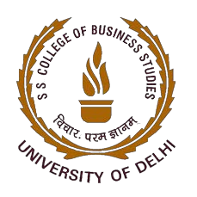

Activity Report

Title of Event: Expert talk on "Process of Innovation Development & Technology Readiness Level (TRL)" & “Commercialisation of Lab Technologies & Tech-Transfer”
Date of Session: 23 February 2022 (Wednesday)
Time: 01:00 PM - 02:00 P.M.
Teacher Coordinator: Mr. Jigmet Wangdus
Speaker(s): Dr. Ashutosh Pastor, Incubation Manager – FITT, IIT Delhi

Poster/Banner/Brochure of the event:
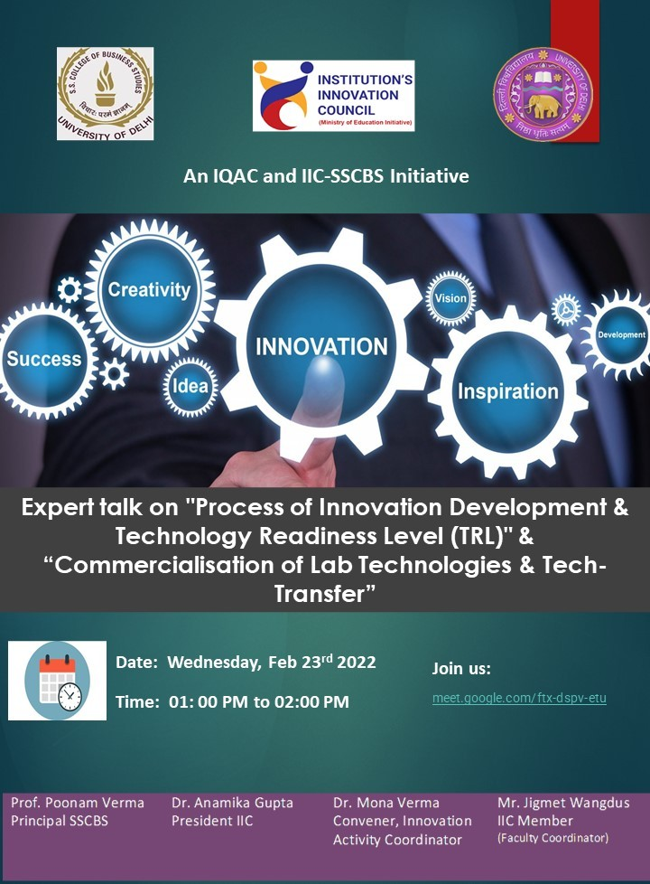

Activity Summary

BRIEF BIO OF SPEAKER

Speaker Name: Dr. Ashutosh Pastor
Dr. Ashutosh Pastor is managing Startup Incubation at the Foundation for Innovation and Technology Transfer at Indian Institute of Technology Delhi. He is supporting implementation of various funding programs for innovators and entrepreneurs in the Biotechnology domain like BIRAC BIG, SEED, LEAP, Pfizer-IIT Delhi Innovation and IP program, and many other government and CSR funded programs. He has completed his Ph.D. at IIT Delhi and has been associated with FITT since 2015 when the Biotechnology Business Incubation Facility was started at IIT Delhi. He is closely working with various Biotechnology startups and is always interested to interact with innovators and scientists at various institutes across the country.

OBJECTIVE OF THE EVENT
The session focused on the innovation development and understanding technology readiness level, manufacturing readiness level and investment readiness level.

Topics covered by Dr. Ashutosh Pastor in the session:
- Innovation
- Product Development
- Product Management Lifecycle
- Readiness level
- Technology Readiness Level
- Manufacturing Readiness Level
- Investment Readiness Level

KEY OUTCOMES OF THE EVENT
The session gives insights about product management lifecycle which will help students and entrepreneur to understand the different stages on product development. The session also discusses the challenging TRL levels of Product challenges, Business challenges, Innovation challenges and process challenges.

PHOTOGRAPHS

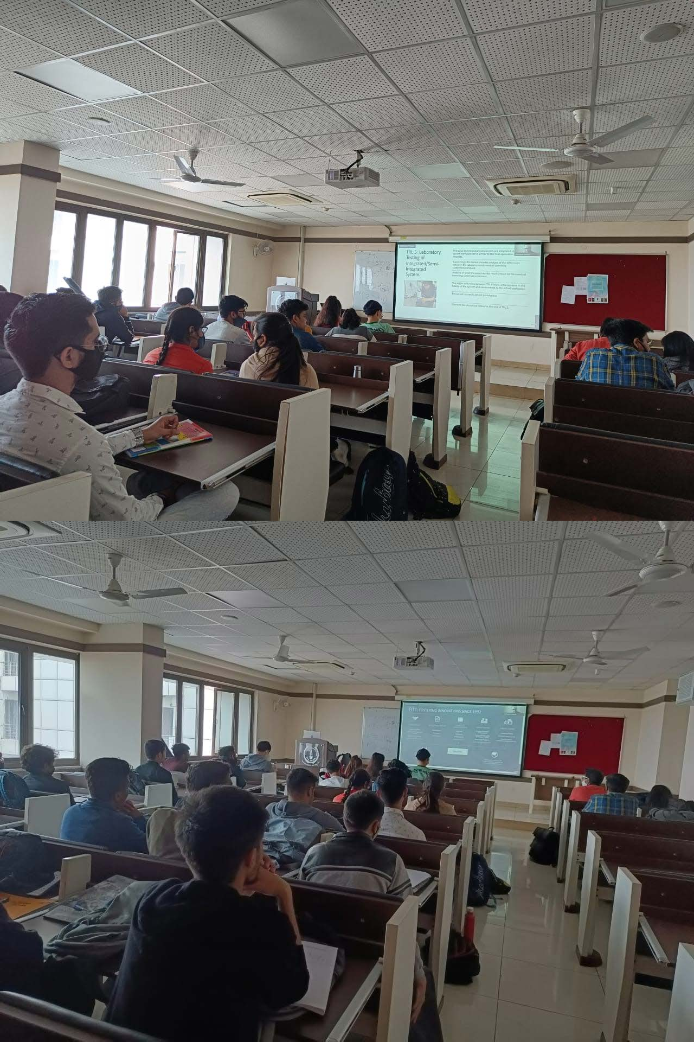

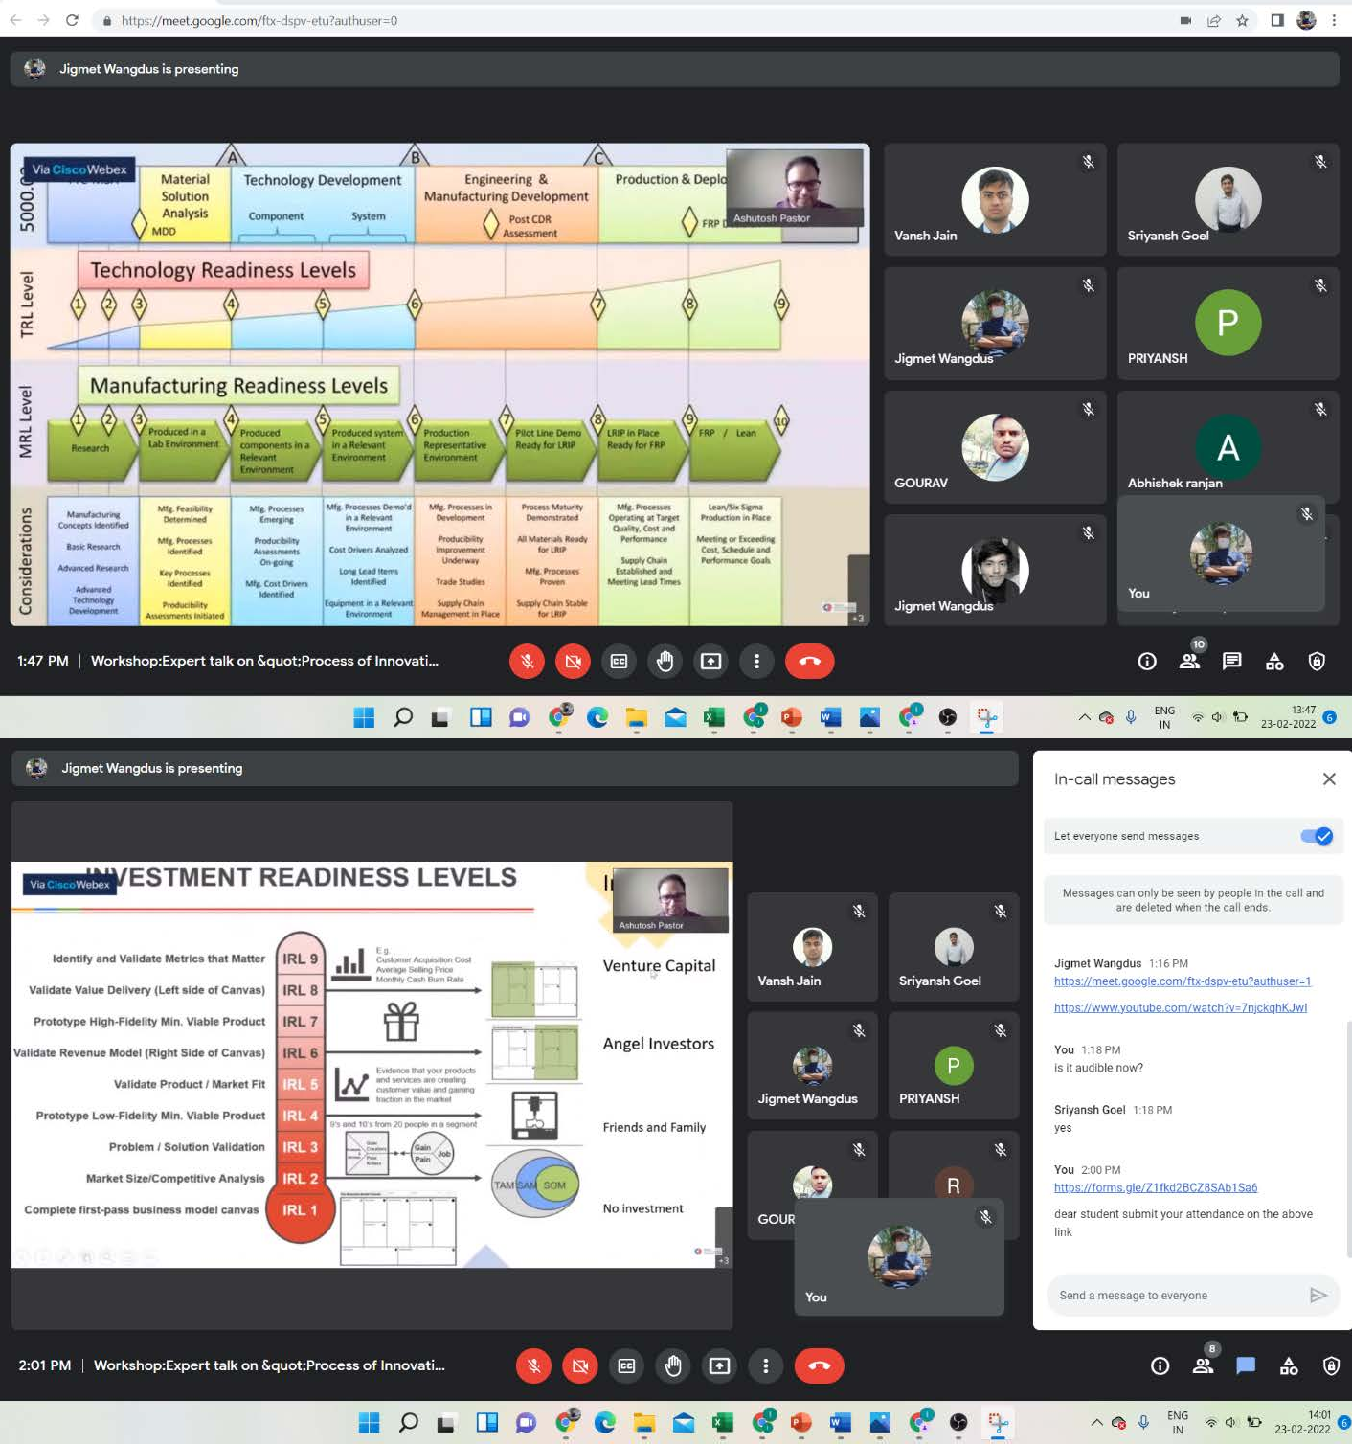

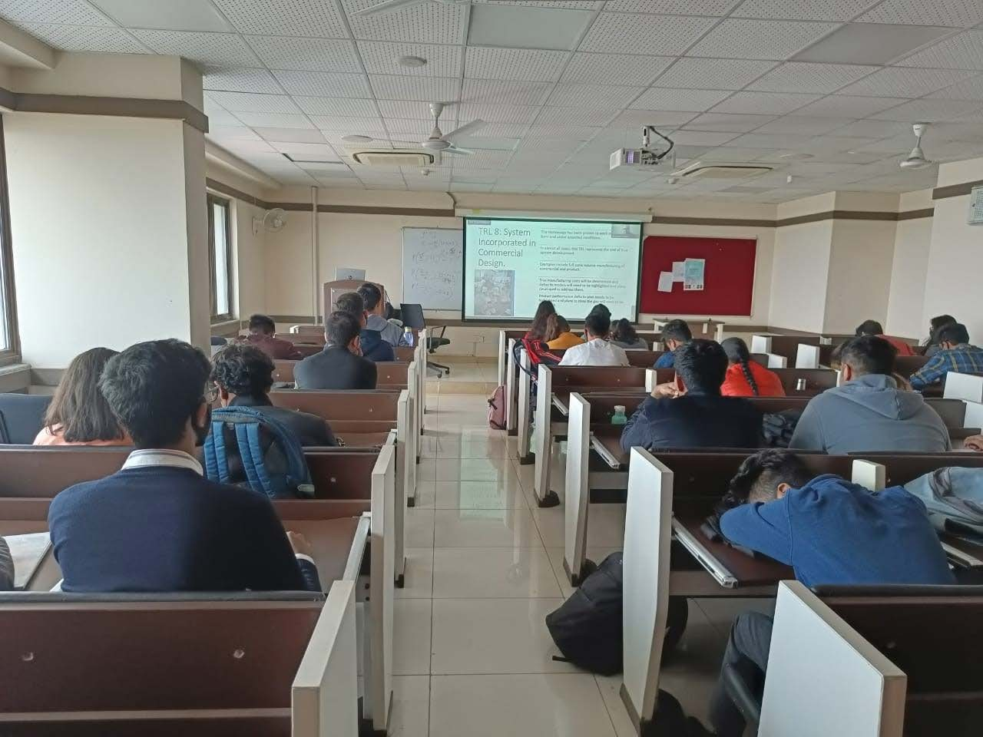

Attendance: 55+ (Students + Faculties)

Student Participants: (Attendance +Feedback)

S.N  o | Full Name | Roll No | College | Course | Rate [Comprehensiven ess of the Topics  Covered] | Rate [Preparedne ss of the  Trainer] | Rate [Queri es solved by the Trainer  ] | Rate [Meeting your expectatio  n] | Rate: [Overall Organisati on of the  workshop] | Will you be interested in attending similar talks/workshops/confere  nce in the future?
1 | Ananyaa Mangla | 20021 | SSCBS | BMS | 3 | 3 | 2 | 2 | 3 | Yes
2 | Ashish Jangra | 20040 | SSCBS | BMS | 1 | 1 | 1 | 1 | 1 | Yes
3 | Gaurang M  lakhani | 20071 | SSCBS | BMS | 5 | 5 | 5 | 5 | 5 | Yes

4 | Ishpreet Kaur Saini | 20087 | SSCBS | BMS | 4 | 3 | 4 | 3 | 4 | Yes
5 | Kripa | 20108 | SSCBS | BMS | 4 | 5 | 4 | 5 | 5 | Yes
6 | Kunal Kataria | 20111 | SSCBS | BMS | 5 | 5 | 5 | 5 | 5 | Yes
7 | Abhishek  Ranjan | 20307 | SSCBS | BFIA | 2 | 3 | 3 | 3 | 3 | Yes
8 | Aditya Singh Ramola | 20309 | SSCBS | BFIA | 4 | 4 | 5 | 5 | 4 | No
9 | Gourav | 20338 | SSCBS | BFIA | 2 | 2 | 1 | 2 | 2 | Yes
10 | Jayant Sumit  Toppo | 20349 | SSCBS | BFIA | 2 | 2 | 2 | 2 | 2 | Maybe
11 | Sarthak krishna  sharma | 20386 | SSCBS | BFIA | 5 | 5 | 5 | 5 | 5 | Yes
12 | Sukhvinder Singh | 20402 | SSCBS | BFIA | 2 | 1 | 1 | 1 | 1 | Maybe
13 | Vansh Jain | 20408 | SSCBS | BFIA | 3 | 3 | 1 | 2 | 3 | Maybe
14 | Yashika Goyal | 20420 | SSCBS | BFIA | 1 | 1 | 1 | 2 | 1 | Yes
15 | Priyansh | 20428 | SSCBS | BFIA | 4 | 4 | 4 | 4 | 4 | Maybe
16 | Priyansh | 20428 | SSCBS | BFIA | 5 | 5 | 5 | 5 | 5 | Maybe
17 | Emama Islam | 21067 | SSCBS | BMS | 1 | 1 | 1 | 1 | 1 | Yes
18 | Fernando Sankhil Lamkang | 21070 | SSCBS | BMS | 2 | 2 | 2 | 2 | 2 | Maybe
19 | Gaorav | 21071 | SSCBS | BMS | 5 | 5 | 5 | 5 | 5 | Yes
20 | Garv Jain | 21072 | SSCBS | BMS | 4 | 4 | 4 | 4 | 4 | Yes
21 | Gyandeepika | 21075 | SSCBS | BMS | 4 | 4 | 4 | 4 | 4 | Yes
22 | Harsha Saman Bandara Dias | 21079 | SSCBS | BMS | 5 | 5 | 5 | 5 | 5 | Maybe
23 | Harshil Rana | 21080 | SSCBS | BMS | 5 | 5 | 5 | 5 | 5 | Yes
24 | Harshit Agarwal | 21081 | SSCBS | BMS | 3 | 3 | 3 | 3 | 3 | Maybe
25 | Harshita Gupta | 21082 | SSCBS | BMS | 5 | 5 | 5 | 5 | 5 | Maybe
26 | Himani | 21085 | SSCBS | BMS | 4 | 4 | 4 | 4 | 4 | Maybe
27 | Ibrahim Ghaffar | 21088 | SSCBS | BMS | 5 | 5 | 5 | 5 | 5 | Maybe
28 | Ishan Goel | 21091 | SSCBS | BMS | 5 | 5 | 5 | 5 | 5 | No
29 | Ishika | 21092 | SSCBS | BMS | 1 | 2 | 1 | 1 | 2 | Yes
30 | Kashish Vohra | 21098 | SSCBS | BMS | 5 | 5 | 5 | 5 | 5 | Yes
31 | Kavya Deep | 21099 | SSCBS | BMS | 5 | 4 | 4 | 4 | 4 | Maybe
32 | Kodonshel Hongsha | 21104 | SSCBS | BMS | 2 | 2 | 2 | 2 | 2 | Maybe
33 | Komal Kataria | 21105 | SSCBS | BMS | 3 | 3 | 3 | 3 | 3 | Maybe
34 | Kopal Agrawal | 21106 | SSCBS | BMS | 4 | 5 | 5 | 4 | 5 | Yes
35 | Kumar Keshav | 21113 | SSCBS | BMS | 3 | 3 | 3 | 3 | 3 | Yes
36 | Lakshay  chhabra | 21114 | SSCBS | BMS | 3 | 3 | 3 | 3 | 3 | Yes
37 | Lavanya  Kumar | 21115 | SSCBS | BMS | 5 | 5 | 4 | 4 | 4 | Yes
38 | Lovneesh Kumar | 21117 | SSCBS | BMS | 3 | 3 | 3 | 3 | 3 | Yes
39 | Luv Sehgal | 21118 | SSCBS | BMS | 3 | 3 | 3 | 3 | 3 | Maybe
40 | Maharshi  Jaiswal | 21120 | SSCBS | BMS | 5 | 4 | 5 | 4 | 4 | Yes
41 | Malvika Sharma | 21124 | SSCBS | BMS | 5 | 5 | 5 | 5 | 5 | Maybe
42 | Manan Jain | 21125 | SSCBS | BMS | 1 | 1 | 1 | 1 | 1 | Yes
43 | SRIYANSH GOEL | 21231 | SSCBS | BMS | 4 | 1 | 1 | 4 | 4 | Yes
44 | Arpita Verma | 21264 | SSCBS | BMS | 1 | 1 | 1 | 1 | 1 | Yes
45 | Devhans Gurjar | 21265 | SSCBS | BMS | 2 | 2 | 2 | 2 | 2 | Maybe
46 | Mugdha Raj | 21270 | SSCBS | BMS | 5 | 3 | 2 | 2 | 2 | Yes
47 | Khushi Verma | 20105 | SSCBS | BMS | 4 | 4 | 3 | 3 | 2 | Maybe
48 | Laksh Meena | 20113 | SSCBS | BMS | 3 | 4 | 3 | 3 | 4 | Yes
49 | Dev Shukla | 20111 | SSCBS | BMS | 4 | 4 | 5 | 4 | 4 | Maybe
50 | Dhruv | 20116 | SSCBS | BMS | 3 | 4 | 4 | 4 | 4 | Maybe

Faculty/Non-Teaching/Others Participants:
- Dr. Anamika Gupta
- Dr. Mona Verma
- Dr. Pratibha Maurya
- Mr. Rishi Rajan Sahay
- Mr. Jigmet Wangdus

Link of recording (Youtube): https://youtu.be/Ibr6dC9v_2w

