Activity Report

Title of event: Entrepreneurship in Field of Art: My Story
Date of Session: 25th February 2022
Time: 1 PM to 2 PM
Speaker: Ms. Suman Sonthalia

Poster:
Youtube: https://bit.ly/3JRqQok Instagram: https://bit.ly/3tbglFx Twitter: https://bit.ly/3pf8be8

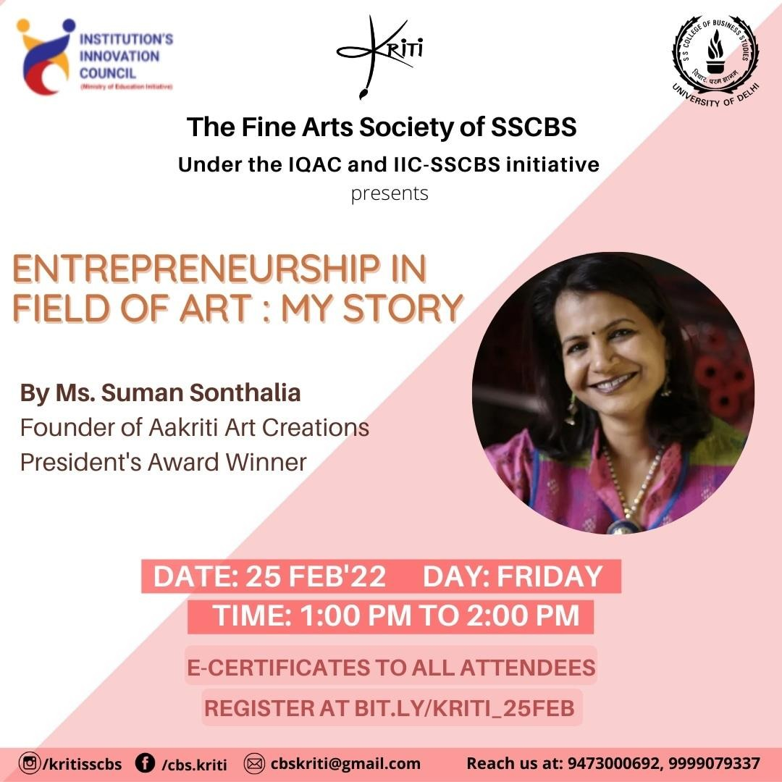

Summary:
Ms. Suman talked about how she was a housewife and wanted to gain financial independence which provoked her to start making paintings. Her paintings were sold at Central cottage emporium and many other places. She learned and tried different types of painting like mandala etc. She has been honoured with many awards in her eventful career like President's National Award for Master Craftsperson in 2011, State Awards in both 2009 and 2010. With all the exceptional skills she possesses, she is an environmentalist who prefers to use environment-friendly materials like Vegetable Dyes, Jute, Terracotta Clay, and many more. We got to know about how to approach real-life problems and how to work and ideate on the same. We witness how her unmatched aesthetic sense and unconventional business approach led to graduating her from being an artist to a successful entrepreneur in a very short span of time.

SCREENSHOTS

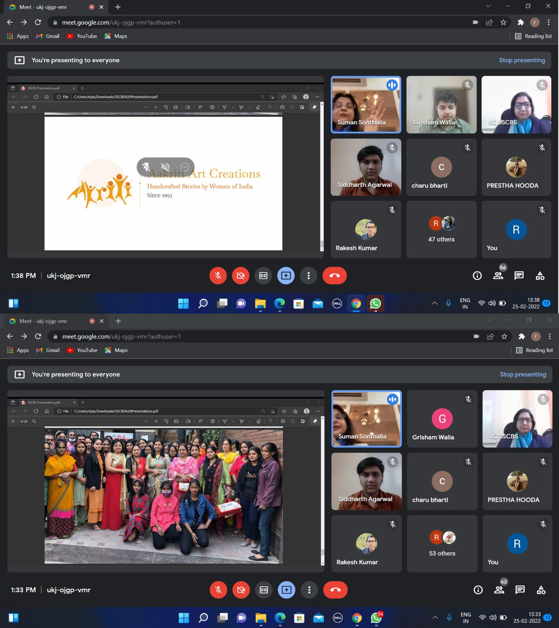

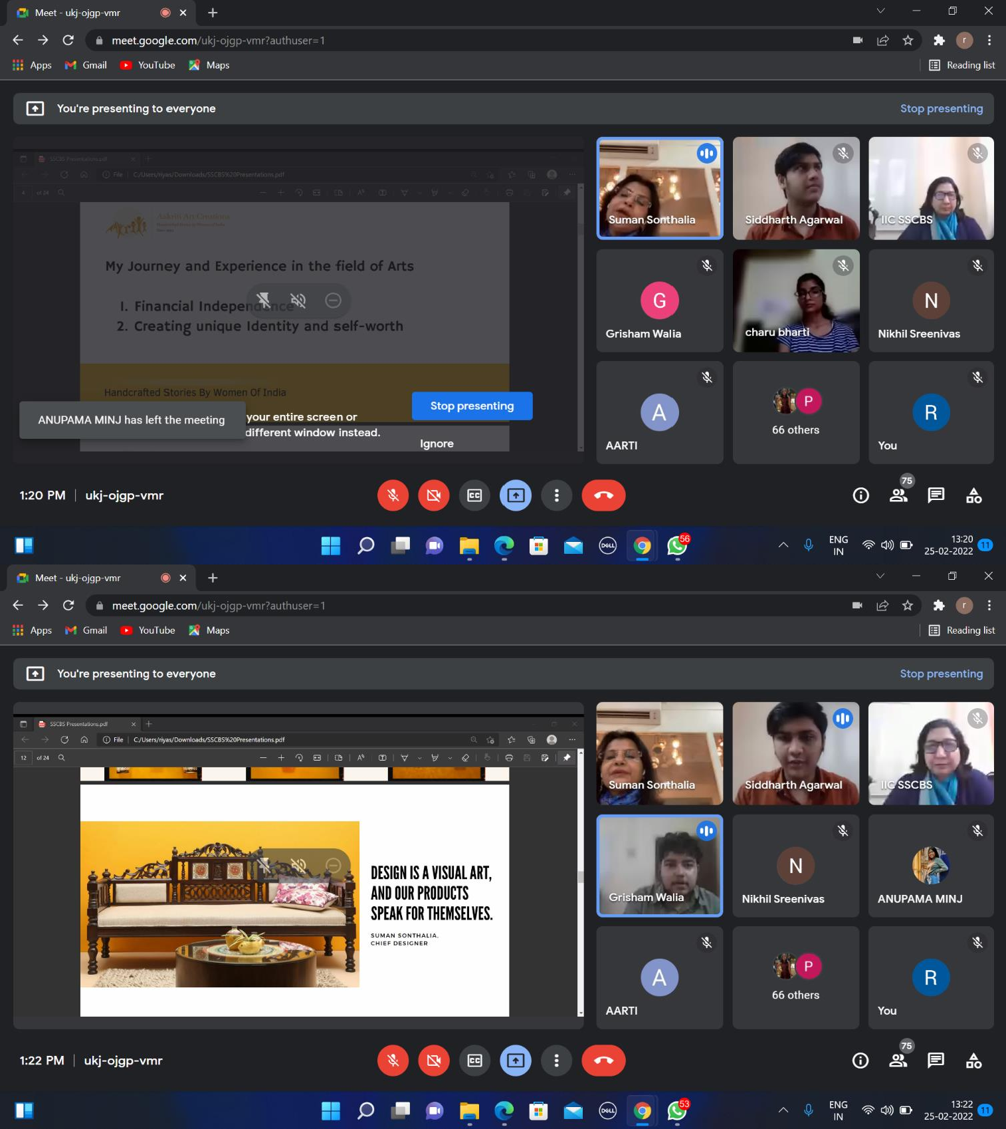

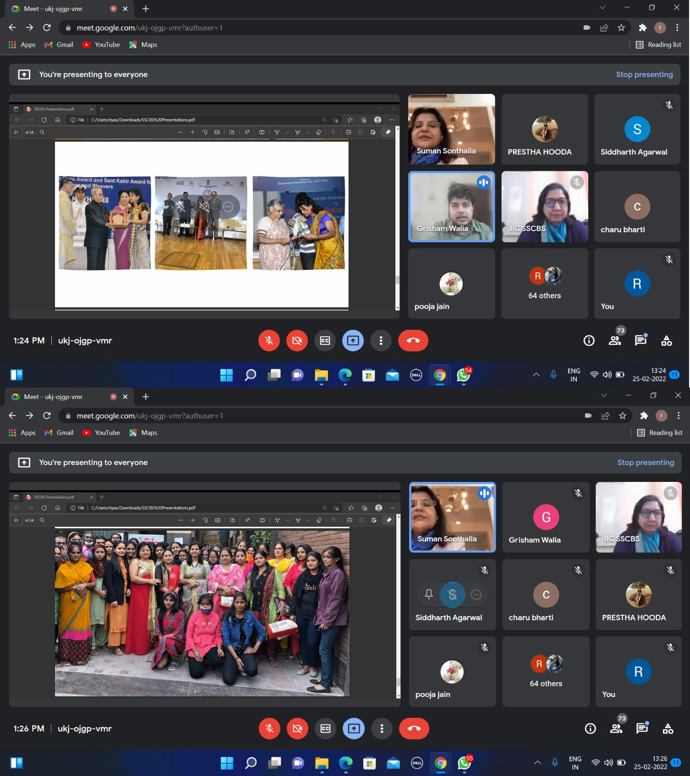

Attendance: 90

External Participants-39
S.No. | Name | Email | Contact | College
1 | Sofia Bhardwaj | sofiaisonline@gmail.com | 8800650593 | Miramda House
2 | Priyanshi Pandey | priyanshi5may95@gmail.com | 6388751229 | NA
3 | Shikha Sharma | palletsandpotraits@gmail.com | 8318684236 | Shri Ramswaroop Memorial Group Of Professional College
4 | Afsana Malik | afsanamalik924@gmail.com | 8178845535 | Vivekananda College
5 | Kirti | kirtisethi161@gmail.com | 7206780533 | Sd Pg College Panipat
6 | Hrishita Makkar | hmakkar2003@gmail.com | 9911336700 | Sri Guruvtegh Bhadur Khalsa College

7 | Shrasthi | shrasthij1@gmail.com | 7669825542 | Shaheed Rajguru College Of Applied Science For Women
8 | Anjali Giri | anjalig000066@gmail.com | 9971315667 | Maharaja Agrasen College
9 | Vidhi | vidhihooda6@gmail.com | 9992426363 | Spm
10 | Vardan Chawla | vardanchawla3108@gmail.com | 9306898802 | Delhi University
11 | Khem Singh Choudhary | khemsingh6375@gmail.com | 6375574913 | Hansraj College
12 | Gopal Goyal | gopalgoyalias@gmail.com | 9518164042 | Gopal Goyal
13 | Monika Yadav | monikayadav90017@gmail.com | 9001765033 | Kamala Nehru College (Du)
14 | Suman Kumari Yadav | sumanky.9654@gmail.com | 9654282340 | Kirori Mal College
15 | Radhika Mittal | radhikamittal132127@gmail.com | 9211228034 | Shyama Prasad Mukherji College
16 | Divyanshu Gupta | divyanshugupta913@gmail.com | 9643017975 | Shaheed Bhagat Singh Evening College
17 | Shrishti Singh Yadav | yadavshrishtisingh@gmail.com | 9761150005 | Maitreyi College, University Of Delhi
18 | Aakriti Kaur Khurana | akkukhurana21@gmail.com | 8130664458 | Lady Irwin College
19 | Anjali Sharma | anjali1102sharma@gmail.com | 9310696363 | Vivekananda College
20 | Anjali Kashyap | anjalikashyap2091@gmail.com | 9717212929 | Vivekananda College, University Of Delhi
21 | Pallavi Sharma | plsharma019@gmail.com | 7217777395 | Pallavi Sharma
22 | Shubham Goswami | goswamishubham037@gmail.com | 7007312573 | NA
23 | Shaswat Singh | shaswatsinghgzp@gmail.com | 9598619543 | Ramjas College
24 | Priyanka Kumari | priyanka913640@gmail.com | 9136401646 | Vivekananda College
25 | Vinay | vs010745@gmail.com | 8860344106 | Ram Lal Anand College
26 | Anusha Ratan Lal | anushalal2015@gmail.com | 9654361707 | Indraprastha College For Women, University Of Delhi
27 | Tanu Baisoya | tanubaisoya516@gmail.com | 7065643264 | Vivekananda College
28 | Megha | meghahaha24@gmail.com | 9058554493 | Ramanujan College, University Of Delhi
29 | Sweekriti Singh | sweekritisingh12c@gmail.com | 9839014503 | Hansraj College Du
30 | Sonali | sonaligautam714@gmail.com | 8826169742 | Vivekananda College
31 | Shinjinee Bhattacharyya | shinjinee.2021.277@mirandahouse.ac.in | 9830823473 | Miranda House
32 | Vanshika Narsaria | vanshika2110663@keshav.du.ac.in | 9470489488 | Keshav Mahavidyalaya
33 | Abhishek Bijarnia | abhishekbijarnia0421@gmail.com | 9413900421 | University Of Delhi
34 | Annu Kashyap | yashika33kashyap@gmail.com | 9971977216 | Annu Kashyap
35 | Pooja Jain | pooja0625jain@gmail.com | 9891761419 | Hansraj College Delhi University
36 | Samriddhi Agrawal | samriddhi.ug012@lic.du.ac.in | 9953504406 | Lady Irwin College Du
37 | Kajol | kajolkm16092002@gmail.com | 8287557737 | Drc
38 | Gauri Wadhwa | gauriwadhwadhwa282@gmail.com | 9560879853 | Rajdhani College, Delhi University
39 | Kirti Hasija | kirtihasija9115@gmail.com | 8307860591 | Model School, Rohtak

Student Participants: 90
S.No. | Name | Email | Contact | College
1 | Piyush Sankhla | piyush.21372@sscbs.du.ac.in | 9811080154 | Shaheed Sukhdev College Of Business Studies
2 | Grisham Walia | grisham.21336@sscbs.du.ac.in | 8130132499 | Shaheed Sukhdev College Of Business Studies

3 | Anushka | anushka.19020@sscbs.du.ac.in | 9212622801 | Shaheed Sukhdev College Of Business Studies
4 | Riya singhal | riya.21190@sscbs.du.ac.in | 8384094315 | Shaheed Sukhdev College Of Business Studies
5 | Rajdeep Khare | rajdeep.21180@sscbs.du.ac.in | 9522184161 | Shaheed Sukhdev College Of Business Studies
6 | Prestha Hooda | prestha.20533@sscbs.du.ac.in | 9999079337 | Shaheed Sukhdev College Of Business Studies
7 | Khushi verma | khushiv.2301@gmail.com | 8510060045 | Shaheed Sukhdev College Of Business Studies
8 | Priyanka saini | priyanka.21381@sscbs.du.ac.in | 9811924298 | Shaheed Sukhdev College Of Business Studies
9 | Aarti | aarti.20501@sscbs.du.ac.in | 7082140872 | Shaheed Sukhdev College Of Business Studies
10 | Charu Bharti | charu.21322@sscbs.du.ac.in | 9873444511 | Shaheed Sukhdev College Of Business Studies
11 | Radhika Saini | Sainiradhika082@gmail.com | 9625334264 | Shaheed Sukhdev College Of Business Studies
12 | Siddharth Agarwal | siddharth.21408@sscbs.du.ac.in | 9643995909 | Shaheed Sukhdev College Of Business Studies
13 | Prachi Singh | prachi.21167@sscbs.du.ac.in | 9336212040 | Shaheed Sukhdev College Of Business Studies
14 | Himani | himani.21085@sscbs.du.ac.in | 9650062552 | Shaheed Sukhdev College Of Business Studies
15 | Rakesh Kumar | Rakesh.21182@sscbs.du.ac.in | 6201416714 | Shaheed Sukhdev College Of Business Studies
16 | Parth Gupta | parth.21161@sscbs.du.ac.in | 7007514918 | Shaheed Sukhdev College Of Business Studies
17 | Shubham Tiwari | shubham.21266@sscbs.du.ac.in | 9667855493 | Shaheed Sukhdev College Of Business Studies
18 | Nikhil Sreenivas | nikhil.21154@sscbs.du.ac.in | 9110721540 | Shaheed Sukhdev College Of Business Studies
19 | Mohit Chhimpa | mohit.21140@sscbs.du.ac.in | 7678532399 | Shaheed Sukhdev College Of Business Studies
20 | Paurush Garg | paurush.21164@sscbs.du.ac.in | 895061632 | Shaheed Sukhdev College Of Business Studies
21 | Ria Pandit | ria.21184@sscbs.du.ac.in | 7903783467 | Shaheed Sukhdev College Of Business Studies
22 | Parv Gupta | parv.21163@sscbs.du.ac.in | 7838485378 | Shaheed Sukhdev College Of Business Studies
23 | Rishi Singhvi | rishi.21187@sscbs.du.ac.in | 9928853361 | Shaheed Sukhdev College Of Business Studies
24 | LUBHANSHU DHAMIJA | lubhanshu.21271@sscbs.du.ac.in | 9643383853 | Shaheed Sukhdev College Of Business Studies
25 | Nancy | nancy.21150@sscbs.du.ac.in | 9971066875 | Shaheed Sukhdev College Of Business Studies
26 | Rohan Tandon | rohan.21191@sscbs.du.ac.in | 7011290793 | Shaheed Sukhdev College Of Business Studies
27 | Myank Gulati | mayank.21132@sscbs.du.ac.in | 7428939465 | Shaheed Sukhdev College Of Business Studies
28 | Mohammad Saad | mohammad.21138@sscbs.du.ac.in | 9305502966 | Shaheed Sukhdev College Of Business Studies
29 | Rohit Shekhar | rohitshekhar1150@gmail.com | 8434442315 | Shaheed Sukhdev College Of Business Studies
30 | Rishikesh Jadhav | rishikesh.21188@sscbs.du.ac.in | 9321780110 | Shaheed Sukhdev College Of Business Studies
31 | Prabhat kumar | prabhat.21165@sscbs.du.ac.in | 9335962723 | Shaheed Sukhdev College Of Business Studies
32 | Prabhu Mehrotra | prabhu.21166@sscbs.du.ac.in | 9873220053 | Shaheed Sukhdev College Of Business Studies
33 | Parth Malhotra | parth.21162@sscbs.du.ac.in | 7982319481 | Shaheed Sukhdev College Of Business Studies
34 | Lubhanshu Dhamija | lubhanshu.21271@sscbs.du.ac.in | 9643383853 | Shaheed Sukhdev College Of Business Studies
35 | Sangharsh Ishwardas Khandare | sangharsh.21280@sscbs.du.ac.in | 8668752278 | Shaheed Sukhdev College Of Business Studies
36 | Nandini Gupta | nandini.21152@sscbs.du.ac.in | 7291067778 | Shaheed Sukhdev College Of Business Studies
37 | Prabhleen Kaur | prabhleen.21276@sscbs.du.ac.in | 8130060637 | Shaheed Sukhdev College Of Business Studies
38 | Nalin Mundeja | nalin.21146@sscbs.du.ac.in | 7011128780 | Shaheed Sukhdev College Of Business Studies
39 | Priyanka Goel | priyanka.21175@sscbs.du.ac.in | 8920596448 | Shaheed Sukhdev College Of Business Studies
40 | Gurjeet Kaur | gurjeetkaur@sscbsdu.ac.in | 9868353778 | Shaheed Sukhdev College Of Business Studies
41 | Tanya Goel | tanya.21416@sscbs.du.ac.in | 9810134551 | Shaheed Sukhdev College Of Business Studies
42 | Kanika Tanwar | kanika.19529@sscbs.du.ac.in | 8130092813 | Shaheed Sukhdev College Of Business Studies

Faculty Participants: 7
1 | Dr. Satish Kumar Goel | satish@sscbsdu.ac.in | SSCBS
2 | Dr. Anamika Gupta | anamikargupta@sscbsdu.ac.in | SSCBS
3. | Dr. Mona Verma | monavermag@sscbsdu.ac.in | SSCBS
4. | Dr. Pratibha Maurya | pratibhamaurya@sscbsdu.ac.in | SSCBS
5. | Dr. Anusha | anushagoel@sscbsdu.ac.in | SSCBS
6. | Dr. Jigmet | jigmet@sscbsdu.ac.in | SSCBS
7. | Mr. Tushar Marwaha | tusharmarwaha@sscbsdu.ac.in | SSCBS

Link of recording on YouTube channel: https://bit.ly/3JRqQok

