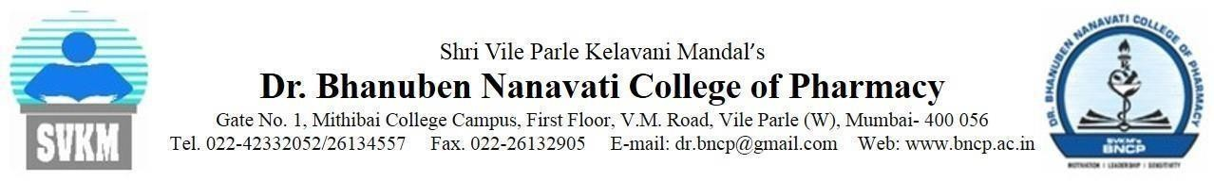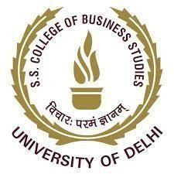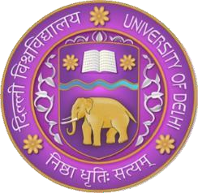
Shaheed Sukhdev College of Business Studies
Dr. K.N. Katju Marg Rohini, Sector 16, PSP Area IV, New Delhi, Delhi 110089
Tel. 011-22154581/22160681 Fax .011-22159941 Email: cbs@sscbsdu.ac.in Web: sscbs.du.ac.in

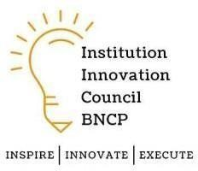Theme- Online Session

Institute innovation council

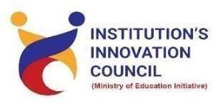
Ministry of Education (MoE) IIC ID: IC202216216

Activity name- I&E Initiatives & Programs of MoE for HEIs
Date- 24 January 2022
Time- 2:30 p.m. onwards Mandatory/ Elective – Mandatory Participants: Teachers and
Mode of activity- Online
Inauguration of Innovation ambassador training program 2021 online session was conducted on 24th January 2022 via MHRD Innovation Cell YouTube channel. The session was started with an introduction of speakers by Mr. Udyan Maurya.

The speaker of the day Mr. Deepan Sahu (Assistant innovation director, ministry of education Innovation cell) briefed about the institute innovation council, IIC 4.0 Registration and Participation Guidelines, the New Features of IIC 4.0 Portal and How to Use It. He also gave information about the various innovation and entrepreneurial initiatives of the ministry of education innovation cell for higher education institutes. He gave insights on policy framework which is called national innovation and startup policy for faculty and students which includes equity sharing, revenue sharing, IP sharing, and various sharing’s that faculty and students can take while maintaining the balance between academics and startups and can take the positions accordingly. Further, he explained the role of innovation ambassador in an institute, and gave insights on ARIA ranking systems that is the Atal Ranking ofInstitutions on Innovation Achievements.

He further explained about the Incentives and measurement of performance IIC Institutions effort and highlighted the points about innovation ambassadors will strengthen the IIC Council. He gave a detailed information on Integrated policy approach for maximum impact - NISP+IIC+ARIIA. The role of the IIC council is breaking of isolation, resource mobilization, andconductingtheactivitiesthroughoutthe year by maintaining the ranking scores on the IIC portal by IIC driven, self-driven, or MIC drivenactivities. To conclude he gave a glimpse of further modules which would take place under IIC Ministryof education (MoE).

Attendance Record: Teaching and Non-Teaching Staff
Sl No. | Names
1 | Ajay Jaiswal
2 | Abhimanyu Verma
3 | Anamika Gupta
4 | Mona Verma
5 | Rishi Rajan Sahay
6 | Pratibha Maurya
7 | Mohd. Rashid Shamim
8 | Onkar Singh
9 | Raj Kumar
10 | Rohini Singh
11 | Sanjay Kumar Goyal
12 | Shikha Gupta
13 | Sushmita
14 | Anusha Goel
15 | Anuja Mathur
16 | Gurjeet Kaur
17 | Amit Kumar
18 | Shalini Prakash
19 | Paridhi
20 | Kishori Ravi Shankar
21 | Saket Chattopadhyay
22 | Tushar Marwaha
23 | Jigmet Wangdus
24 | Sandra Suresh
25 | Ravi Yadav
26 | Deepak Tiwari
27 | Ankita Arora
28 | Nidhi Kesari
29 | Vijaylakshmi
30 | Gaurav Kumar Chaurasia

Students Attended the Session: 400 +(More than 400 students)
Glimpse of the event:
